Investering og finansiering overblik:
Indholdsfortegnelse
Fixed income: 4
Diskontering: 4
Forwardrate formler: 4
Bond market 4
First fundamental theorem of asset pricing : 5
Pricing of sure cashflow 5
Par rates: 6
Accured interest: 6
Duration: 7
Convexity: 8
Immunizisation: 8
Approximating Price changes when yield changes: 9
yield curves and spotrates: 9
Forwardrates: 10
Par rates defninition: 10
Floating rate theorem: 10
Shape of the term structure/spotrate kurve/yield kurve 11
Extracting discontrates from market prices: 11
Bootstrapping 11
Pros and cons of bootstrapping 11
Curve fitting 12
Faults with curve fitting: 12
Fischer Weil duration 12
Quasi modified duration 13
Random tø results: 13
Portfolio theory: 13
Unsystematic risk: 14
Systematic risk: 14
The feasible set: 15
The critical frontier: 15
The efficient frontier: 15
The two fund seperation theorem 16
The one fund theorem: 16
Tø resultater: 18
The market portfolio: 18
CAPM: 19
The sml(security market line) 19
Beta and return: 21
Performance evaluation: 21
Jensens alpha: 21
Sharpe index: 22
Pricing via CAPM 22
qritiques of CAPM 22
Noter fra TØ: 23
Factor models and APT 23
CAPM as a factor model: 25
Arbitrage pricing theory: 25
For a single factor model: 26
For multifactor models in matrix form: 26
APT and CAPM: 27
Choosing factors: 27
Estimators of asset parameters: 27
Stochastic stuff: 28
Utility functions: 28
The stochastic discount factor 28
Pricing with the stochastic discountfactor 29
A probability measuere: 29
State prices: 29
State price vector: 30
FTAP: 30
Completeness: 30
Absence of arbitrage: 31
No arbitrage in general: 32
Summary of state prices: 32
Derivatives: 32
A replicating strategy: 32
No-Arbitrage arguments: 32
Risk neutral pricing: 33
Forwards: 33
Convenience yield 35
General far forwards pricing 35
Futures: 35
Hedging with futures: 36
swaps: 37
Vanilla comodoties swap 37
interest rate swaps: 38
Stochastic processes 39
Binomial træ: 39
Brownian motion: 43
Ito process/ stochastic differantial equation: 43
Itos lemma: 43
Ito’s lemma related to binomal model… 44
Geometric brownian motion: 44
Noter fra tø: 45
Options: 45
European: 45
Call: 45
Put: 45
American: 45
Moneyness: 46
Intrinsic and extrinsic value: 46
Put call parity: 47
Pricing options in the binomial model: 48
Risk neutral probabilities in binomial model: 48
Pricing general derivatives on a binomial tree: 49
Limit as $Δt→0$ for european call/put in the binomial tree 49
Pricing american options: 49
First just american options: 49
Dividends: 50
Black Scholes Merton: 51
Overview between binomial vs BSM model: 51
BSM assumptions: 51
The BSM differantial equation: 51
The BSM options pricing formula: 52
Options Greeks of the BSM 52
Implied volatility: 53
Girsanovs theorem: 53
General risk neutral pricing in the BSM world: 54
Pricing call options with risk neutral pricing: 54
Portfolio insurance: 55
Pricing with montecarlo simulation 56
BSM with dividends: 57
BSM pros - shortcomings: 57
Stochastic interest rates: 58
ZCB pricing on binomial tree 59
State prices in the bond market: 60
Callable bond pricing: 60
Immunisisation: 61
Diskrete interest rate models 62
Ho-Lee model: 62
Black-derman-Toy model: 62
Interest rate models in continous time 63
Ho-Lee model 63
The Vasicek model 64
Cox-Ingersoll-Ross model (CIR) 65
Interest rate derivatives: 67
In the continous ho lee model: 67
In Affine models 68
In the vasicek model 68

Fixed income:

Diskontering:
penge i morgen er (oftest) mindre værd end penge i dag da kan vi knytte en nutidsværdi til penge i morgen eller til tid T
Ved fast diskontering: altså $r konstant$
$$d_{t}=\frac{1}{{\left(1+r\right)}^{t}}$$
Ved n årlige perioder
$$d_{t}=\frac{1}{{\left(1+\frac{r}{n}\right)}^{t}}$$
til samme tid som før
$$d_{t}=\frac{1}{{\left(1+\frac{r}{n}\right)}^{n·t}}$$
Kontinuert diskontering
$$d_{t}=e^{-rt}$$

Forwardrate formler:
Overholder per no arbitrage: for $j>i$
$${\left(1+s_{i}\right)}^{i}{\left(1+f_{i,j}\right)}^{j-i}={\left(1+s_{j}\right)}^{j}$$
Også skrevet
$$\frac{1}{d_{i}}{\left(1+f_{i,j}\right)}^{j-i}=\frac{1}{d_{j}}⇔f_{i,j}={\left(\frac{d_{i}}{d_{j}}\right)}^{\frac{1}{j-i}}-1$$

Bond market

Et financielt markede (i denne kontext fixed income) med n aktiver og T perioder
Med
Priser:
$$P={\left(\begin{matrix}P_{1} & … & P_{n}\end{matrix}\right)}^{T}$$
Og fremtidige cashflows:
$$B=\left(\begin{matrix}B_{1,1} & … & B_{1,T} \\ … & … & … \\ B_{n,1} & .. & B_{n,T}\end{matrix}\right)$$
En portfølje af aktiverne kan da beskrives som en lineær kombination af aktiverne i markedet altså som
$$θ∈R^{n}:B^{pf}=θ^{T}B,P^{pf}=θ^{T}P$$
Hvor negativ indgang i theta selvfølgelig er at du går kort i aktivet
Vi definerer arbitrage i et fixed income markede som
$$\left(B,P\right) has arbitrage⇔∃θ∈R^{n}:θ^{T}P=0,B^{pf}≥0 med B_{j}^{pf}>0 for some j$$
$$eller θ^{T}P<0,θ^{T}B≥0$$
This is under no market imperfektions i.e no transaction cost, short selling is allowed on all assets etc. if the market isen perfect this statement wont hold but there still wont be any real arbitrage because of these market imperfections
Any real arbitrage will be quickly adjusted by market forces driving prices into equilibrium

First fundamental theorem of asset pricing :
$$(B,P) is arbitragefree⇔∃d∈R_{+}^{T}: P=Bd$$
Where d is exactly the discount factors in the market

Completeness:
$$B is complete⇔∀B^{pf}∈R^{T}∃θ∈R^{n}:θ^{T}B=B^{pf}⇔rank\left(B\right)=T$$
$$\left(B,P\right) is arbitragefree and complete⇔B is invertible and B^{-1}P=d>0$$

Pricing of sure cashflow
For prissætningen af et generelt garenteret cashflow har vi formlen for n kashflows
$$PV=\sum_{k=1}^{n}{d_{t_{k}}x_{k}}$$

Vi har en række formler for priser disse afhænger dog ofte af en kendt struktur som kan gøre de ikke kan bruges:

P: price
F: face value
A: annual payments
n: number of years until experation
r: risk free rate
m is number of payments per year

Perpertuity: pays out A every period in perpetuity
$$P=\frac{A}{r}$$
Annuitet: pays A every period until experation
$$P=\frac{A}{r}\left(1-\frac{1}{{\left(1+r\right)}^{n}}\right)$$
Otherwise we simply use the general formula for pricing a certain cashflow given above

Yield:yield is the rate of return implied by a price and cashflow. The yield of a cash flow can be calculated by basicly the same formula now just solving for $λ$
$$P=\sum_{k=1}^{n}{\frac{x_{k}}{{\left(1+λ\right)}^{t_{k}}}}$$

This one may be adjusted to non yearly disconting
$$P=\sum_{k=1}^{n}{\frac{x_{k}}{{\left(1+\frac{λ}{m}\right)}^{t_{k}}}}$$
Cupon bond as a yield formula
$$P\left(T\right)=\frac{Fc}{λ}\left[1-\frac{1}{{\left(1+\frac{λ}{m}\right)}^{mT}}\right]+\frac{F}{{\left(1+\frac{λ}{m}\right)}^{mT}}$$

Par rates:
$c=λ$ is called at par $⇒P\left(T\right)=F$
$c>λ$ is called above par $⇒P\left(T\right)>F$
$c<λ$ is called below par $⇒P\left(T\right)<F$

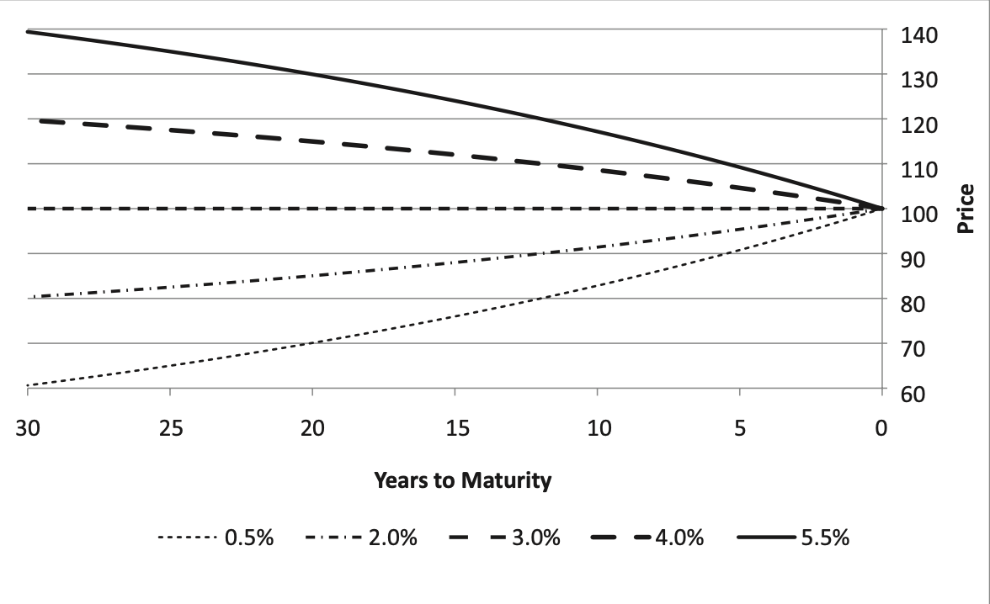
This is a graph of prices of bond at different Times to maturity at different cupon rates when yield curve is flat 3%
Showing that the longer untill maturity the further from Par pricing is the bond

Accured interest:
the value of holding the bond for a certain time without getting payed
We simply have a formula
For payments at time $T_{1},T_{2}$ and $t∈(T_{1},T_{2})$
We have that
$$AI=\frac{t-T_{1}}{T_{2}-T_{1}}\frac{c·F}{m}$$
Hvor $t-T_{1},T_{2}-T_{1}$ er angivet i kalenderdage(normalt, kan selvfølgelig også bare udregnes som andel af en anden slags periode: den egentlige pris for et bond i markedet kan da gives
$$P^{Full}=P^{flat}+AI$$
$$P^{flat}=PV\left(cashflows right after Cupon payment at time T_{1}\right)$$

Duration:
is roughly the sensitivity of a bond price to a change in yield
The duration sometimes called the modified duration is calculated:
$$D_{mod}=-\frac{dP}{dλ}·\frac{1}{P}=\frac{1}{P}·\frac{1}{1+\frac{λ}{m}}\sum_{k=1}^{n}{\frac{t_{k}·x_{k}}{{m·\left(1+\frac{λ}{m}\right)}^{t_{k}}}}$$

Another term is the macauley duration expressed as
$$D_{mac}=\left(1+\frac{λ}{m}\right)D_{mod}$$

Which is exactly the time of payment weighted PV of future payments
Which is rougly the time where half the value of the bond will have been payed out

The modified duration of a 0-cupon bond with payment at time T is exactly
$$D_{mod}^{ZCB}=\frac{T}{1+\frac{λ}{m}}$$
Of course since $λ=s_{T}$ in discrete yearly compounding settings

We have another formula for looking at the duration of a cupon bond hvor:
c: cupon rate
$λ$: yield
M: periods per year
N: antal perioder
$$D_{mac}=\frac{1+\frac{λ}{m}}{m·\frac{λ}{m}}-\frac{1+\frac{λ}{m}+n\left(c-\frac{λ}{m}\right)}{mc·\left[{\left(1+\frac{λ}{m}\right)}^{n}-1\right]+λ}$$
Hvor vi kan se at $c^{'}>c→D_{mac}^{'}<D_{mac}⇔D_{mod}^{'}<D_{mod}$
Og $n^{'}>n⇒D_{mac}^{'}>D_{mac}⇔D_{mod}^{'}>D_{mod}$
$$n→∞⇒D_{mac}=\frac{1+\frac{λ}{m}}{λ}⇔D_{mod}=\frac{1}{λ}$$
Som er præcis hvad vi forventer ved en pertuitet
Disse illustreret:

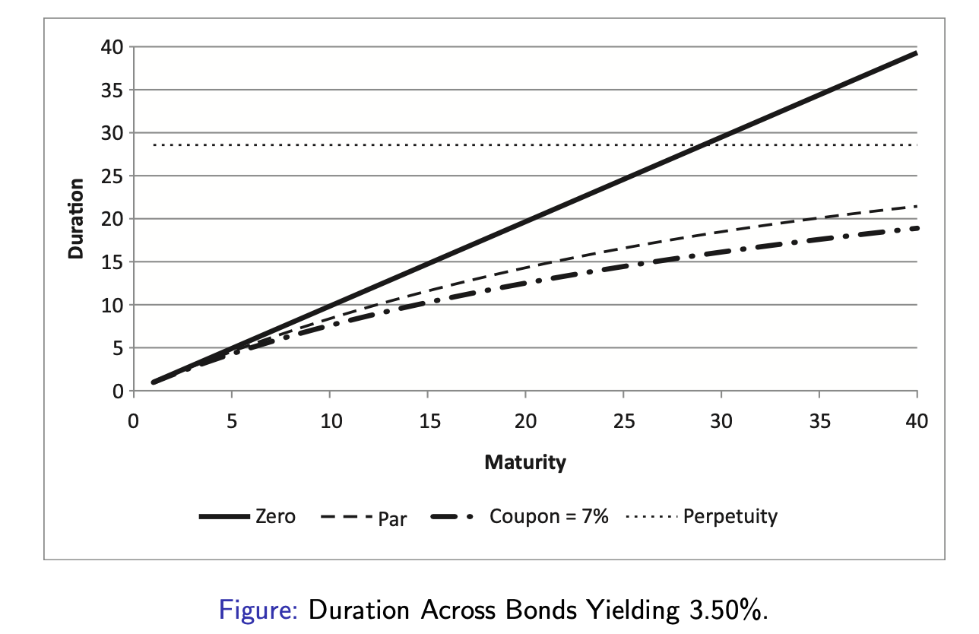

We see that any cupon bond approaches a perpetuity for maturity going towards infinity

The convexity of a bond is the next derivative given:
$$C=\frac{1}{P}·\frac{d^{2}P}{dλ^{2}}=\frac{1}{P}·\frac{1}{{\left(1+\frac{λ}{m}\right)}^{2}}\sum_{k=1}^{n}{\frac{t_{k}+1}{m}\frac{t_{k}}{m}\frac{x_{k}}{{\left(1+\frac{λ}{m}\right)}^{t_{k}}}}$$

For a portfolio of assets with weights $w_{i}$ in each asset
$$P^{pf}=∑w_{i}P^{i}$$
Modified Duration
$$D^{PF}=\sum{\frac{w_{i}P^{i}}{P^{PF}}D^{i}}⇔D^{PF}P^{PF}=\sum{w_{i}P^{i}D^{i}}$$

Convexity:
$$C^{PF}=\sum{\frac{w_{i}P^{i}}{P^{PF}}C^{i}} ⇔P^{PF}C^{PF}=\sum{{w_{i}P}^{i}C^{i}}$$

Immunizisation:
Trying to become immune to a change in yield in a noncomplete market; in a complete market you just create the exact cashflows
Given a arbitrary bond $B$ that we cant reconstruct in the market we create a portfolio such that
$$P^{B}=P^{pf}$$
$$D^{B}=D^{PF}⇔\frac{dP^{B}}{dλ}(λ_{0})=\frac{dP^{PF}}{Dλ}(λ_{0})$$
$$C^{B}=C^{PF}⇔\frac{d^{2}P^{B}}{dλ^{2}}(λ_{0})=\frac{d^{2}P^{PF}}{dλ^{2}}(λ_{0})$$

By selling the portfolio we’ve constructed we will have created a total portfolio with
$$P^{T}=0$$
$$D^{T}=0$$
$$C^{T}=0$$
Again for as many derivatives as we have available
In a non complete market with n<T assets we can hedge to the nth degree
EX in a market with only 2 assets and a non traded asset is introduced we can only hedge to the second degree giving thus with price and duration

This is only a momentary hedge since the next derivatives are only matched if we have exact cashflows thus after a change in yield we will need to adjust the hedge
To match the equations above

Approximating Price changes when yield changes:
Given taylor approximation
$$P\left(λ+Δλ\right)≈P\left(λ\right)+\frac{dP}{dλ}·Δλ+\frac{1}{2}·\frac{d^{2}P}{dλ^{2}}·(Δ{λ)}^{2}$$
$$\frac{ΔP}{P}≈\frac{1}{P}·\frac{dP}{dλ}·Δλ+\frac{1}{P}·\frac{1}{2}·\frac{d^{2}P}{dλ^{2}}·(Δ{λ)}^{2}$$
$$\frac{ΔP}{P}≈-D_{mod}·Δλ+\frac{1}{2}·C·(Δ{λ)}^{2}$$
$$ΔP≈P·(-D_{mod}·Δλ+\frac{1}{2}C·(Δ{λ)}^{2})$$
a result of this is that its rather clear that, when immunizising we would rather be long convexity because given a fall in yield the price would fall less since duration also falls more
being long C means we accelerate faster but also decellerate faster
illustrated:

yield curves and spotrates:
definition of a spotrate for a ZCB(zero cupon bond) paying F at maturity in t years then the spotrate based on xompunding m times a year $s_{t}$ is defined as the solution to
$$P=\frac{F}{{\left(1+\frac{s_{t}}{m} \right)}^{mt}}$$
When continous compounding
$$P=F·e^{-s_{t}·t}$$
This gives us a direct connection to the discountfactors
$$d_{t}=\frac{1}{{\left(1+\frac{s_{t}}{m}\right)}^{mt}}$$
Or continous
$$d_{t}=e^{-s_{t}·t}$$

Forwardrates:
Forwardrates are the rates you right now can get on money invested in time I to be payed out at time J these follow for $j>i$ in discrete compounding
$${\left(1+\frac{s_{i}}{m}\right)}^{i}{\left(1+\frac{f_{i,j}}{m} \right)}^{j-i}={\left(1+\frac{s_{j}}{m}\right)}^{j}$$
For continous:
$$e^{s_{2}t_{2}}=e^{s_{1}t_{1}}·e^{f_{t_{1},t_{2}}\left(t_{2}-t_{1}\right)}$$
In general with discountrates we have that for $i<k<j$
$$d_{i,j}=d_{i,k}·d_{k,j}$$
Where under discrete compounding:
$$d_{k,j}=\frac{1}{{\left(1+\frac{f_{k,j}}{m}\right)}^{j-k}}$$
Eller for continuert
$$d_{k,j}=e^{-f_{k,j}(j-k)}$$

Par rates defninition:
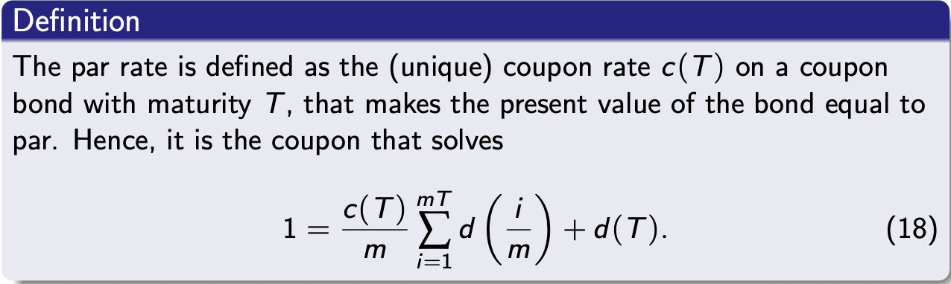

Floating rate theorem:
The value of a floating rate bond is equal to par at any resting point
(altså for et bond der udbetaler præcis den aktuelle risk free rate på dine penge hver periode har pris lig frace value lige efter hver udbetaling)
$$PV\left(B_{floatingrate}\right)=F$$

Shape of the term structure/spotrate kurve/yield kurve
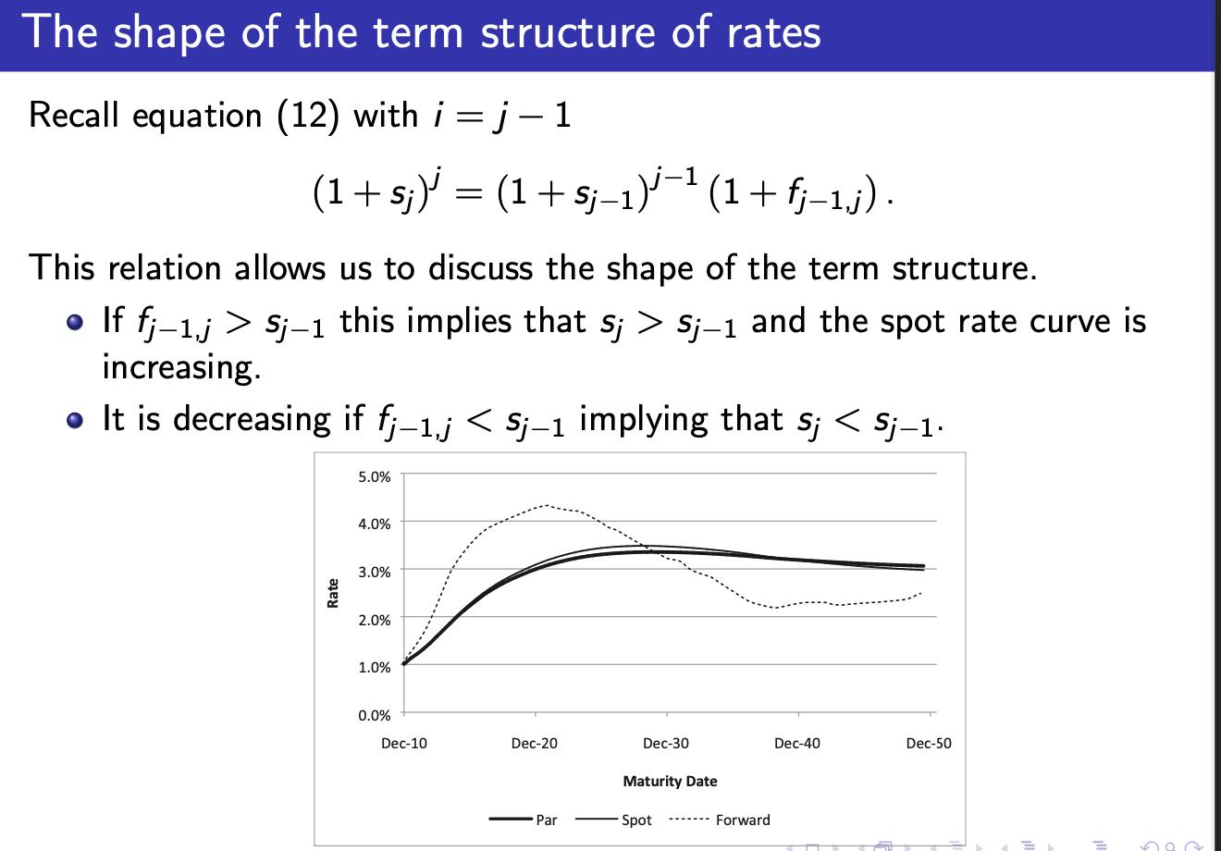

Explenations of the shape of the yield curve:
- Market expectations of rate changes.
- Liquitity preferences/risk premia : spotrates should be rising since longer maturities means holing risk longer
- Market segmentation: different buyers buying different products pricing them different

Extracting discontrates from market prices:

Bootstrapping
In a market with N bonds with payments in n different dates we have

$$P=\left(\begin{matrix}B_{11} & 0 & … & 0 \\ B_{21} & B_{22} & … & 0 \\ … & … & … & … \\ B_{N,1} & B_{N2} & .. & B_{Nn}\end{matrix}\right)\left(\begin{aligned}d_{1} \\ … \\ d_{n}\end{aligned}\right)$$
In this way we only get an answer if B has full rank which is when we have n bonds with linearly independent cashflows

Pros and cons of bootstrapping
Pros: all $d_{i}$ are exact
Simple to compute
Cons:
gaps in curve between points
noise in prices are incoporated into curve
sometimes the curve becomes very unsmooth
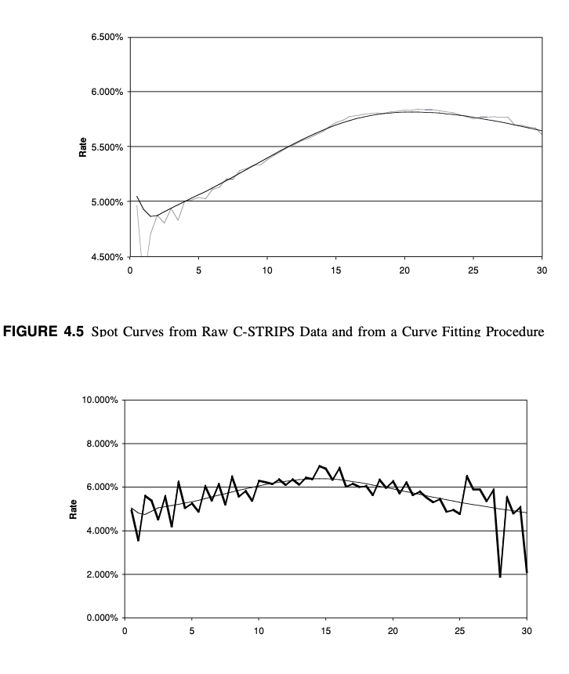

Curve fitting
Select a parametric model with parameters $β$which makes a smooth curve the calculate model based $P_{B}(β)$ then we adjust the model such that we minimize the sum of square errors from the actual prices in the market
$$SSE=\sum_{i=1}^{N}{{\left(P_{i}^{market}-P_{i}^{B}\right)}^{2}}$$
One such model is the nelson siegel
$$s_{t}=β_{0}+\frac{β_{1}\left(1-e^{-λt}\right)}{λt}+β_{2}\left(\frac{1-e^{-λt}}{λt}-e^{-λt}\right)$$
Where
$β_{0}$ ie the level factor
$β_{1}$ is the slope factor
$β_{2}$ is the curvature factor
$λ$ is the decay factor that controlls ow fast we approach the level

Faults with curve fitting:
- In general there are fewer bonds in the longer term meaning less datapoints and thus a skew towards fitting closer to actual
- Less liquidity both in long and short end mening less correct prices
- Only a snapshot of current market which we expect to change over time

Fischer Weil duration
Ud fra den lidt mere generelle spotratekurve har vi Fischer Weil duration
For
$$P=\sum_{i=0}^{n}{x_{t_{i}}·e^{-s_{i}·t_{i}}}$$
$$D_{FW}=\frac{1}{P}\sum_{i=0}^{n}{{t_{i}·x}_{t_{i}}·e^{-s_{i}·t_{i}}}$$
Also we introduce the price as a function of a parralel shift in yield
$$P\left(δ\right)=\sum_{i=0}^{n}{x_{t_{i}}·e^{-{(s}_{i}+δ) ·t_{i}}}$$
The price sensitivity to a parlel shift in yield is then exactly
$$\frac{dP\left(δ\right)}{dδ}\left(0\right)=-\sum_{i=0}^{n}{{t_{i}·x}_{t_{i}}·e^{-s_{i}·t_{i}}}$$
Then we see that the fisher weil duration is actually
$$D_{FW}=-\frac{1}{P\left(0\right)}·\frac{dP\left(δ\right)}{dδ}\left(0\right)=\frac{1}{P(0)}\sum_{i=0}^{n}{{t_{i}·x}_{t_{i}}·e^{-s_{i}·t_{i}}}$$

Quasi modified duration
The same principle in discrete time gives us the quasi modified duration
$$D_{Q}=-\frac{1}{P\left(0\right)}·\frac{dP\left(δ\right)}{dδ}\left(0\right)=\frac{1}{P\left(0\right)}·\sum_{k=1}^{n}{\frac{k}{m}·\frac{x_{k}}{{\left(1+\frac{s_{k}}{m}\right)}^{(k+1)}}}$$

Random tø results:
If the spotcurve is flat then the forwardrate curves are also flat:
$$s_{t}=r ∀t⇒f_{t,t+k}=r ∀t,k$$

If 2 bonds $A,B$ have the same yield then the bond $A+B$ has the same yield a result of this is that
if $s_{t}=r$ Then the yield of all bonds in the market must also have $λ=r$
(this of course also holds in subsets of markets but is nice when doing exercises with flat spot curves)

Portfolio theory:
Assumptions:
One period model
Investors only care about the mean and variance of return
Investors all agree on the expected returns, the variance of returns and how they covary
All information is available at no cost
No transaction costs
Assets are infinnately divisible
Agents are rational and risk averse

General:
N: number of risky assets
$P_{it}$ : price of Asset I at time t
$R_{i}=\frac{P_{i1}}{P_{i,0}}$ : total return of asset i
$R_{i}-1$: rate of return of asset i
${\overline{r}}_{i}=E[r_{i}]$ : expected return of asset i(under P?)
$σ_{i}^{2}$ : variance of asset i
$σ_{i,j}=cov(r_{i},r_{j})$: covariance of asset I and j
$ρ_{i,j}=\frac{σ_{i,j}}{σ_{i}·σ_{j}}$: the corralation between assen I and j
$w_{i}$: weight of portfolio in asse I with $∑w_{i}=1$

We will do it all in matrix form:
With n risky assets
$r=\left(\begin{aligned}r_{1} \\ … \\ r_{n}\end{aligned}\right)$ vektor of atual returns
$\overline{r}=\left(\begin{aligned}\overline{r_{1}} \\ … \\ {\overline{r}}_{n}\end{aligned}\right)$ vector of expected returns
$Σ=\left(\begin{matrix}σ_{11}^{2} & … & σ_{n,1} \\ … & … & … \\ σ_{1,n} & … & σ_{n}^{2}\end{matrix}\right)$ covariansmatrix which is symetric i.e $Σ=Σ^{T}$
$w=\left(\begin{aligned}w_{1} \\ … \\ w_{n}\end{aligned}\right)$ portfolio weights
$I=\left(\begin{aligned}1 \\ … \\ 1\end{aligned}\right)$
Actual return of a portfoli can always be written
$$r_{p}=w_{p}^{T}r$$
Expected return of a protfolio can always be written as
$${\overline{r}}_{p}=E\left[r_{p}\right]=w_{p}^{T}\overline{r}$$
Variance of a portfolio can always be calculated
$$σ_{p}^{2}=w_{p}^{T}Σw_{p}$$
Covariance of 2 portfolio can always be calculated
$$σ_{p,p'}=w_{p}^{T}Σw_{p'}=w_{p'}^{T}Σw_{p}$$

Unsystematic risk:
The risk associated with a specific asset, this risk can be diversified away

Systematic risk:
The risk that all assets are exposed to and therefore not possible to diversify away

How much we are able to diversify away depends on the structure of the covariance matrix $Σ$
The more positively assets are correlated the less risk can be diversified away

The feasible set:
Set of available portfolios depicted in the $\left(σ,\overline{r}\right)-$diagram
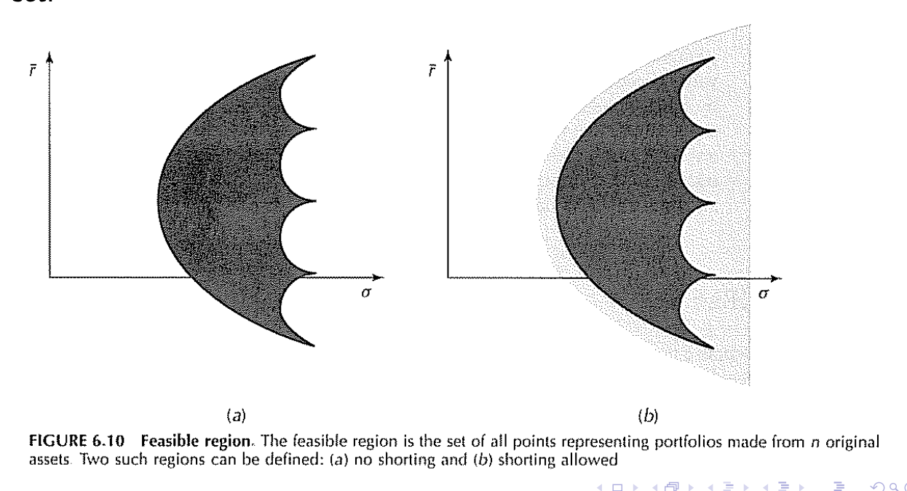
The depiction to the left is of a no short selling restriction

The critical frontier:
The set of portfolios defined as minimum variance for a given return

The efficient frontier:
The portfolios with max return given a certain risk (a rational investor will always invest on the efficient frontier since he prefers low risk and high reward)
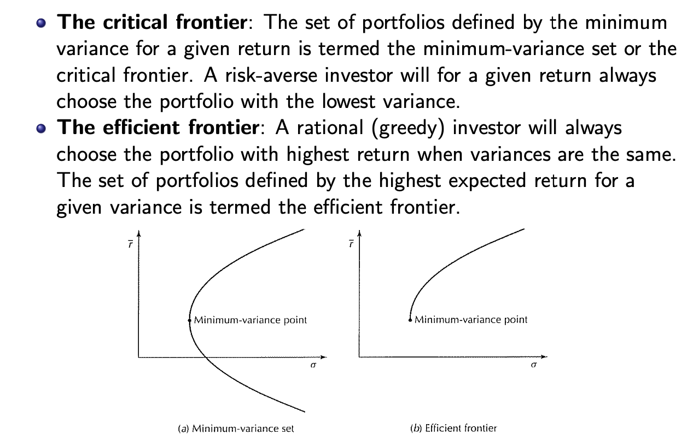

The markowitz framework
$$\min{σ_{p}^{2}}=\min{w^{T}Σw}$$
$$s.t w^{T}\overline{r}={\overline{r}}_{p}$$
$$w^{T}I=1$$
Giving us the following equations:
$$a=I^{T}Σ^{-1}I>0$$
$$b=I^{T}Σ^{-1}\overline{r}$$
$$c={\overline{r}}^{T}Σ\overline{r}>0$$
$$d=ac-b^{2}>0$$
And
$$w^{⋆}=\frac{a·{\overline{r}}_{p}-b}{d}Σ^{-1}\overline{r}+\frac{c-{\overline{r}}_{p}b}{d}Σ^{-1}I$$
Which then has return:
$${w^{⋆}}^{T}r=r_{p}$$
$$σ_{p}^{2}={w^{⋆}}^{T}Σw^{⋆}=\frac{a{\overline{r}}_{p}-2b{\overline{r}}_{p}+c}{d}$$
En andengradslining I ${\overline{r}}_{p}$
The minimum variance portfolio:
$$w_{mvp}=\frac{1}{a}Σ^{-1}I=\frac{Σ^{-1}I}{I^{T}Σ^{-1}I}$$
$$σ_{mvp}^{2}=w_{mvp}^{T}Σ^{}w_{mvp}=\frac{1}{a^{2}}·I·Σ^{-1}·Σ·Σ^{-1}·I=\frac{1}{a}$$
$${\overline{r}}_{mvp}=\frac{b}{a}=w_{mvp}^{T}\overline{r}$$

In general we can add short selling constraints to the markowitz problem but this dosent nessesarily give a nice solution

The two fund seperation theorem
(when there is no riskfree asset):
Any efficient portfolio can be attained by investing in 2 efficient portolios or in math
$$y,x effecient and y≠x⇒(w effecient⇒∃α:α·y+\left(1-α\right)·x=w)$$
Or simply by return
$$y,x effecient and \overline{r_{y}}≠\overline{r_{x}}⇒∀\overline{r}>0∃α:α\overline{r_{y}}+\left(1-α\right)\overline{r_{x}}=\overline{r}$$
And for this alpha ${\left(α·y+\left(1-α\right)·x\right)}^{T}Σ{\left(α·y+\left(1-α\right)·x\right)}^{}=\min{σ_{p}^{2}}s.t$

Adding a risk free asset paying returning $r_{f}$

The one fund theorem:
$$There exists a single effecient fund F of risky assets such that any$$
$$effecient portfolio is a combination for the risk free aset and the fund F$$
We call this portfolio the tangent portfolio
Giving us return:
$${\overline{r}}_{p}=w_{0}r_{f}+\left(1-w_{0}\right){\overline{r}}_{tan}$$
And variance:
$$σ_{p}^{2}={\left(1-w_{0}\right)}^{2}σ_{tan}^{2}⇔σ_{p}=\left(1-w_{0}\right)σ_{tan}$$
Thus any efficient portfolio must have these caracteristics
We calculate the tangency portfolio: where $\overline{r_{e}}=\overline{r} -r_{f}$
$$w_{tan}=\frac{Σ^{-1}{\overline{r}}_{e}}{I^{T}Σ^{-1}{\overline{r}}_{e}}$$
Calculating variance and return as usual
This portfolio is the portolio with the highest sharp ratio of portfolios only consisting of risky assets
In this setting it is impossible to get a higher sharp than the tangency portfolio

This of course means that given a risk free asset any efficient portflio must be on the line made by
$$\left(0,r_{f}\right),(σ_{tan},\overline{r_{tan}})$$
$${\overline{r}}_{p}=r_{f}+\frac{\overline{r_{tan}}-r_{f}}{σ_{tan}}·σ_{p}$$
Thus the efficient set must be exactly
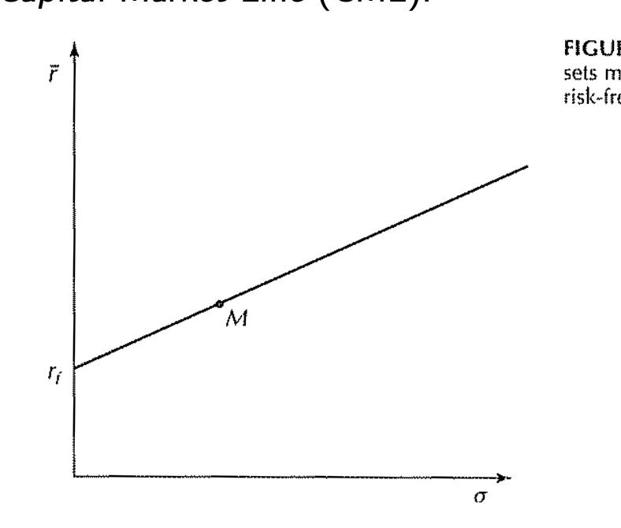
In the CAPM setting this is called the CML (Capital Market Line) depicting the line from the risk free asset to the Market portfolio)
With the equation
$${\overline{r}}_{p}=r_{f}+\frac{\overline{r_{m}}-r_{f}}{σ_{tan}}·σ_{p}$$

The assumption that investors are mean variance optimising holds in these 2 cases
Returns are normally distributed
$$r\sim N(\overline{r},Σ)$$
And if investors have quadratic utilityfunctions:
$$U\left(r_{p}\right)=r_{p}-br_{p}^{2}$$

Tø resultater:
Given $n uncorrelated assets$ with the same return the minimum varaince portfolio must be
Calculated
$$Σ=\left(\begin{matrix}σ_{1}^{2} & 0 & 0 \\ 0 & … & 0 \\ 0 & 0 & σ_{n}^{2}\end{matrix}\right)$$
$$Σ^{-1}=\left(\begin{matrix}\frac{1}{σ_{1}^{2}} & 0 & 0 \\ 0 & … & 0 \\ 0 & 0 & \frac{1}{σ_{n}^{2}}\end{matrix}\right)$$
$$\frac{1}{I^{T}Σ^{-1}I}=\frac{1}{{\left(\begin{aligned}1 \\ … \\ 1\end{aligned}\right)}^{T}·V^{-1}·\left(\begin{aligned}1 \\ … \\ 1\end{aligned}\right)}=\frac{1}{\sum_{k=1}^{n}{\frac{1}{σ_{k}^{2}}}}$$
$$W=\frac{1}{\sum_{k=1}^{n}{\frac{1}{σ_{k}^{2}}}}·\left(\begin{matrix}\frac{1}{σ_{1}^{2}} & 0 & 0 \\ 0 & … & 0 \\ 0 & 0 & \frac{1}{σ_{n}^{2}}\end{matrix}\right)\left(\begin{aligned}1 \\ … \\ 1\end{aligned}\right)=σ^{2}\left(\begin{aligned}\frac{1}{σ_{1}^{2}} \\ … \\ {1/σ}_{n}^{2}\end{aligned}\right)$$
Where as $σ^{2}=\frac{1}{\sum_{k=1}^{n}{\frac{1}{σ_{k}^{2}}}}$

The market portfolio:
The one fund theorem implies that the only portfolio being bought is exactly the tangency portfolio
Given the total value in the market the tangency portfolio must be exactly the portfolio consisting of the total value of all assets this implies that the market portfolio must have strictly positive weights in every asset
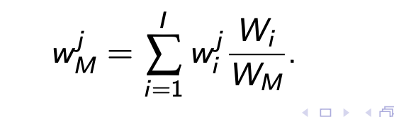
CAPM
On the CML
We describe the $s_{tan}=\frac{\overline{r_{tan}}-r_{F}}{σ_{tan}}$ as the price of risk or how much excess return you need to give for 1 less risk.
This is only applicable for efficient portfolios
For looking at non-efficient portfolios we introduce the CAPM(Capital Asset Pricing Model)

CAPM:
Assumptions
Returns can be catagorised into market driven and asset specifik return
There is no reward for holding asset specific risk
+ all markowitz assumptions
The market portfolio is exactly the tangency portfolio

The expected excess return of any asset
$$\overline{r_{i}}-r_{f}=β_{i}\left({\overline{r}}_{m}-r_{f}\right)$$
$$β_{i}=\frac{σ_{im}}{σ_{m}^{2}}$$

The sml(security market line)
This model lets us build another line the SML(security market line)
$$\overline{r_{i}}=r_{f}+β_{i}\left({\overline{r}}_{m}-r_{f}\right)=r_{f}+\frac{σ_{im}\left({\overline{r}}_{m}-r_{f}\right)}{σ_{m}^{2}}$$
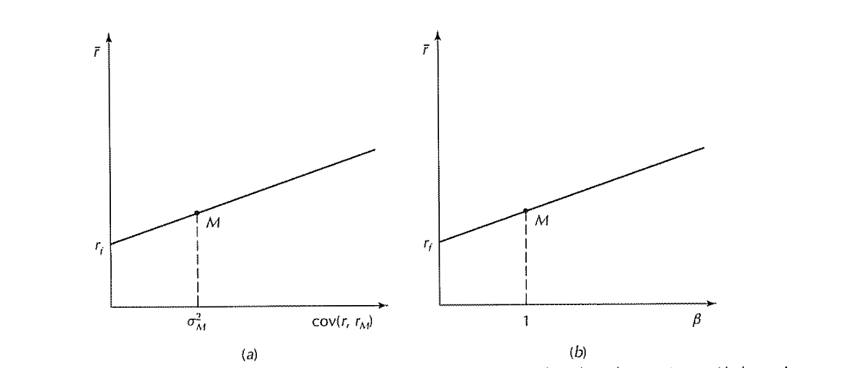
(if an asset is above the security market line if capm holds it should be bid up reducing its expected return until it is exactly on the SML, in the same way if it is below it becomes less attractive thus the price falls and it approaches the SML, In CAPM equilibrium we should be exactly on this line)

In the model we catagorise movement of the asset into a systematic part and a asset specific part
$$r_{i}=r_{f}+β_{i}\left({\overline{r}}_{m}-r_{f}\right)+ϵ_{i}$$
the capm assumes that there is no gain in holding unsystematic risk(or in other words the market is the only driving force of consistent gains) or in math
$$E\left[ϵ_{i}\right]=0,cov\left(ϵ_{i},r_{m}\right)=0$$

any risk of an asset into the assosiated market risk(systematic risk) and the assets unsystematic risk (idiosyncratic risk) with
$$σ_{i}^{2}=β_{i}^{2}σ_{m}^{2}+V(ϵ_{i})$$
Where
$β_{i}^{2}σ_{m}^{2}$ is systematic risk and
$V(ϵ_{i})$ Is unsystematic risk

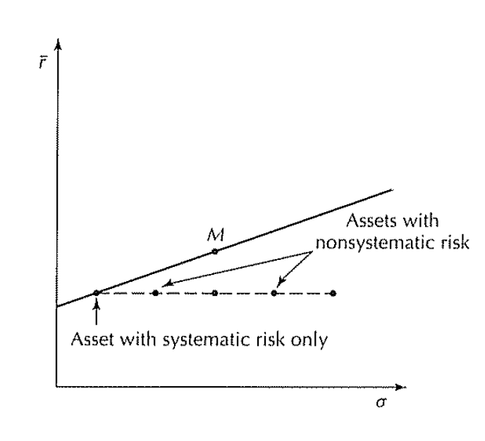
When looking at the CML plotting assets the distance from the left to the line is the systematic risk and the distance from the line to the asset is the unsystematic risk

Beta and return:
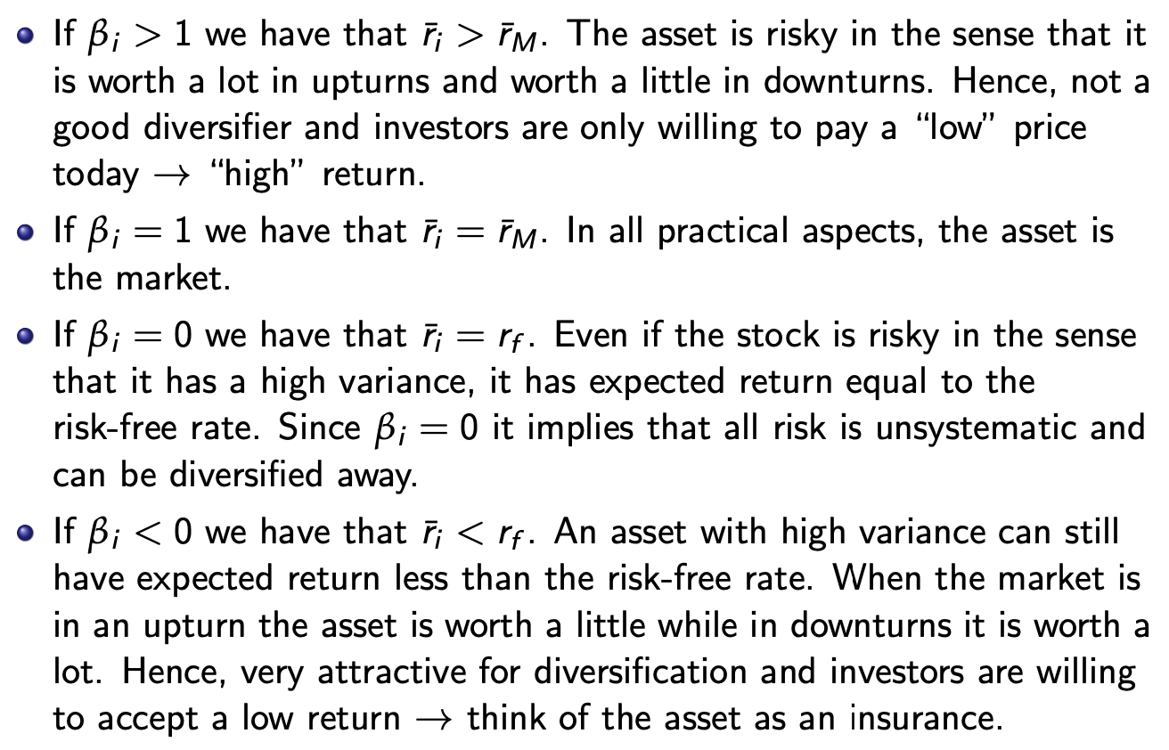
Betas of a portfolio are easily calculated
$$β_{p}=w^{T}β$$
Where
$$β=\frac{1}{σ_{m}^{2}}Σw_{m}$$

Performance evaluation:
The book takes 2 approaches:

Jensens alpha:
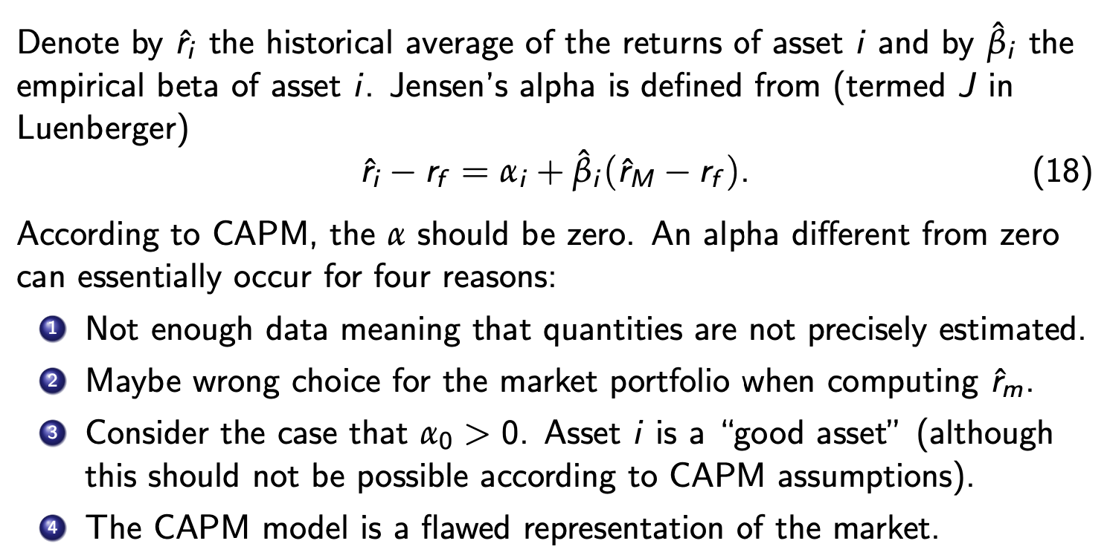

Sharpe index:
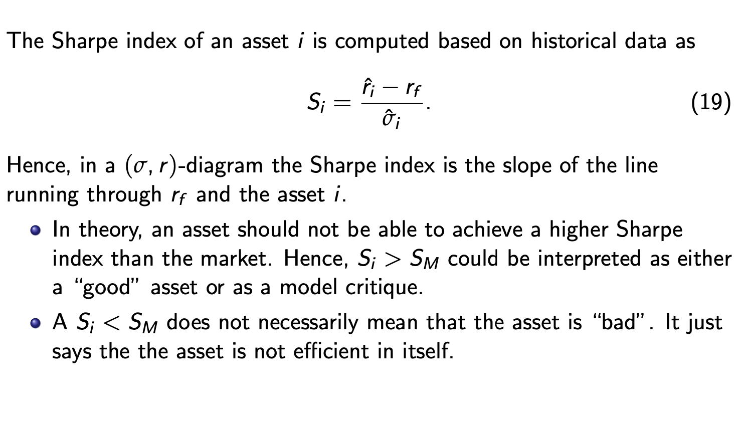

Pricing via CAPM
$${\overline{r}}_{i}=E\left[\frac{P_{i1}-P_{i0}}{P_{i0}}\right]=\frac{E\left[P_{i1}\right]}{P_{i0}}-1=r_{f}+β_{i}\left({\overline{r}}_{m}-r_{f}\right)$$
$$⇔P_{i0}=\frac{E\left[P_{i1}\right]}{1+r_{f}+β_{i}\left({\overline{r}}_{m}-r_{f}\right)}$$
neutral disconuting beacause the cashflow isstochastic we add a premium $β_{i}\left({\overline{r}}_{m}-r_{f}\right)$to the discountrate
this can be interpreted as a risk averse nvestor charging a risk premium for investing in the risky asset thus paying a lower price
this CAPM relation implies linear pricing

qritiques of CAPM
the CAPM is to simplistic a model for real markets:
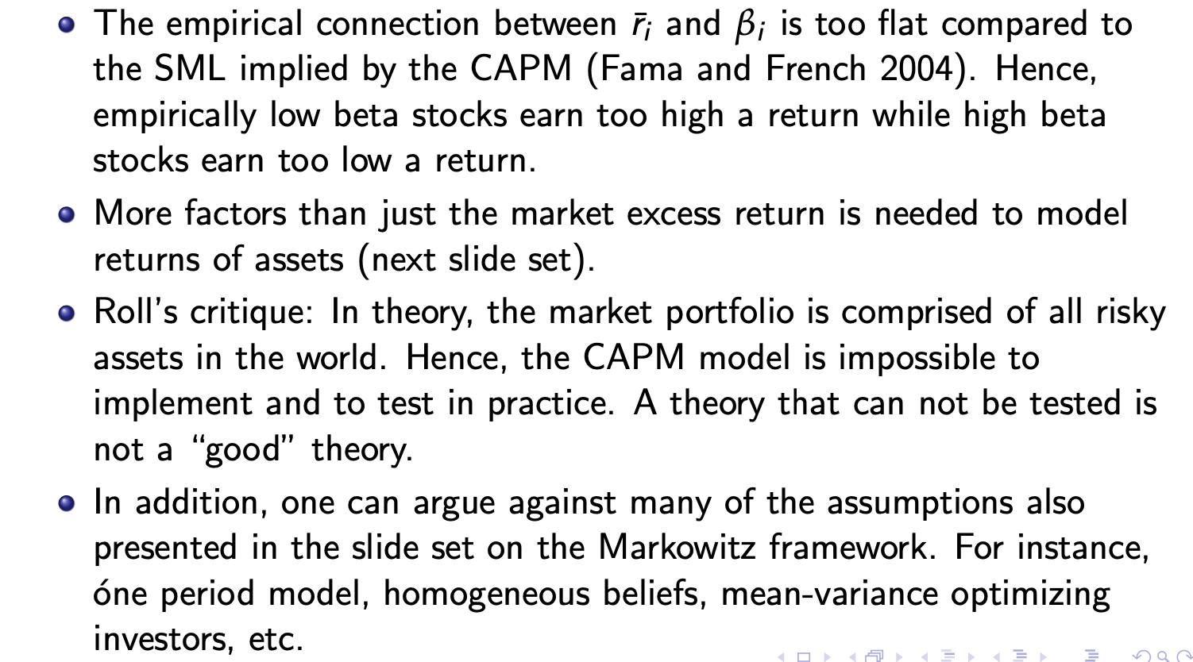

Noter fra TØ:
Hvis du har 2 effeccient portolios $w,v$ og CAPM er opfyldt så ved vi at tangentportføljen=marketsportføljen
$$θ∈\{α·w+\left(1-α\right)v:α∈R,αw_{i}+\left(1-α\right)v_{i}≥0∀i\}$$

Factor models and APT
A factor model Is a model of a market assuming a number of factors and som asset specific error term(all other assumptions from markowitz and capm are gone)
Thus for a single factor model driving asset returns of a market of n assets
$$r_{i}=a_{i}+b_{i}f+ϵ_{i} ∀i=1,…,n$$
$a_{i}$ is asset specific constant
$b_{i}$ is the assets exposure to the factor f
$f$ is the factor of the model
$ϵ_{i}$ Is the error term for the asset which has $E\left[ϵ_{i}\right]=0,cov\left(ϵ_{i},f\right)=0,cov\left(ϵ_{i},ϵ_{j}\right)=0for i≠j$
We assume $σ_{ϵ_{i}}$ known
the model can be viewed as a simple linear regression of each assets as a funktion of f
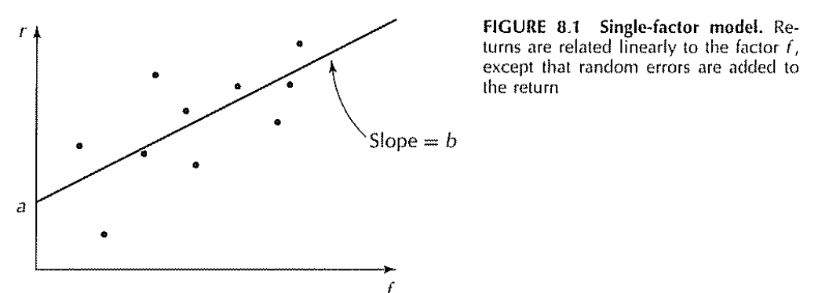
With the errors being exactly

In this framework we can calculate the expected return and variance
$${\overline{r}}_{i}=a_{i}+b_{i}·\overline{f}$$
$$σ_{i}^{2}=b_{i}^{2}σ_{f}^{2}+σ_{ϵ_{i}}^{2}$$
And covariance between returns
$$σ_{ij}=b_{i}b_{j}σ_{f}^{2}$$
And covariance between return and factor
$$cov\left(f,r_{i}\right)=b_{i}·σ_{f}^{2}⇔b_{i}=\frac{cov\left(f,r_{i}\right)}{σ_{f}^{2}}$$
This framework lets us create the covariance matrix with $2n+1$ parameters instead of the
$n·\frac{n-1}{2}$ in the markowitz framework
When assuming $σ_{ϵ_{i}}^{2}$ known we just need $b_{i}$ and $σ_{f}^{2}$

For a portfolio of these assets we simply have
$$r_{p}=\sum_{i=1}^{n}{w_{i}r_{i}}=\sum_{i=1}^{n}{w_{i}a_{i}}+f\sum_{i=1}^{n}{w_{i}b_{i}}+\sum_{i=1}^{n}{w_{i}ϵ_{i}}$$
$$=a_{p}+f·b_{p}+ϵ_{p}$$
With
$$a_{p}=\sum_{i=1}^{n}{w_{i}r_{i}}, b_{p}=\sum_{i=1}^{n}{w_{i}b_{i}}, ϵ_{p}=\sum_{i=1}^{n}{w_{i}ϵ_{i}}$$
With $E\left[ϵ_{p}\right]=0, cov\left(ϵ_{p},f\right)=0$
$$σ_{ϵ_{p}}^{2}=\sum_{i=1}^{n}{w_{i}^{2}σ_{ϵ_{i}}^{2}}$$
Med porteføljevariansen
$$σ_{p}^{2}=b_{p}^{2}σ_{f}^{2}+σ_{ϵ_{p}}^{2}$$
I faktormodeller er det muligt at diversifikerer størstedelen af ens usystematiske risiko væk eller hvertfald ved lige fordeling af portefølgen givet $σ_{ϵ_{i}}<S$ for et eller andet s
$$σ_{ϵ_{p}}^{2}=\frac{1}{n^{2}}·\sum_{i=1}^{n}{σ_{ϵ_{i}}^{2}}$$
Hvis vi har uendeligt mange aktiver må vi have
$$σ_{ϵ_{p}}^{2}→0,ϵ_{p}→0 konstant$$
Og derved opnå
$$σ_{p}^{2}=b_{p}^{2}σ_{f}^{2}$$
Altså at al den risiko man tager kommer fra eksponeringen til faktoren f

En enkel faktor betyder at ens model bliver for simplificeret man kan modellere i en multifaktor model hvor man har m faktorer
$$r_{i}=a_{i}+\sum_{k=1}^{m}{b_{ki}·f_{ik}}+ϵ_{i}$$
$a_{i}$ is asset specific constant
$b_{i}$ is the assets exposure to the factor f
$f$ is the factor of the model
$ϵ_{i}$ Is the error term for the asset which has $E\left[ϵ_{i}\right]=0,cov\left(ϵ_{i},f_{k}\right)=0 forall k,i ,cov\left(ϵ_{i},ϵ_{j}\right)=0for i≠j$
We assume $σ_{ϵ_{i}}$ known

We can fit a factor model to parameters if we have nough data
In general if we have a correlation with error terms we need more factors
For US stocks its normal to have between 3 and 15 factors

CAPM as a factor model:
CAPM is essentially a factor model assuming market covariance is the only factor
It comes from completely different assumptions based in financial theory while
Capm models excess return with $r_{m}-r_{f}$ as the only factor essetially making the market the driving factor

$$r_{i}-r_{f}=α+β_{i}\left(r_{m}-r_{f}\right)+ϵ_{i}$$
$$\overline{r}-r_{f}=α_{i}+β_{i}\left(\overline{r_{m}}-r_{f}\right)$$
Where CAPM looks like a model where $α_{i}=0$

A generic factor model would be based completely in statistics
And dosent assume anything about the efficiency of the market portfolio
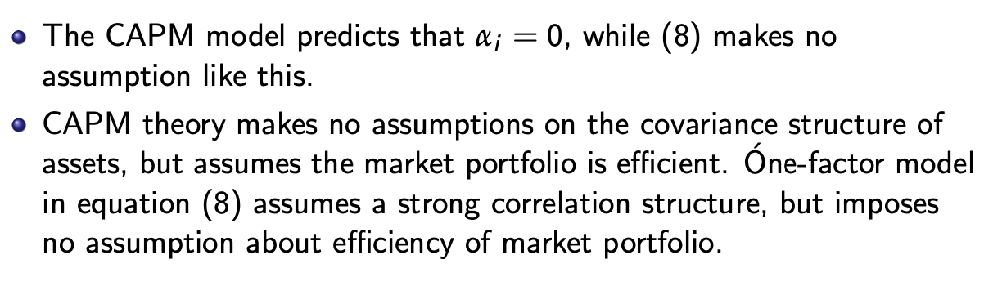

Arbitrage pricing theory:
A way to make factor models usefull are the APT framework assuming:
Investors prefer greater return to lower return
No arbitrage
There are infinite assets in the market

Thus we can calculate the expected return of assets if enough linearly independent ones(in their factor exposure) are available

Given the existence of n<m well diversified assets(with errorterm 0)
$$r_{i}=a_{i}+\sum_{k=1}^{M}{b_{ik}f_{k}} for i=1,…,n$$
We will have
$${\overline{r}}_{i}=λ_{0}+\sum_{k=1}^{M}{b_{ik}λ_{k}} for i=1,…,n$$

For a single factor model:
With at least 2 well diversified portfolios
$$r_{i}=a_{i}+b_{i}f for i=1,2$$
Har vi
$$λ_{0}=r_{f}$$
$$λ_{1}=\frac{a_{i}-λ_{0}}{b_{i}}+\overline{f}$$

For multifactor models in matrix form:
If we have n linearly independent assets(in their factor exposure)
$$\overline{r}=\left(\begin{matrix}1 & b_{11} & … & b_{1m} \\ … & … & … & … \\ 1 & b_{n1} & … & b_{nm}\end{matrix}\right)\left(\begin{aligned}λ_{0} \\ … \\ λ_{m}\end{aligned}\right)$$
Given we have $n=m+1$ $(I B)$ is invertible and thus
$${\left(\begin{matrix}1 & b_{11} & … & b_{1m} \\ … & … & … & … \\ 1 & b_{n1} & … & b_{nm}\end{matrix}\right)}^{-1}\overline{r}=λ$$
$λ_{k}$ can be interpreted as the price of risk or how much return you are able to gain for having more exposure to the factor k

APT and CAPM:
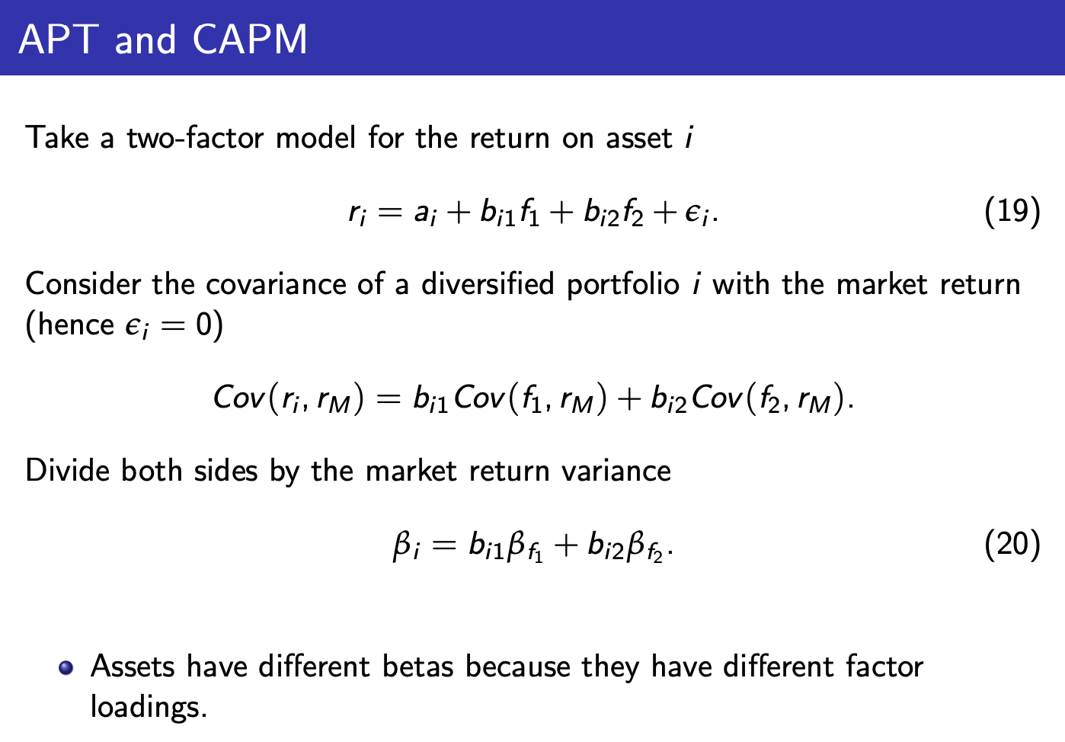

Choosing factors:
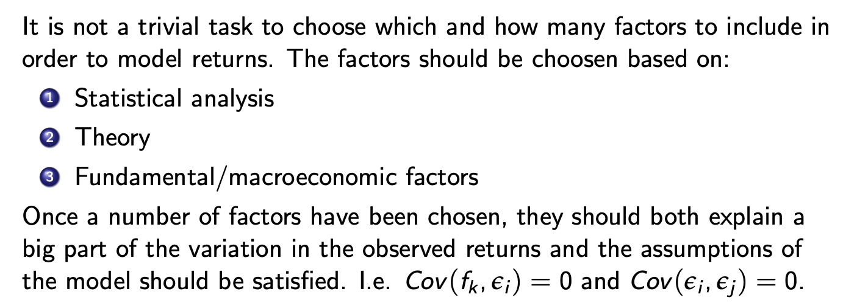

Estimators of asset parameters:
Sample mean:
$$\hat{r_{i}}=\frac{1}{T}\sum_{t=1}^{T}{r_{it}}→{\overline{r}}_{i}$$
Sample variance:
$${\hat{σ_{i}}}^{2}=\frac{1}{T-1}\sum_{t=1}^{T}{{\left(r_{it}-\hat{r_{i}}\right)}^{2}}→σ_{i}^{2}$$

Sample covariance:
$$\hat{σ_{i,j}}=\frac{1}{T-1}\sum_{t=1}^{T}{{\left(r_{it}-\hat{r_{i}}\right)}^{}}\left(r_{jt}-\hat{r_{j}}\right)→σ_{i,j}$$
With deviation given the normal strocture of samples
$$stdev\left({\hat{r}}_{i}\right)=\frac{σ_{i}}{\sqrt{T}}$$
$$stdev\left(\hat{σ_{i}^{2}}\right)=\frac{\sqrt{2}σ_{i}^{2}}{\sqrt{T-1}}$$
Thus we see that the deviation of the sample variance approaches 0 faster that that of the sample mean

Stochastic stuff:
We basically always assume no arbitrage!

Utility functions:
A utility function is assumed to be:
Continous: like returns give like utility
Monotonely increasing: more money is better
(Typically) concave: investos are risk averse

A investor will
$$\max{E\left(X\right)}$$
In a one period setting we assume an investor will have the utility function
$$U\left(c_{0},c_{1}\right)=u\left(c_{0}\right)+δE\left[u\left(c_{1}\right)\right]$$
Where $c_{0}$ is consumption today
$c_{1}$ is consmption tomorrow
And $δ$ is the personal discontfactor(how much the investor appreciates money tomorrow
This maximisation problem implies the euler equation:
$$P_{0}=E[\frac{δu^{'}\left(c_{1}\right)}{u^{'}\left(c_{0}\right)}X]$$
Where X is the price of the asset at time 1
(the expectation under P)
We call
$$Λ=\frac{δu^{'}\left(c_{1}\right)}{u^{'}\left(c_{0}\right)}$$

The stochastic discount factor
Which can always be used to price an asset in a 1 period model
In this setting we also have:
$$E\left[R_{i}·Λ\right]=1$$
$$⇒1=cov\left(Λ,R_{i}\right)+E\left[R_{i}\right]·E[Λ]$$
Thus for the risk free asset implies
$$E\left[Λ\right]=\frac{1}{1+r_{f}}$$
And thus

Pricing with the stochastic discountfactor
$$1=cov\left(Λ,R_{i}\right)+E\left[R_{i}\right]·E\left[Λ\right]⇔1=cov\left(Λ,R_{i}\right)+E\left[R_{i}\right]·\frac{1}{1+r_{f}}$$
$$⇔E\left[r_{i}\right]-r_{f}=-\left(1+r_{f}\right)·cov\left(r_{i},Λ\right)$$
For the risk

A probability measuere:
A function $P\left(A\right)∈\left[0,1\right] hvor A⊆Ω er et udfald i udfaldsrummet Ω$ som opfylder
$$P\left(Ø\right)=0,P\left(Ω\right)=1$$
$$P\left(∪_{i∈I}A_{i}\right)=\sum_{i∈I}{P(A_{i})} når A_{i}er disjukte$$
For en stokastisk variable X under de 2 forskellige sandsynlighedsmål har måske ikke samme PDF
$$E^{P}\left[X\right]=\sum_{i∈I}{x_{i}P\left(x_{i}\right)}, E^{Q}\left[X\right]=\sum_{i∈I}{x_{i}·Q\left(x_{i}\right)}$$
Ved et simpel trik kan vi skifte mål:
$$E^{P}\left[X\right]=\sum_{i∈I}{x_{i}P\left(x_{i}\right)}=\sum_{i∈I}{\frac{x_{i}P\left(x_{i}\right)}{Q\left(x_{i}\right)}}Q\left(x_{i}\right)=E^{Q}[\frac{P\left(X\right)}{Q\left(X\right)}·X]$$
This lets us link the euler equation to pricing by state prices

State prices:
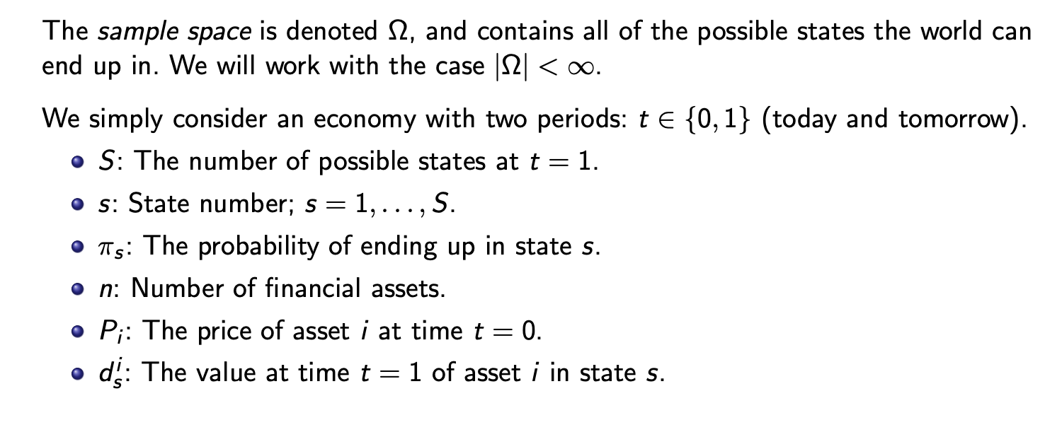
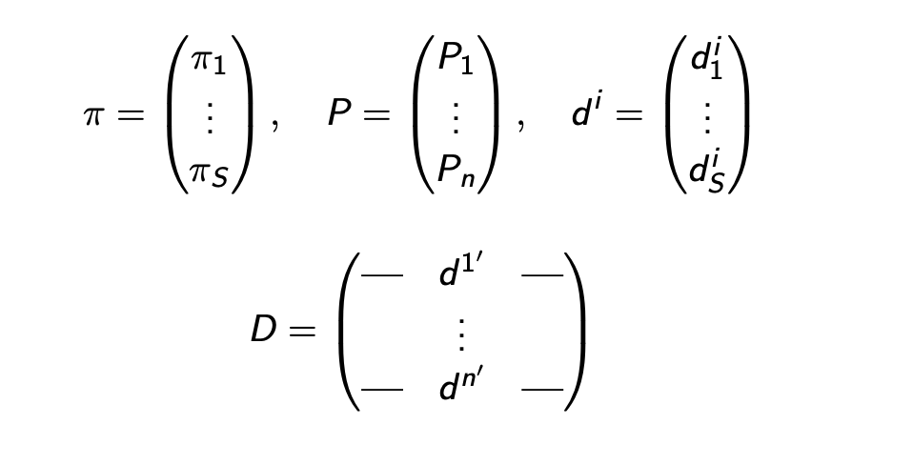

State price vector:
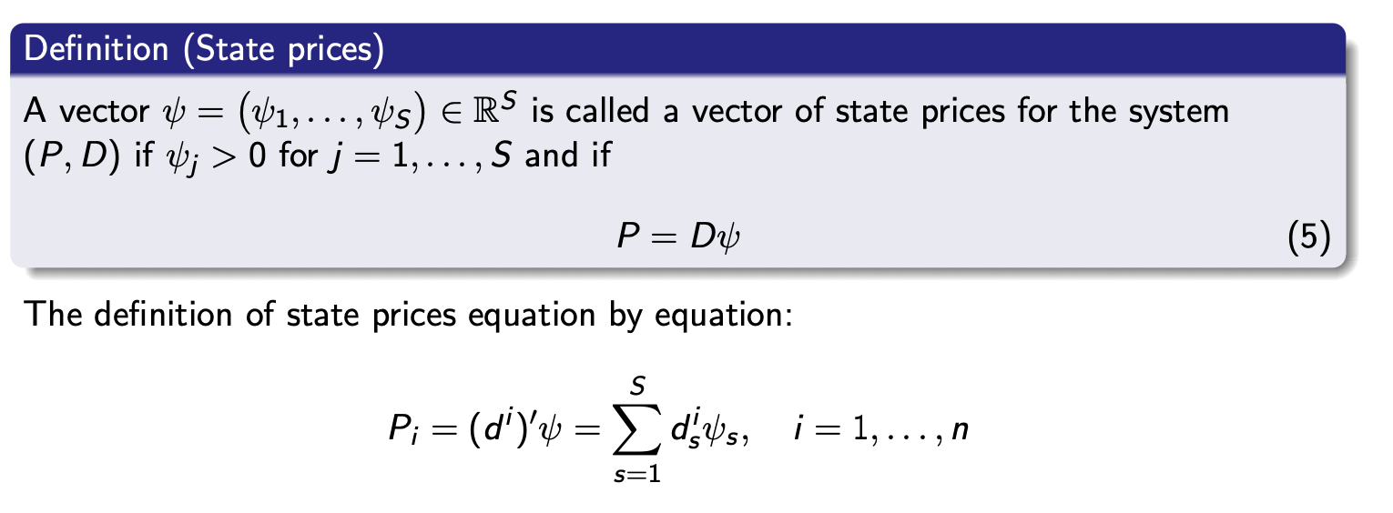
the state prices are exactly the prices for gaining 1 in state i

FTAP:
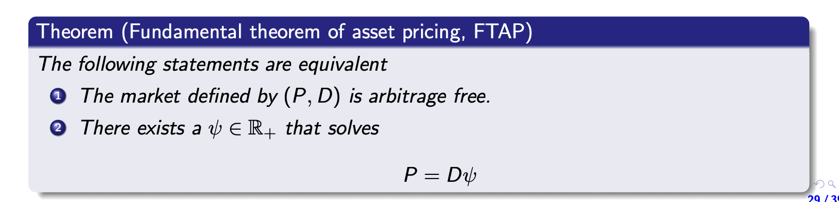
$$\left(P,D\right) is arbitrage free⇔∃ψ>0:P=Dψ$$

Completeness:
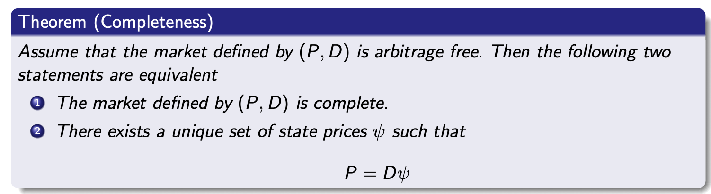
Thus
$$\left(P,D\right) is arbitragfree and complete⇔D is invertible and D^{-1}P>0$$
Or 3 rows of D are invertible wih
$$D_{3}^{-1}P_{3}>0$$

The asset with payments
$$d=(\begin{matrix}1 & … & 1\end{matrix})$$
Is risk free thus per no arbitrage
$$ψ_{0}=\sum_{s=1}^{S}{ψ_{s}}=\frac{1}{1+r_{f}}$$
We have the risk neutral probabilities
$$q_{s}=\frac{ψ_{s}}{ψ_{0}}$$
Whereas we see that pricing by the state prices of an asset X
$$P=\sum_{s=1}^{S}{x_{s}ψ_{s}}=ψ_{0}·E^{Q}\left[X\right]=\frac{1}{1+r_{f}}E^{Q}[X]$$

Absence of arbitrage:
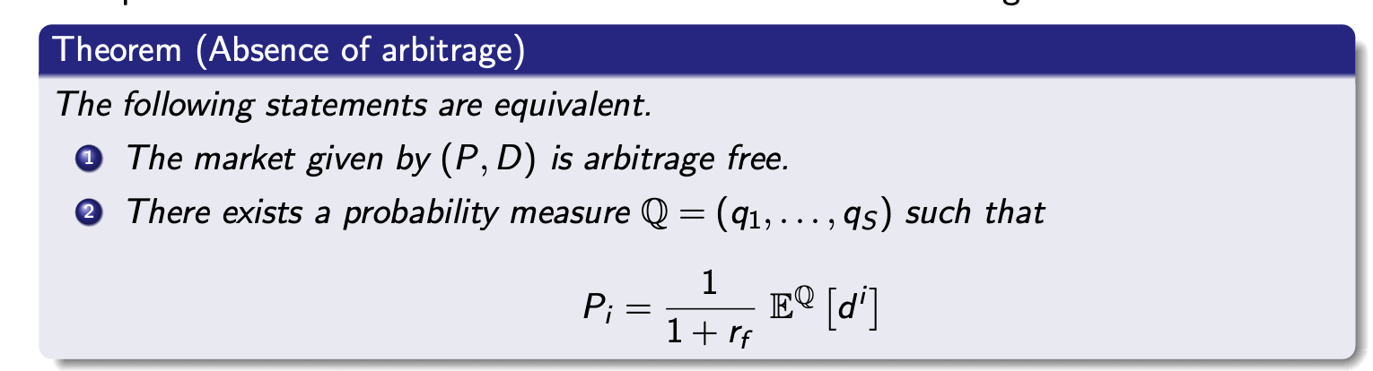
We connect this to the physical expectation via the stochastic discountfactor
$$P=\frac{1}{1+r_{f}}E^{Q}\left[X\right]=\frac{1}{1+r_{f}}E^{P}\left[\frac{Q\left(X\right)}{P\left(X\right)}X\right]=E^{P}[ΛX]$$

1 period model gives different equivalent ways of pricing a uncertain cashflow x
(in this case we are assuming certain risk free rate $r_{f}$
Discounted riskneutral expectation under Q:
$$P=\frac{E^{Q}\left[x\right]}{1+r_{f}}$$
In terms of state prices
$$x=\left(\begin{matrix}x_{1} & … & x_{n}\end{matrix}\right)$$
$$P=\sum_{i=1}^{n}{d_{i}·x_{i}}$$
$$P=E^{P}[ΛX]$$
Where $Λ$ is the stochastic discountfactor

No arbitrage in general:
$$A financial market is free of arbitrage⇔there exists a riskneutral measure Q$$
Therefore given a uncorrelated discontfactor
We can price any asset
$$P_{0}=d_{0,T}E^{Q}[P_{T}]$$

Summary of state prices:
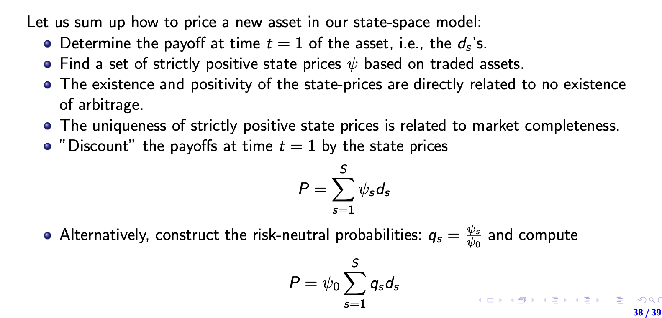

Derivatives:
We have 3 main ways of pricing them:

A replicating strategy:
We recreate the exact cashflow and must have “by the law of one price” the same price

No-Arbitrage arguments:
Pretty simuler but 1 side at a time with this we can price something even though we cant completely recreate the cashflow for example:

Example with forward: with cashflow
$$f\left(S\left(t\right)\right)=S-X$$
T=0 | T=1
$$v_{0}$$ | $$X-S_{T}$$ | Start with shortforward
$$Xd_{0,T}-S_{0}$$ | $$S_{T}-X$$ | Long stock borrow $Xd_{0,t}$
$$v_{0}+Xd_{0,T}-S_{0}$$ | $$0$$ | together
Thus per no arbitrage
$$v_{0}+Xd_{0,T}-S_{0}≥0$$
The opposite this requires that shortselling is allowed
T=0 | T=1
$$-v_{0}$$ | $$S_{T}-X$$ | Start with shortforward
$$-Xd_{0,T}+S_{0}$$ | $$X-S_{T}$$ | Long stock borrow $Xd_{0,t}$
$$-v_{0}-Xd_{0,T}+S_{0}$$ | $$0$$ | together
$$v_{0}+Xd_{0,T}-S_{0}≤0$$
These together
$$v_{0}=S_{0}-Xd_{0,T}$$

Risk neutral pricing:
This approach needs us to model the underlying asset which we usually would rather avoid
Pricing of any derivative(almost)
$$P_{0}=d_{0,T}E^{Q}[f\left(S\left(T\right)\right)]$$
Where f is the function describing the payoff of the derivative
If interestrates are sthochastic we actually have
$$P_{0}=E^{Q}[d_{0,T}f\left(S\left(T\right)\right)]$$
Thus if deterministic then independent and then the formula above

Forwards:
The obligation to buy an asset S at price X at time T giving the payoff at time T
$$S-X$$

Value of a forward:
$$v_{0}=S_{0}-Xd_{0,T}$$
A fair forward price demands $v_{0}=0$ and thus
$$S_{0}=Xd_{0,T}⇔X=\frac{S_{0}}{d_{0,T}}=E^{Q}\left[S_{T}\right]$$
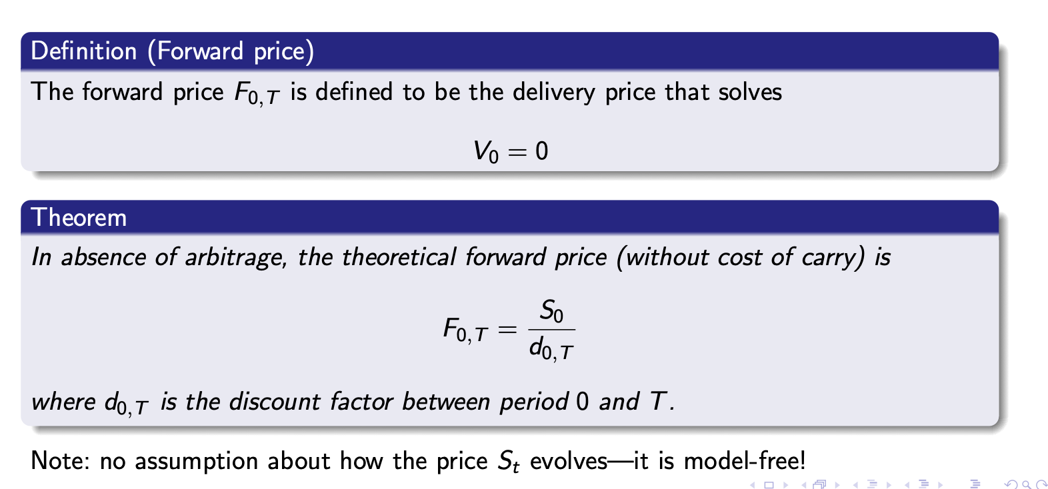
When it costs $c_{k}$ to hold the asset to the k$∈\{0,1,…,M\}$ period assuming you can but the asset
t=0 | t=k<T | t=T | note
$$v_{0}$$ | 0 | $$X-S_{T}$$ | Short forward
$$Xd_{0,T}-S_{0}$$ | $$-c_{k}$$ | $$S_{T}-X$$ | Long asset borrow $Xd_{0,T}$
$$-\sum_{k=0}^{M}{d_{0,k}·c_{k}}$$ | $$c_{k}$$ | 0 | put $\sum_{k=0}^{M}{d_{0,k}·c_{k}}$ in the ank and pay the cost of carry in every period
$$v_{0}+Xd_{0,T}-S_{0}-\sum_{k=0}^{M}{d_{0,k}·c_{k}}$$ | 0 | 0 | Now together

Implies by no arbitrage
$$v_{0}+Xd_{0,T}-S_{0}-\sum_{k=0}^{M}{d_{0,k}·c_{k}}≤0⇔v_{0}≤S_{0}+\sum_{k=0}^{M}{d_{0,k}·c_{k}}-Xd_{0,T}$$
or for $v_{0}=0$
$$X≤\frac{S_{0}+\sum_{k=0}^{M}{d_{0,k}·c_{k}}}{d_{0,T}}$$
Now the opposite argument(this assumes you are allowed to short the asset S

t=0 | t=k<T | t=T | note
$$-v_{0}$$ | 0 | $$-X+S_{T}$$ | long forward
$$-Xd_{0,T}+S_{0}$$ | $$c_{k}$$ | $$-S_{T}+X$$ | short asset put $Xd_{0,T}$ in the bank
$$\sum_{k=0}^{M}{d_{0,k}·c_{k}}$$ | $$-c_{k}$$ | 0 | borrow $\sum_{k=0}^{M}{d_{0,k}·c_{k}}$  and pay off c_k each period
$$-(v_{0}+Xd_{0,T}-S_{0}-\sum_{k=0}^{M}{d_{0,k}·c_{k}})$$ | 0 | 0 | Now together
This implies
$$v_{0}≥S_{0}+\sum_{k=0}^{M}{d_{0,k}·c_{k}}-Xd_{0,T}$$
Or if $v_{0}=0$
$$X≥\frac{S_{0}+\sum_{k=0}^{M}{d_{0,k}·c_{k}}}{d_{0,T}}$$
Together

With cost of carry:

$$X=\frac{S_{0}+\sum_{k=0}^{M}{d_{0,k}·c_{k}}}{d_{0,T}}$$

Convenience yield

Often it is not possible to short the asset meaning we can only derive the 1. Inequality

$$X≤\frac{S_{0}+\sum_{k=0}^{M}{d_{0,k}·c_{k}}}{d_{0,T}}$$
This doesn’t imply an arbitrage opportunity but rather that you are willing to pay for holding the asset this aount you are willing to pay for holding the asset each period is excatly the convinience yield(more figuratively and thus directionally if you cant go long the asset we would have
$$X≥\frac{S_{0}+\sum_{k=0}^{M}{d_{0,k}·c_{k}}}{d_{0,T}}$$
And the convinience yield can be calculated
$$X=\frac{S_{0}+\sum_{k=0}^{M}{d_{0,k}·(c_{k}-y)}}{d_{0,T}}$$
$y>0$ you are willing o pay for holding the asset, $ify<0$ you would need someone to pay you for holding the asset(maybe something that dosent have a diret cost but gives you some kind of negative reputation y holding it)

Forwards are an over the counter produkt being setled only once at the end
Which means a perfect hedge against price movements in the stock is still rather risky because of default risk,

Thus futures

General far forwards pricing
When discount rates arent deterministic we have more generally that
$$F_{0,T}=\frac{E^{Q}\left[d_{0,T}·S\left(T\right)\right]}{B_{0,T}}=E^{Q}\left[S\left(T\right)\right]+\frac{cov\left(d_{0,T},S\left(T\right)\right)}{B_{0,T}}$$

The value of a forward:
Suppose a forward contract has a deliveryprice $F_{0}$ at time T
And a current forwad price $F_{t}$ the value of the contract is then
$$f_{t}=\left(F_{t}-F_{0}\right)d_{t,T}$$

Futures:
Standardised forwards seteled every period(on an exchange garenting
Given $G_{0,T}$
If you are long one futures contract then at every period $k≤T$
The cashflow
$$G_{k+1}-G_{k}$$
Happens
The value of a future is exactly
$$G_{0,T}=E\left[S_{T}\right]=\frac{S_{0}}{d_{0,T}}$$

In general when
Rates are deteministic then
$$G_{0,T}=F_{0,T}=\frac{S_{0}}{d_{0,T}}$$

Hedging with futures:
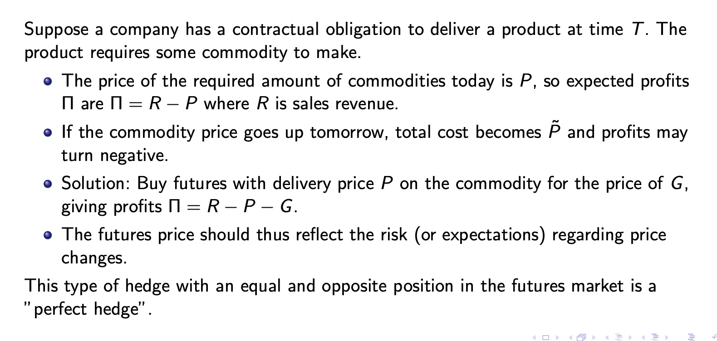

Using a future to hedge an obligation to deliver we create a
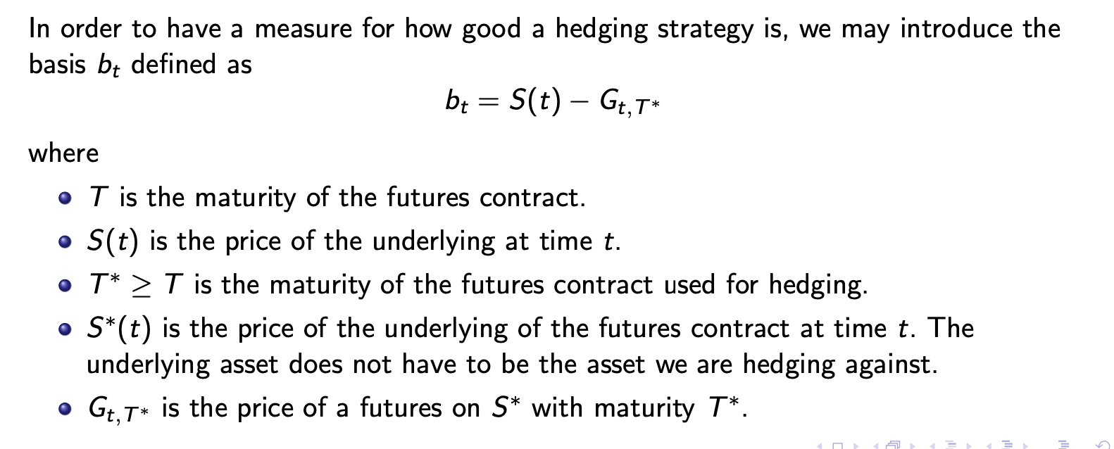
If $S=S^{⋆}, T=T^{⋆}$ then we can hedge perfectly
We hedge by creating the position
Long asset short h futures contracts at time 0 then sell it at time T even though the futures expires at time $T^{⋆}$ the value of this portfolio is thus:
$$V_{T}-V_{0}=S\left(T\right)-S\left(0\right)+h(G_{T,T^{⋆}}-G_{0,T})$$
We wish to hedge and thus minimize our risk
$$\min{V\left(V_{T}-V_{0}\right)=}\min{V(S\left(T\right)-S\left(0\right)+h\left(G_{T,T^{⋆}}-G_{0,T}\right)})$$
$$=\min{V\left(S\left(T\right)\right)+h^{2}·V\left(G_{T,T^{⋆}}\right)+2h·cov(G_{T,T^{⋆}},S\left(T\right))}$$

Giving
$$h=-\frac{cov\left(G_{T,T^{⋆}},S\left(T\right)\right)}{V\left(G_{T,T^{⋆}}\right)}$$

swaps:
a contract to swap future cashflows at times in the future a vanilla swap Is a swap where a floating leg(a constant payment every period) is swapped for a floating rate
these are normally created on thing such as
interest rate swaps
currency swaps
commodities swaps
credit swaps

a vanilla swap is essentially just a collection of forward contracts
thus being long the swap on a asset S agreeing to pay X at times $t_{i} for i=1,…,n$must give the cashflows
$$(f\left(s\left(t_{1}\right)\right)-X, f\left(s\left(t_{2}\right)\right)-X,…, (f\left(s\left(t_{n}\right)\right)-X)$$
With the value
$$V_{0}=\sum_{i=1}^{n}{d_{0,t_{i}}(f(s(t_{i}}))-X)$$

Where fair value is when
$$V_{0}=0$$
And thus $V_{Floating}=V_{fixed}$
For a vanilla commodoties swap we have

Vanilla comodoties swap
$$E^{Q}\left(V_{0}\right)=0$$

$$\sum_{i=1}^{n}{d_{0,i}(E^{Q}[s(i}))]-X)=0$$
$$⇔n·S\left(0\right)-X\sum_{i=1}^{n}{d_{0,i}}⇔X=n·\frac{S\left(0\right)}{\sum_{i=1}^{n}{d_{0,i}}}$$

interest rate swaps:
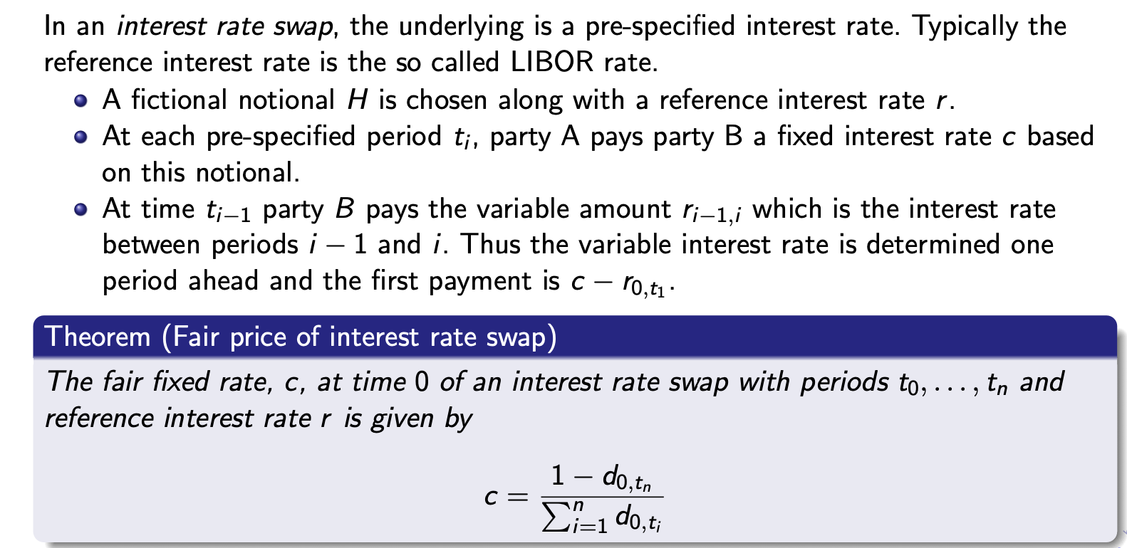
Altså på en vilkårlig mængde penge har vi bare $H·r=c$
Læg mærke til at vi er ligeglade med hodestol
For a fair rate we must have
$$V_{fixed}=V_{floating}$$
The floating leg is a floating rate bond without the principal giving us the value
$$V_{floating}=F-d_{0,t_{n}}F$$
$$V_{fixed}=\sum_{i=1}^{n}{c·F·d_{0,t_{i}}}=c·F·\sum_{i=1}^{n}{d_{0,t_{i}}}$$
Set equal
$$F-d_{0,t_{n}}F=c·F·\sum_{i=1}^{n}{d_{0,t_{i}}}$$
$$⇔1-d_{0,t_{n}}=c·\sum_{i=1}^{n}{d_{0,t_{i}}}$$
$$⇔c=\frac{1-d_{0,t_{n}}}{\sum_{i=1}^{n}{d_{0,t_{i}}}}$$

Swaps: 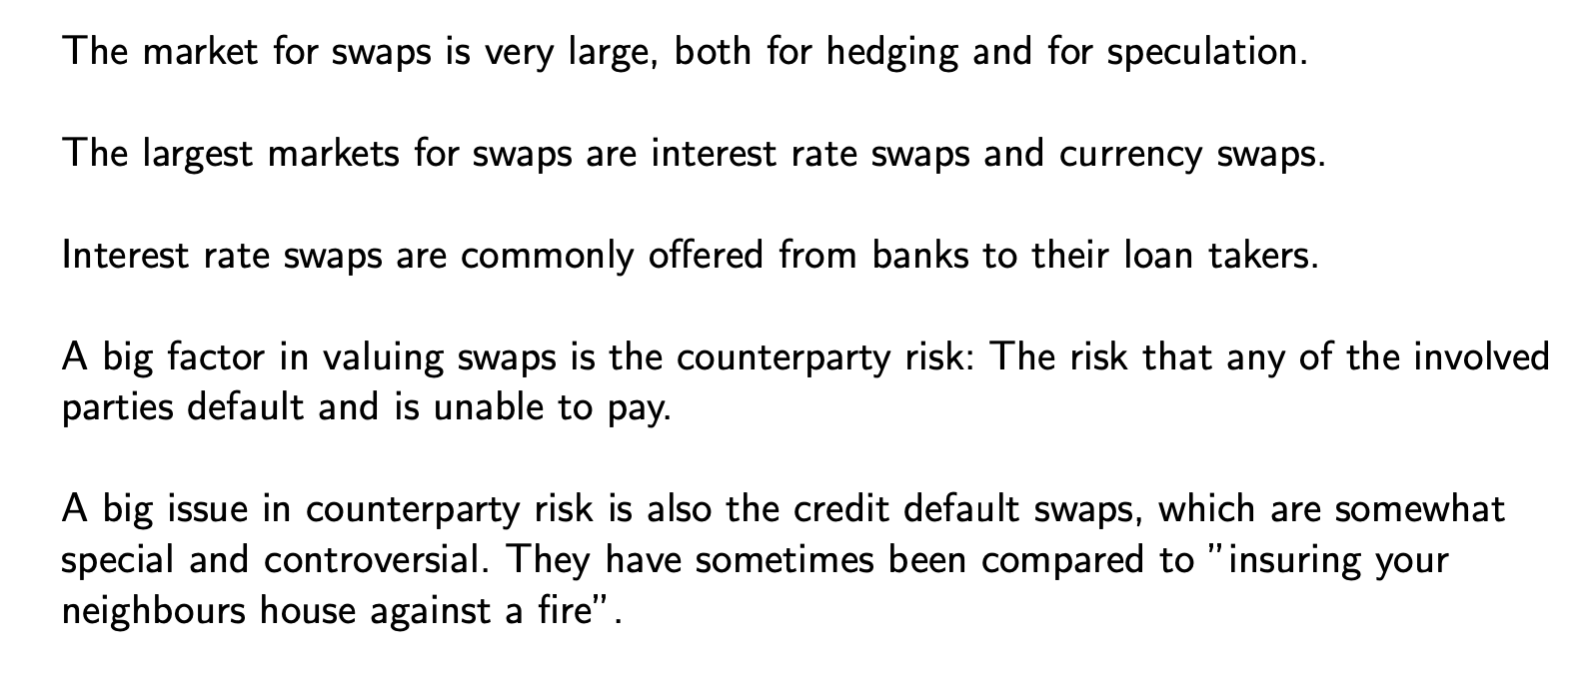
Tø noter:
Mangler
Lav opgave 4 på ugeseddel 46

Stochastic processes
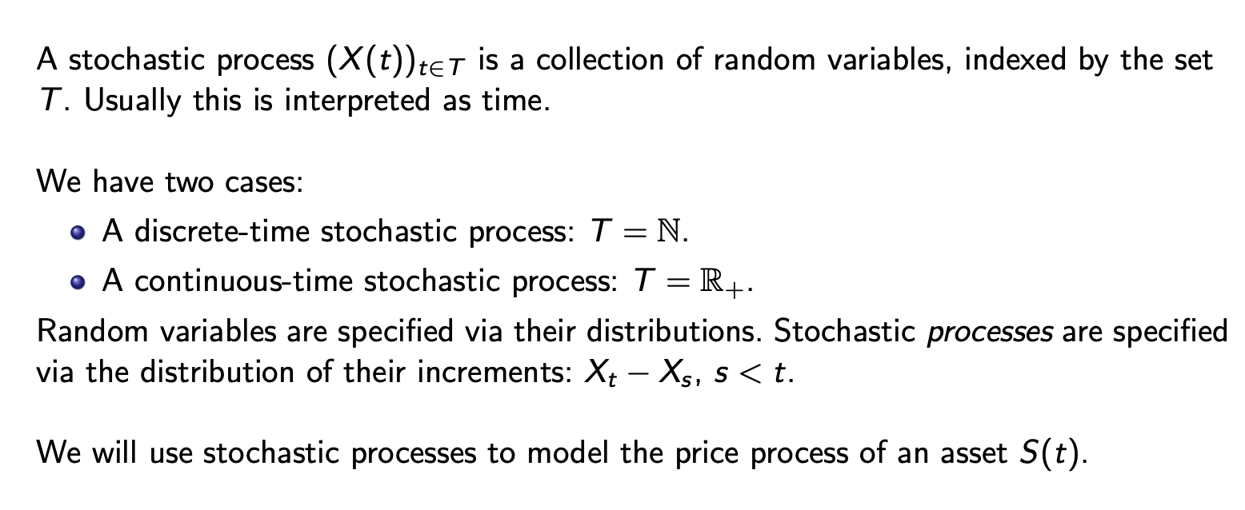

Binomial træ:

Modelling a change in the variable $S_{t}$ is $Δt$ time a way is the binomail model where we have 2 outcomes either “up” or “down”
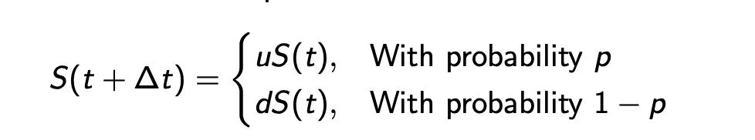
This can of course easily be illustrated especially if we have constant u and d
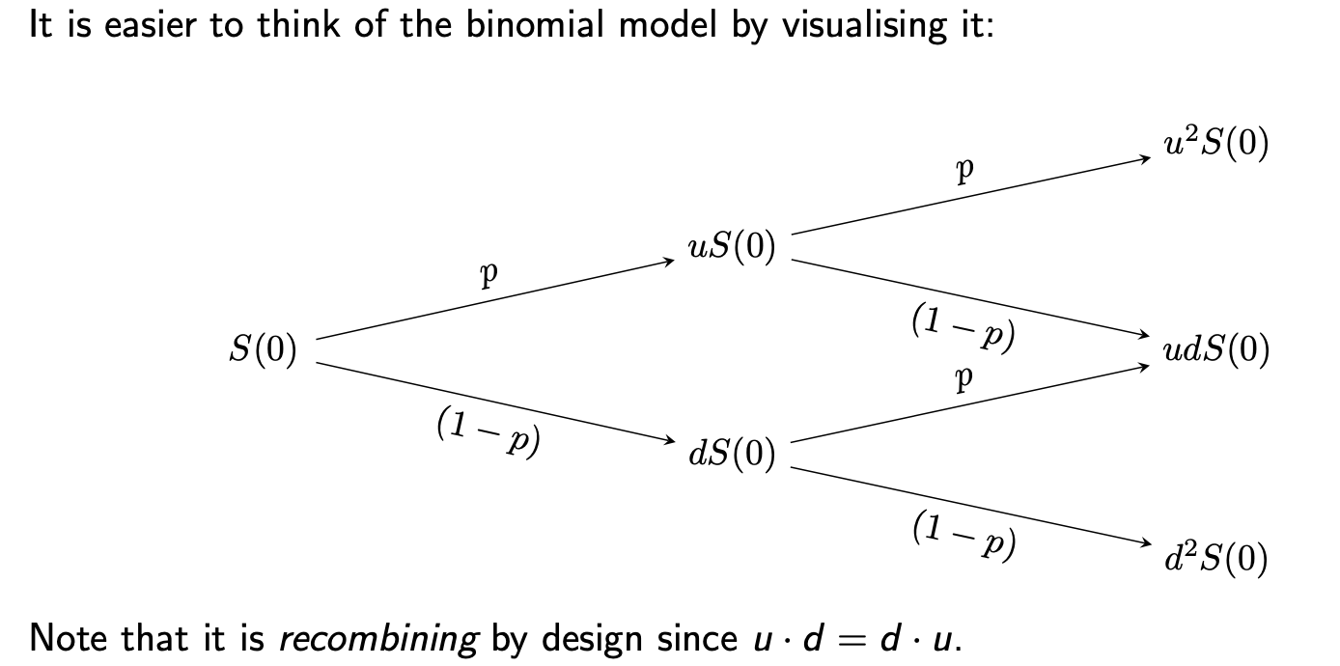
This model assumes constant u and d if not we would of course have 4 states at time 2
Also it assumes constant probabilities for going up and down

In this binomial model with constant u and d and constant p we can calculate the probability of ending up in a given state rather easily when T periods
$$P(S_{T}=S\left(0\right)·u^{K}·d^{T-K}=\left({T \atop K}\right)p^{K}·{\left(1-p\right)}^{T-K}$$

Modelling real world with the binomial model:
We look at log returns
$$log⁡(\frac{S_{t+Δt}}{S_{t}})$$
ved at tilpasse data
$$\hat{μ}·Δt=E\left[\log\left(\frac{S_{t+Δt}}{S_{t}}\right)\right], \hat{σ^{2}}·Δt=V\left[\log\left(\frac{S_{t+Δt}}{S_{t}}\right)\right]$$

$$\hat{μ}=\frac{1}{N}·\sum_{i=1}^{N}{\log\left(\frac{s_{t_{i}}}{s_{t_{i-1}}}\right)}, \hat{σ^{2}}=\frac{1}{N-1}\sum_{i=1}^{N}{[\log\left(\frac{s_{t_{i}}}{s_{t_{i-1}}}\right)-\hat{μ}]^2 }$$

In fitting the model to the data:
$$\hat{μ}·Δt=p·\log\left(u\right)+\left(1-p\right)·\log\left(d\right)$$
$$\hat{σ^{2}}·Δt={\left(\log\left(u\right)-\log\left(d\right)\right)}^{2}·p·(1-p)$$
Choosing $d=\frac{1}{u}$ the model can be solved
Getting
$$p=\frac{1}{2}+\frac{1}{2}\frac{\hat{μ}}{\hat{σ}}\sqrt{Δt}, u=e^{\hat{σ}·\sqrt{Δt}}, d=e^{-\hat{σ}·\sqrt{Δt}},$$

trying to take the binomial model to continous time
since the binomoal model Is multiplicative
$$S\left(t+Δt\right)=s\left(t\right)·ϵ_{t+Δt}$$
Or thus log additive
$$\log\left(S\left(t+Δt\right)\right)=\log\left(S\left(t\right)\right)+log⁡(ϵ_{t+Δt})$$
Where $ϵ_{t+Δt}$ is either u or d with probabilities p and 1-p
A movement of a stock is in the data close enough to a normal istribution that it’s an ok way to model (or rather its log returns are)
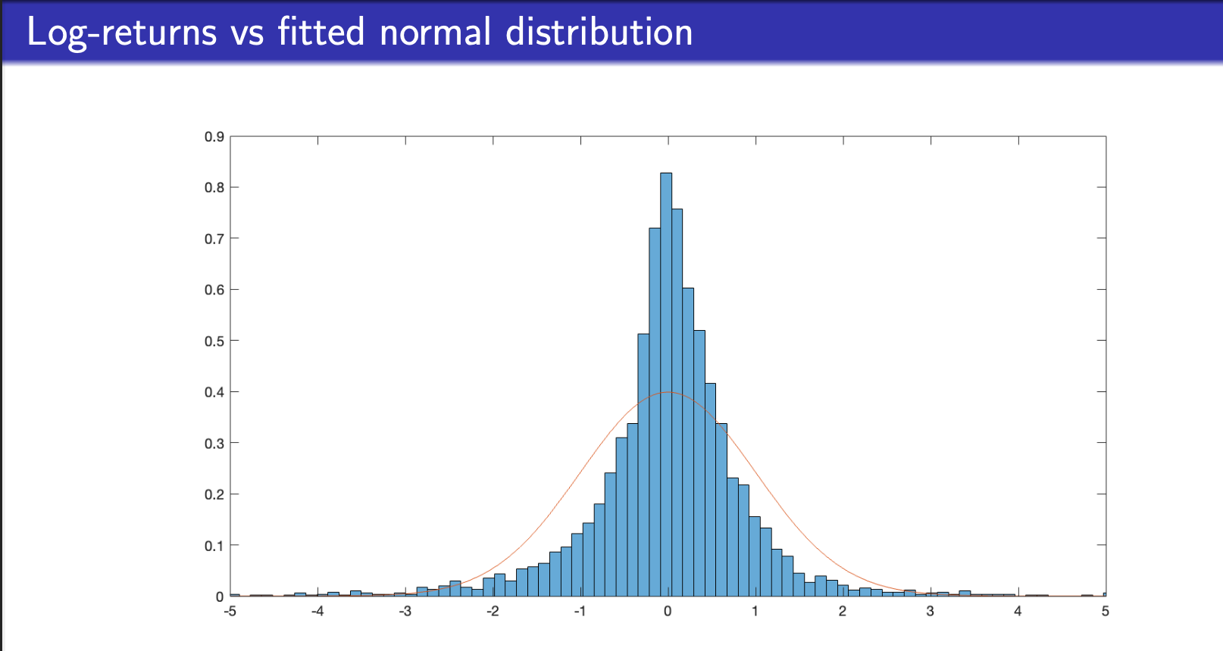

In reality the distributin is more tail heavy and mean heavy for the normal distrubution to fit just right but we say that it is good enough for a start
Thus we assume from now on in our continous model that
$$\log\left(ϵ_{t+Δt}\right)\sim N(μ·Δt,σ^{2}Δt)$$
Thus
$$ϵ_{t+Δt}\sim logN$$
Lognormal distrubution
Which implies
$$\log\left(S_{t+Δt}\right)-\log\left(S_{t}\right)\sim N\left(μ·Δt,σ^{2}Δt\right)$$

$$S_{t+Δt}\sim logN$$
With pdf:
$$f\left(x\right)=1/$$

$$E^{P}\left(S_{t}\right)=S_{0}·e^{\left(μ+\frac{1}{2}σ^{2}\right)t}$$
$$V^{P}\left(S_{t}\right)=\left(e^{σ^{2}t}-1\right)e^{2μ+σ^{2}t}$$
Looking at the lognormal distribution:
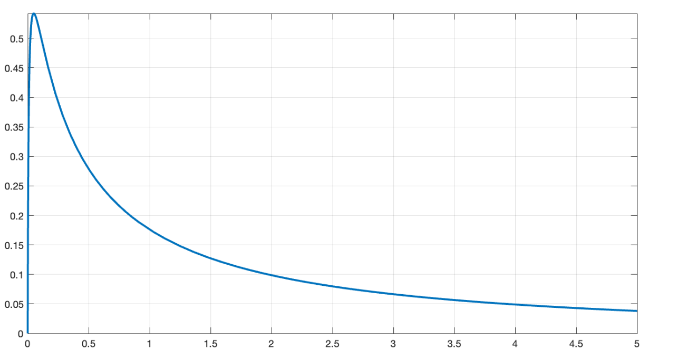
We see that when $μ=0$ we must have half of the probability on the left side of 1 and

the brownian motion:
bringing the binomial model into continous time by letting $Δt→0$ is rather hard so we introduce a brownian motion instead and accept that the binomial model approximately approaches the brownian motion approach

Brownian motion:
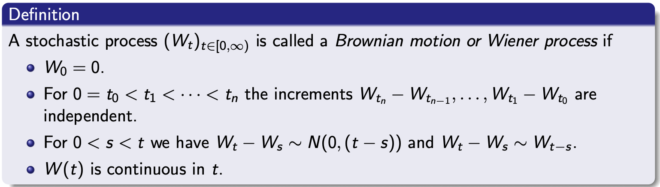
$$V\left[W_{t+Δt}-W_{t}\right]=Δt$$
We define a stochastic integral without knowing what it is:
$$\int_{0}^{t}{f\left(s\right)dW_{s}=\lim_{Δt→0}{\sum_{k=1}^{n}{f(t_{k})(W_{t_{k}}-W_{t_{k}-1})}}⁡}$$
In particular we have
$$\int_{t}^{T}{dW_{s}}=W_{T}-W_{t}$$
Which is really nice when doing manipulations with stochastic processes via itos lemma

Ito process/ stochastic differantial equation:
An ito process/ stochastic differential equation
Let $W_{t}$ be a brownian motion and let $X(t)$ also called an ito process
$$X\left(t\right)=X\left(0\right)+\int_{0}^{t}{a\left(s,X\left(s\right)\right)ds}+\int_{0}^{t}{b\left(s,X\left(s\right)\right)dW_{s}}$$
Then we write the stochastic differential equation:
$$dX\left(t\right)=a\left(t,X\left(t\right)\right)dt+b\left(t,X\left(t\right)\right)dW_{t}$$
Also called the dynamics of X

Given a stock moving according to
$$dlog\left(S_{t}\right)=μ dt+σ dW_{t}$$
Where $μ$ is the drift or trend
$σ$ is the volatility

Itos lemma:
For a ito process following
$$dX\left(t\right)=a\left(t,X\left(t\right)\right)dt+b\left(t,X\left(t\right)\right)dW_{t}$$
Og en funktion $f(s,x)$ som er 2 gange kontinuert differentiabel i x og kontinuert differentiabel i t at
Dynamics af $f(t,X\left(t\right))$ er lig
$$d f\left(t,X\left(t\right)\right)=\left\{\frac{∂f}{∂t}\left(t,x\left(t\right)\right)+a\left(t,X\left(t\right)\right)\frac{∂f}{∂x}\left(t,X\left(t\right)\right)+\frac{1}{2}b{\left(t,X\left(t\right)\right)}^{2}·\frac{∂^{2}f}{∂x^{2}}\left(t,X\left(t\right)\right)\right\}dt+b\left(t,X\left(t\right)\right)·\frac{∂f}{∂x}\left(t,X\left(t\right)\right) dW_{t}$$
Thus drift:
$$\frac{∂f}{∂t}\left(t,x\left(t\right)\right)+a\left(t,X\left(t\right)\right)\frac{∂f}{∂x}\left(t,X\left(t\right)\right)+\frac{1}{2}b\left(t,X\left(t\right)\right)·\frac{∂^{2}f}{∂x^{2}}\left(t,X\left(t\right)\right)$$
And volatility
$$b\left(t,X\left(t\right)\right)·\frac{∂f}{∂x}\left(t,X\left(t\right)\right)$$

Ito’s lemma related to binomal model…
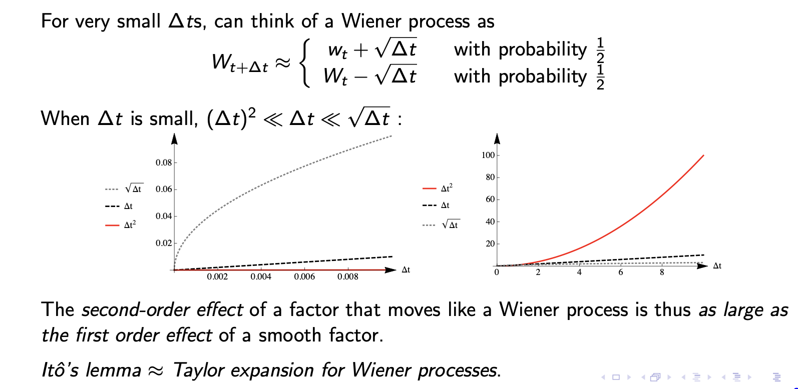

Geometric brownian motion:
A stochastic process following
$$d X\left(t\right)=X\left(t\right)·μ dt+σ·X\left(t\right) dW_{t}$$
Is called a geometric brownian motion using itos lemma:
$$⇔d\log\left(X\left(t\right)\right)=\left(μ-\frac{1}{2}σ^{2}\right)dt+σ dW_{t}$$
$$E\left[X\left(t\right)\right]=X\left(0\right)·e^{μt}$$

Simulations:
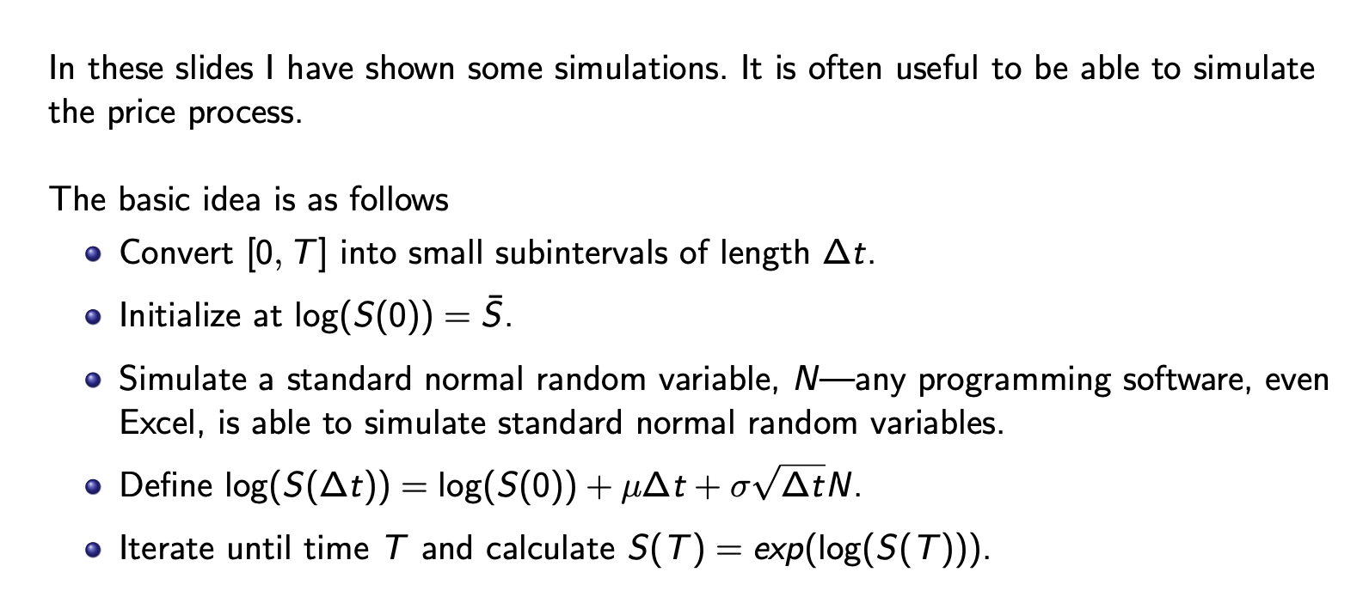

Noter fra tø:
For the function $f\left(X\right)=X^{α}$ we have and X following a geometric brownian motion
$$dX\left(t\right)=X\left(t\right)·μ dt+X\left(t\right)·σ dW_{t}$$
We have
$$d f\left(X\left(t\right)\right)=X{\left(t\right)}^{α}·\left(α·μ+\frac{σ^{2}}{2}·α\left(α-1\right)\right) dt+X{\left(t\right)}^{α}·α·σ dW_{t}$$
With
$$d f\left(X\left(t\right)\right)=X{\left(t\right)}^{α}·μ dt+X{\left(t\right)}^{α}·σ dW_{t}$$
Med nye my og sigma

Options:

European:
Gives the right but not obligation to buy S at price K at time T

Call:
$$max\{{S_{T}-K,0\}}$$

Put:
Gives the right but not obligation to sell at price K
$$\max{\{K-S_{T},0\}}$$
At time T they will have value exactly equal to their payoff

American:
We have the right but not obligation to buy/sell the asset for a price K at any time upuntill T
More optionality implies
$$C_{A}≥C_{E},$$
$$P_{A}≥P_{E}$$
European options are usually traded on indexes where american options are usually traded on single stocks

Moneyness:
For call:
$S_{t}<K⇒C$ out of the money
$S_{t}=K⇒C$ on the money
$S_{t}>K⇒C$ in the money
For put: $S_{t}<K⇒P$ in the money
$S_{t}=K⇒P$ on the money
$S_{t}>K⇒P$ out of the money

Intrinsic and extrinsic value:
Always
$$P=IV+EV$$
We have highest extrinsic value when on the money

For call at time t

Intrinsic value(IV):
$\max{\{S_{t}-K},0\}$ the value if the option expired today
Extrinsic value(EV) :
Value of keeping onto the option instead of exercising

Put at time t:
$$IV=\max{\{}K-S_{t},0\}$$
EV:
Can be negative for example if stockprice is close to zero you might prefer to exercise now which you are not able to

We will always calculate Extrinsic value by
$$P-IV$$
Now illustrated

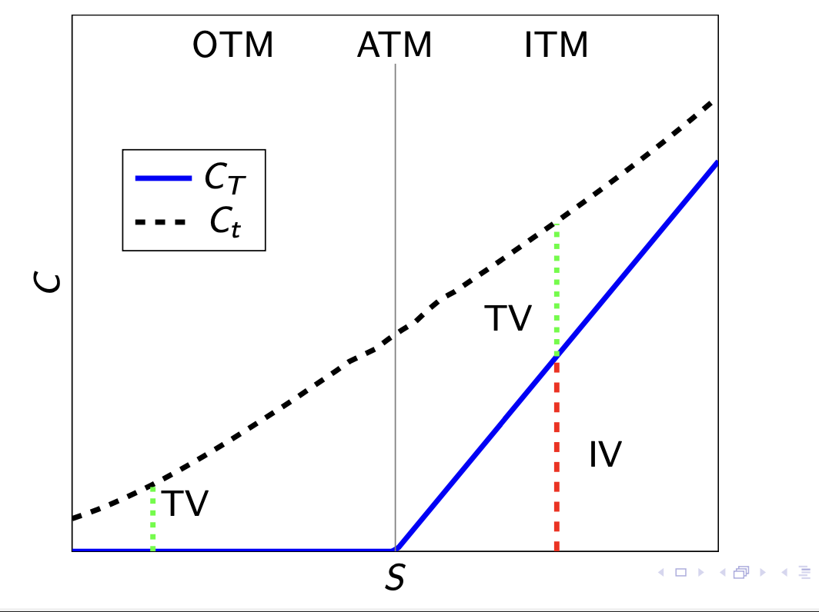
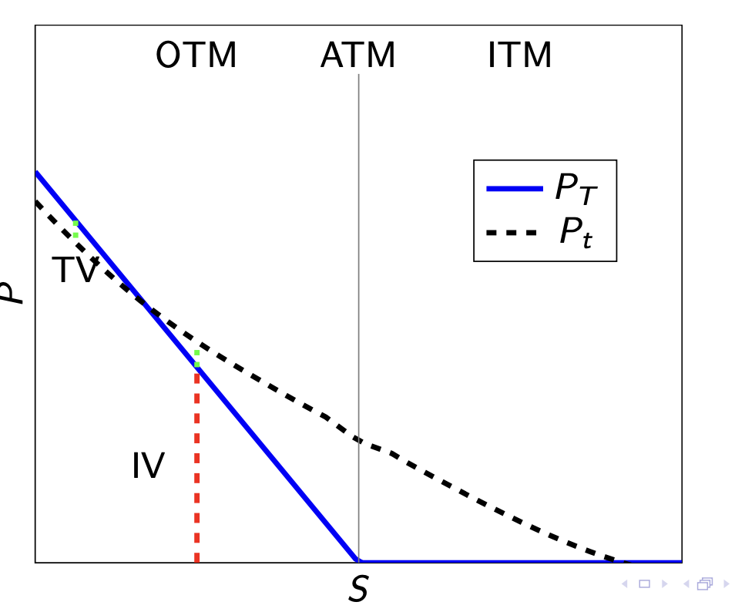

Put call parity:
For european options with expiration T and same strike K we must have
$$C_{t}-P_{t}=S_{t}-d_{t,T}K$$
Rather easy to see when the left side is what you call a synthetic thus meaning you would always excersize one or the other

For american options
$$S_{t}-K≤C_{t}^{A}-P_{t}^{A}≤S_{t}-d_{t,T}K$$

Pricing options in the binomial model:
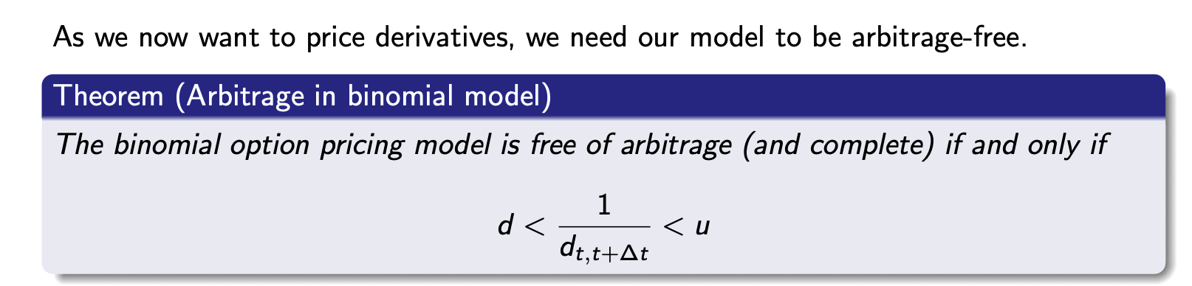
For constant u and d its tis simple
If u and d change (d might also change) this must be true for every single period “submodel”

Hedging in 1 period on the binomial model:
Given tree and discountfactor
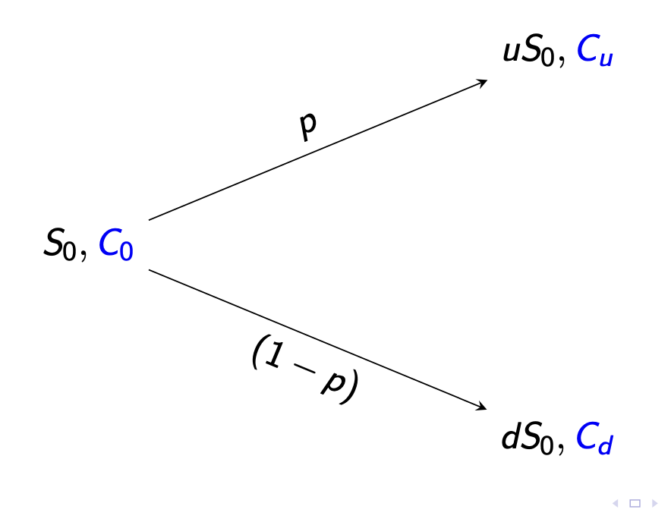
We simply wish to have the same payoff as the option in each state of the world and thus we solve the system o equations
$$ΔS_{u}+\frac{B}{d_{0,T}}=C_{u}$$
$$ΔS_{d}+\frac{B}{d_{0,T}}=C_{d}$$
exactly the same for a put
$$ΔS_{u}+\frac{B}{d_{0,T}}=P_{u}$$
$$ΔS_{d}+\frac{B}{d_{0,T}}=P_{d}$$

Risk neutral probabilities in binomial model:
$$q=\frac{\frac{1}{d_{0,T}}-d}{u-d}, 1-q=\frac{u-\frac{1}{d_{0,T}}}{u-d}$$
If u and d arent the same we need to calculate for every submodel
This is a well defined risk neutral measuere and thus we can simply calculate the risk neutral expectation and discount
$$C_{0}=d_{0,T}E^{Q}[C_{T}]$$

Pricing general derivatives on a binomial tree:
European options(or any other derivative only paying out at time T) when the underlying is expressed by a binomial tree:
$$f_{0}=d_{0,T}·E\left[f_{T}\right]=d_{0,1}\left(q·f_{u}+\left(1-q\right)f_{d}\right)$$
Where $f_{u}=d_{1,2}(q·f_{uu}+\left(1-q\right)·f_{ud})$
Or we simply calculate it directly in an arbitrage free N period model with constant u,d,risk free rate
$$f_{0}=d_{0,T}\sum_{k=0}^{N}{\left({N \atop k}\right)q^{k}·{\left(1-q\right)}^{N-k}f\left(S_{0}u^{k}·d^{N-k}\right)}$$

Limit as $Δt→0$ for european call/put in the binomial tree
Generally when you let the increments go towards 0 you approach the BSM price

Pricing american options:

When pricing american options everything is a little more complicated!

For american calls when no dividends we have
$$C_{E}=C_{A}$$
For puts this does not hold!

American options and other derivatives with optionality on a binomial tree

First just american options:
First create a tree of the payoff of exercising early in every state
Then price it backwards going one period at a time starting at the last
Then in every state of the world decide if you would rather exercise or keep the option
For an american option in a 2 period setting it looks like this

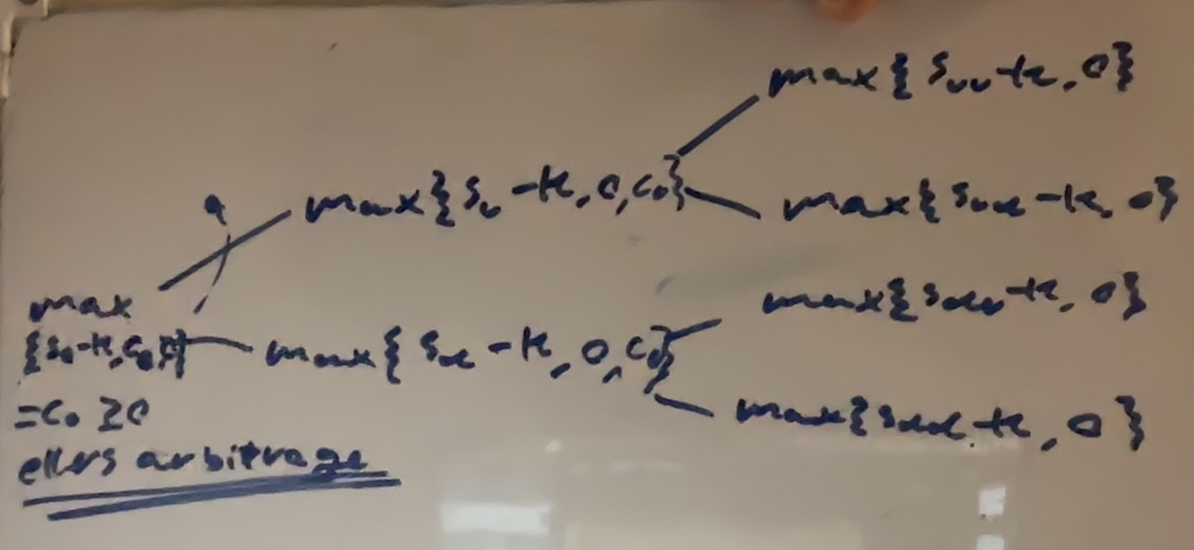

For a general derivative we would need to decide the payoff of excercising and thus decide weather the payoff of excercising is worth more than not exercising

A good example of this is a swaption :eksamensopgave:

Dividends:
When pricing in a dividend payment on a european option we just need to figure out what the different values and probabilities at time T are and calculate as usual
When pricing an american option we need to be carefull about when the dividend is payed out and price as if a normal american option:
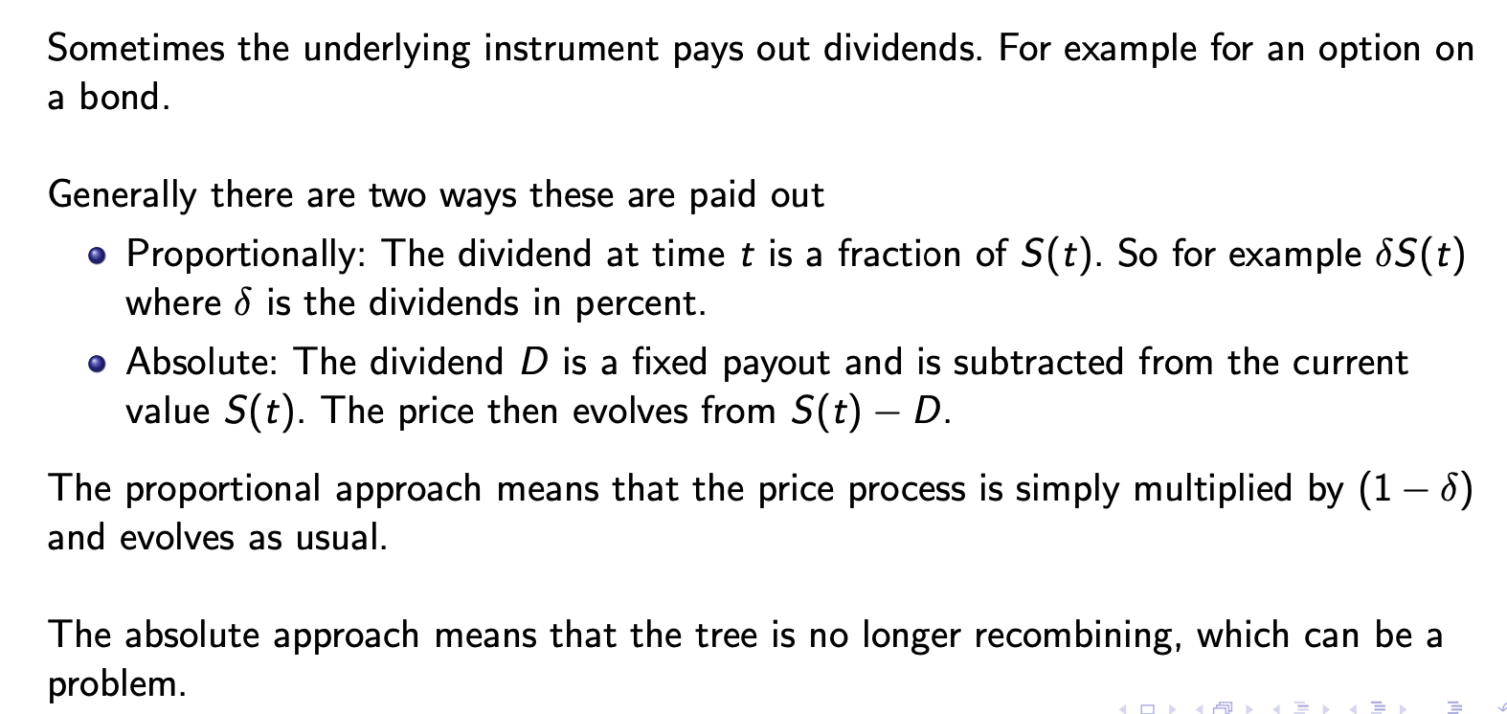

Black Scholes Merton:

Overview between binomial vs BSM model:
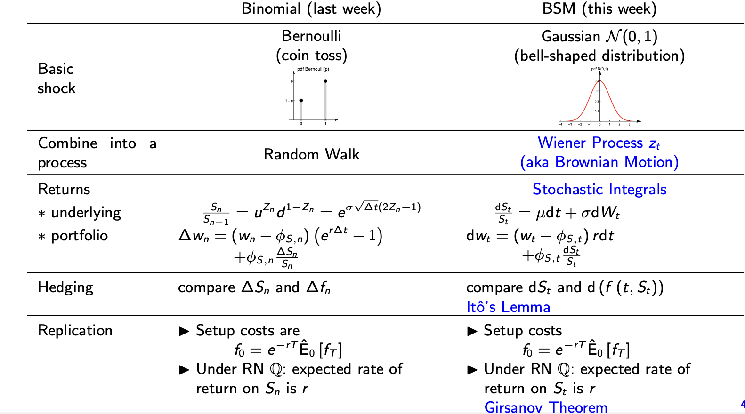

BSM assumptions:
$S_{t}$ follows a geometric brownian motion
$$dS_{t}=S_{t}μ dt+S_{t}σ dW_{t}$$
$$dlog\left(S_{t}\right)=\left(μ-\frac{σ^{2}}{2}\right)dt+σdW_{t}$$
Thus
$$S_{t}=S_{0}·e^{\left(μ-\frac{σ^{2}}{2}\right)·t+σW_{t}}$$
Where $W_{t}\sim N\left(0,t\right)$
We can swap t a risnk neutral measure
By replacing $μ$ with r
$$dlog\left(S_{t}\right)=(r-\frac{σ^{2}}{2})dt+σ dW_{t}$$
$$S_{t}=S_{0}·e^{\left(r-\frac{σ^{2}}{2}\right)·t+σW_{t}}$$

There is a konstant risk free rate or an asset that follows
$$dB_{t}=r·B_{t}dt$$
No market frictons(trading is continous, no transaction costs, no taxes, shortselling is costless, securities are infinitely divisible…)

The BSM differantial equation:
Any derivativeprice f on the underlying S must have
$$r·f\left(t,S\right)=\frac{∂f}{∂t}\left(t,S\right)+r·S·\frac{∂f}{∂S}\left(t,S\right)+\frac{1}{2}σ^{2}S^{2}\frac{∂^{2}f}{∂S^{2}}\left(t,S\right)$$
Thus given a price function f we can check if it is priced correctly be checking the BSM model aswell as boudary conditions i.e what happens at exiration, what happens if the price goes to zero etc

Written in greeks the BSM equation states
$$rf=θ+r·S·Δ+\frac{1}{2}σ^{2}·S^{2}·Γ$$

Sometimes we like to approximate the change in derivative price with(almost) this equation
:
$$δf≈Δ·δS+\frac{1}{2}Γ·{\left(δS\right)}^{2}+Θ·δt$$

The BSM options pricing formula:
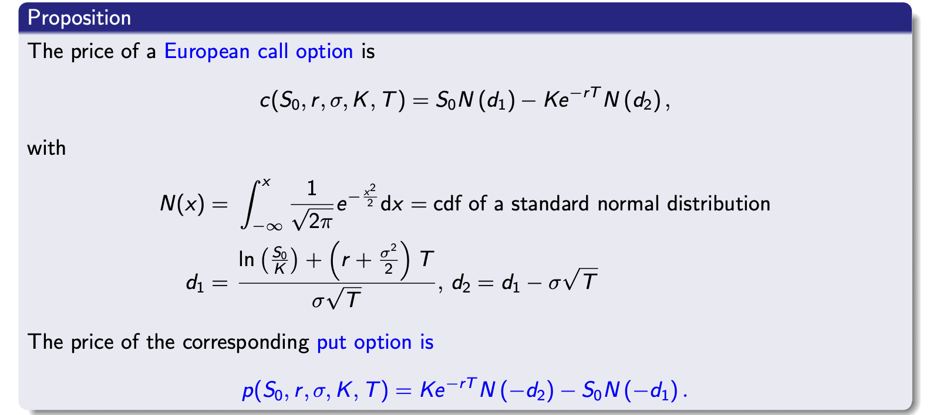
$$c=S_{0}·\int_{-∞}^{d_{1}}{\frac{1}{\sqrt{2π}}·e^{-\frac{x^{2}}{2}}dx}-K·e^{-r·T}\int_{-∞}^{d_{2}}{\frac{1}{\sqrt{2π}}·e^{-\frac{x^{2}}{2}}dx}$$
$$P=K·e^{-r·T}·\int_{-∞}^{-d_{2}}{\frac{1}{\sqrt{2π}}·e^{-\frac{x^{2}}{2}}dx}-S_{0}·\int_{-∞}^{-d_{1}}{\frac{1}{\sqrt{2π}}·e^{-\frac{x^{2}}{2}}dx}$$

$$d_{1}=\frac{\log{\frac{S_{0}}{K}}+\left(r+\frac{σ^{2}}{2}\right)T}{σ\sqrt{T}}$$
$$d_{2}=d_{1}-σ\sqrt{T}$$

$S_{0}$ er prisen på aktivet til tid 0
$r$ er den risikofrie rate
$σ$ er volatility of the asset
$K$ er strikreprice
$T$ er tid til udløb normaliseret til 1 kalenderår altså 20 dage er $T=\frac{20}{365}$

Alle equations in the BSM framework can be written as $T=T-t$ where t is the to day and T is expiration

Options Greeks of the BSM
Call
$$Δ_{C}=\frac{∂C}{∂S}=N(d_{1})$$
$$Γ_{C}=\frac{N^{'}\left(d_{1}\right)}{S_{0}σ\sqrt{T}}$$
$$θ_{c}=\frac{∂C}{∂(-T)}=-S_{0}·\frac{N^{'}\left(d_{1}\right)σ}{2\sqrt{T}}-rKe^{-rt}N(d_{2})$$
Price sensetivity to time passing and thus $T$ becoming smaller

$$V_{C}=\frac{∂C}{∂σ}=S_{0}·\sqrt{T}N'(d_{1})$$
$$ρ_{c}=\frac{∂C}{∂r}=K·T·e^{-rT}N(d_{2})$$
Put:
$$Δ_{P}=-N(-d_{1})$$
$$Γ_{P}=Γ_{C}=\frac{N^{'}\left(d_{1}\right)}{S_{0}σ\sqrt{T}}$$
$$θ_{P}=-S_{0}σ·\frac{N^{'}\left(d_{1}\right)}{2\sqrt{T}}+rK·e^{-rT}N(-d_{2})$$
$$V_{P}=V_{C}=S_{0}·\sqrt{T}N'(d_{1})$$
$$ρ_{P}=K·T·e^{-rT}·N(-d_{2})$$

Implied volatility:
When looking in the market, usually the only unknown parameter is the volatility being calculated into the options price(this is assumed constant in the BSM framework which is not a reasonable assumption) thus since the optionsprice is increasing in volatility we have a well defined volatility inverse and solve for volatility(usually using numerical metods)
Finding a vol such that
$$C\left(S_{0},K,T,r,σ_{iv}\right)=C_{market}$$
This vol is what the market expects the volatility to be

Girsanovs theorem:
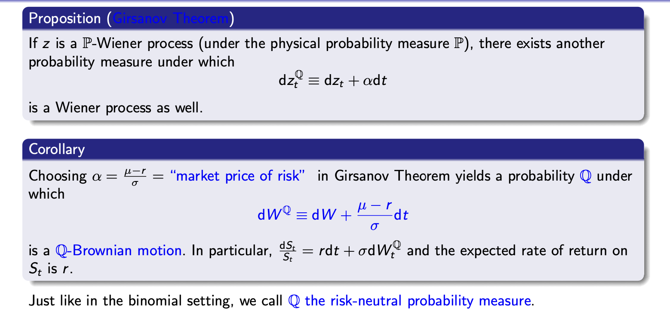
We can now easily price any asset folllowing a Wiener/ito process
Especially any derivative on an asset following a geometric brownian motion

General risk neutral pricing in the BSM world:
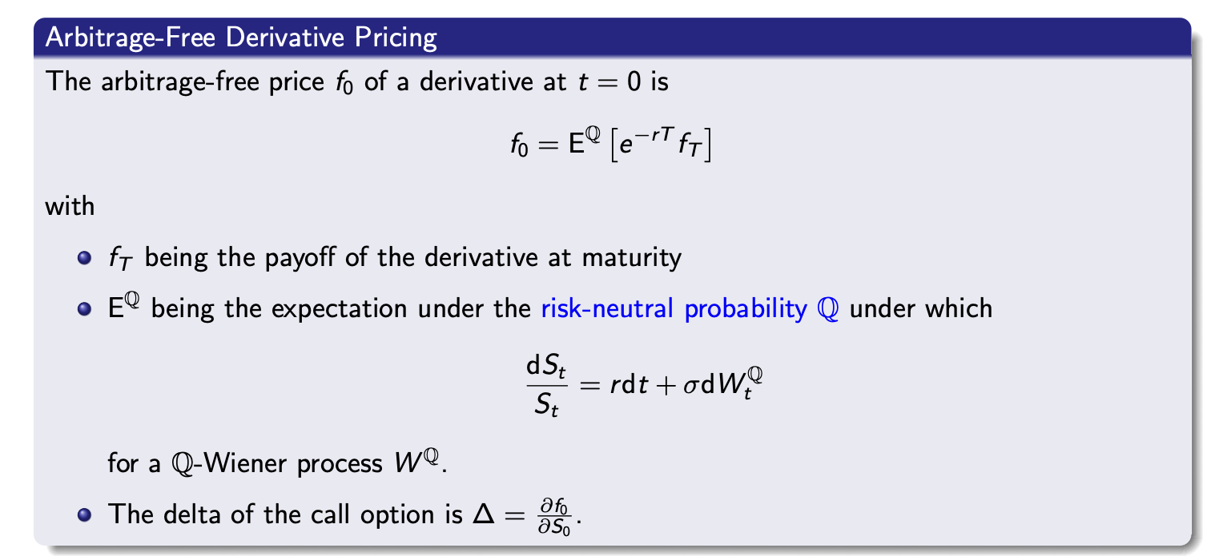
We can price this arbitrary derivative by this integral in the BSM setting
$$E^{Q}\left[e^{-rT}·f\left(S_{t}\right)\right]=e^{-rT}\int_{-∞}^{∞}{f\left(s\right)·\frac{1}{s}·\frac{1}{\sqrt{2πσ^{2}T}}·e^{-\frac{1}{2}·\frac{\log\left(s\right)-μ}{σ^{2}T}}ds}$$
$$μ=\log\left(s_{0}\right)+\left(r-\frac{1}{2}σ^{2}\right)T$$

This equation also gives:
$$S_{0}=E^{Q}\left[S_{t}·e^{-rt}\right]=e^{-rt}·E^{Q}\left[S_{t}\right]$$
$$S_{0}·e^{rt}=E^{Q}\left[S_{t}\right]$$
With

Pricing call options with risk neutral pricing:
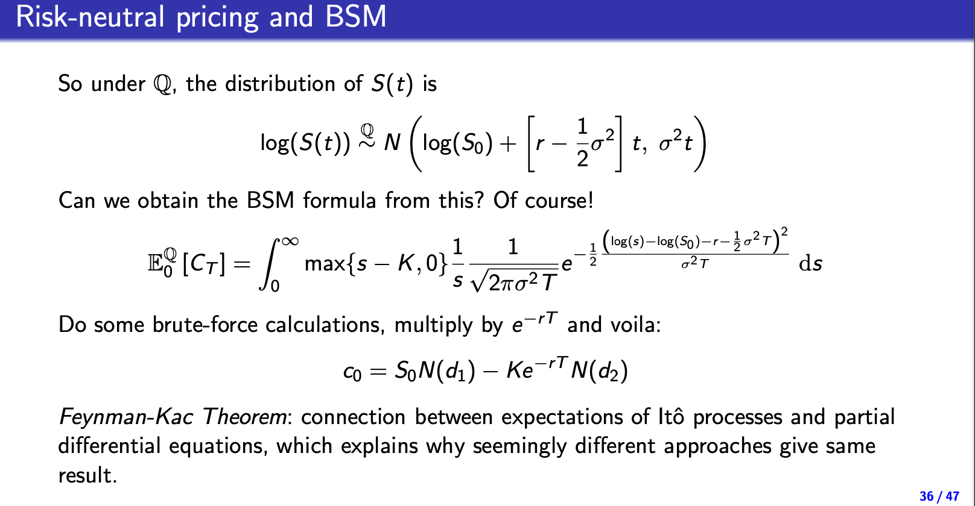
Normalfordeling pricing

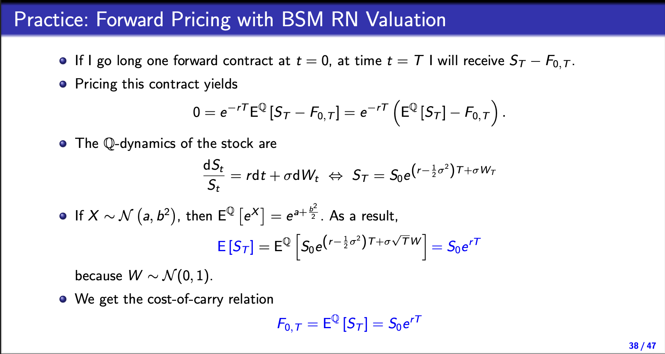

Portfolio insurance:
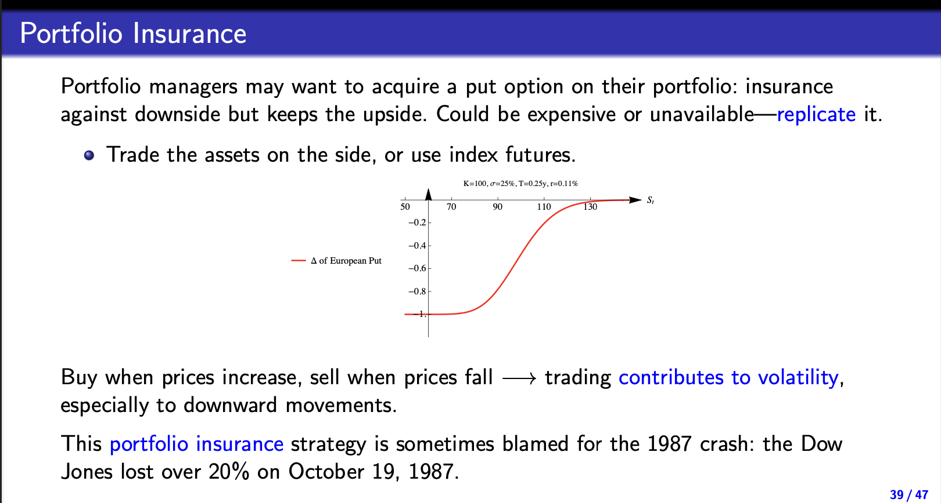

Pricing with montecarlo simulation
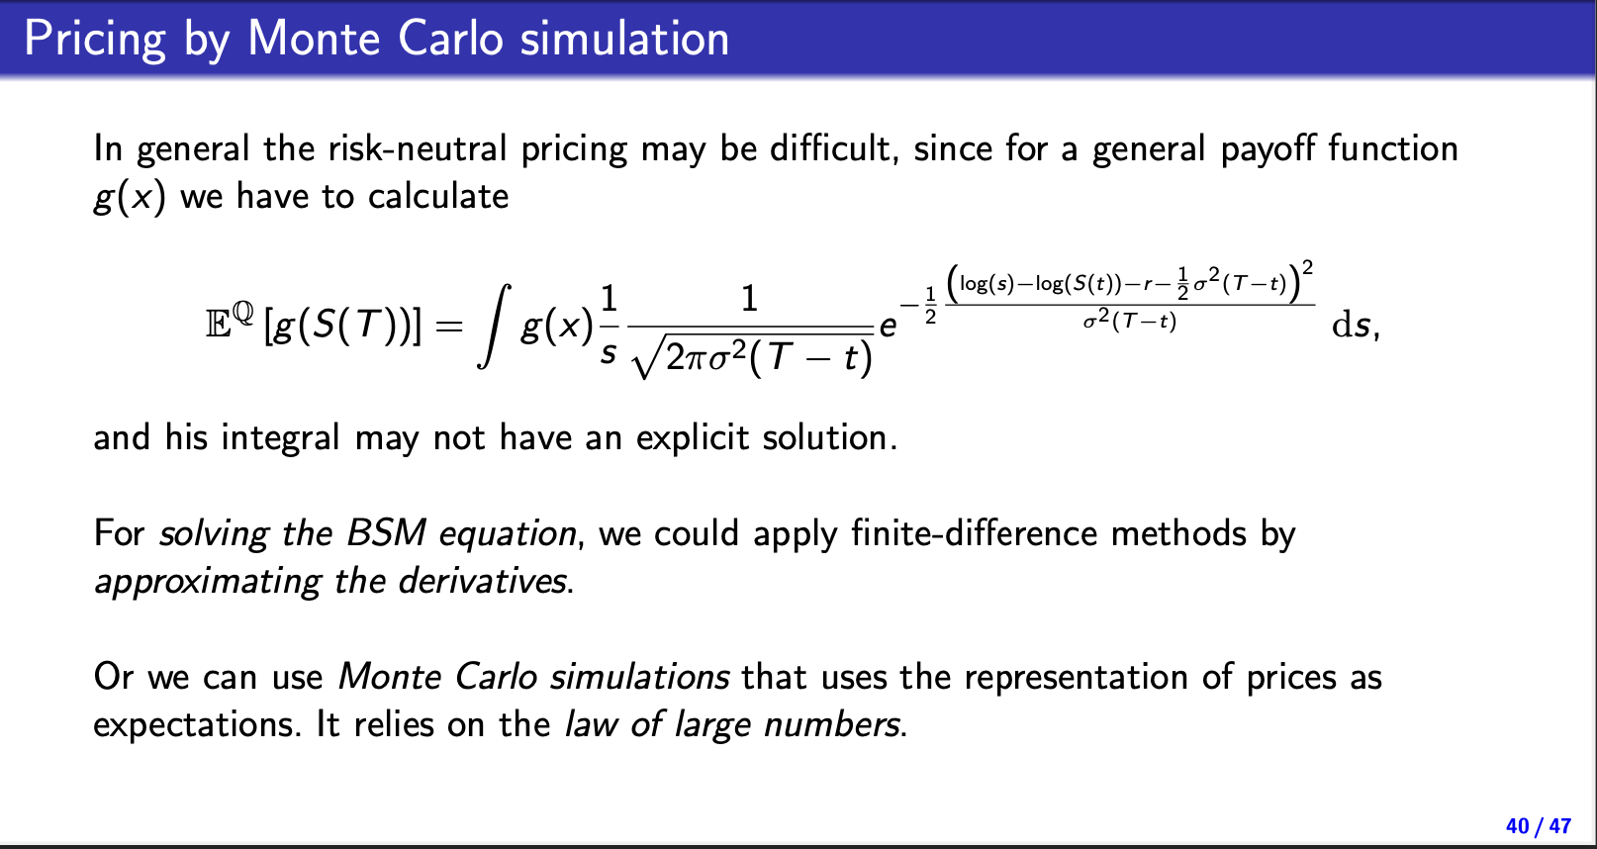
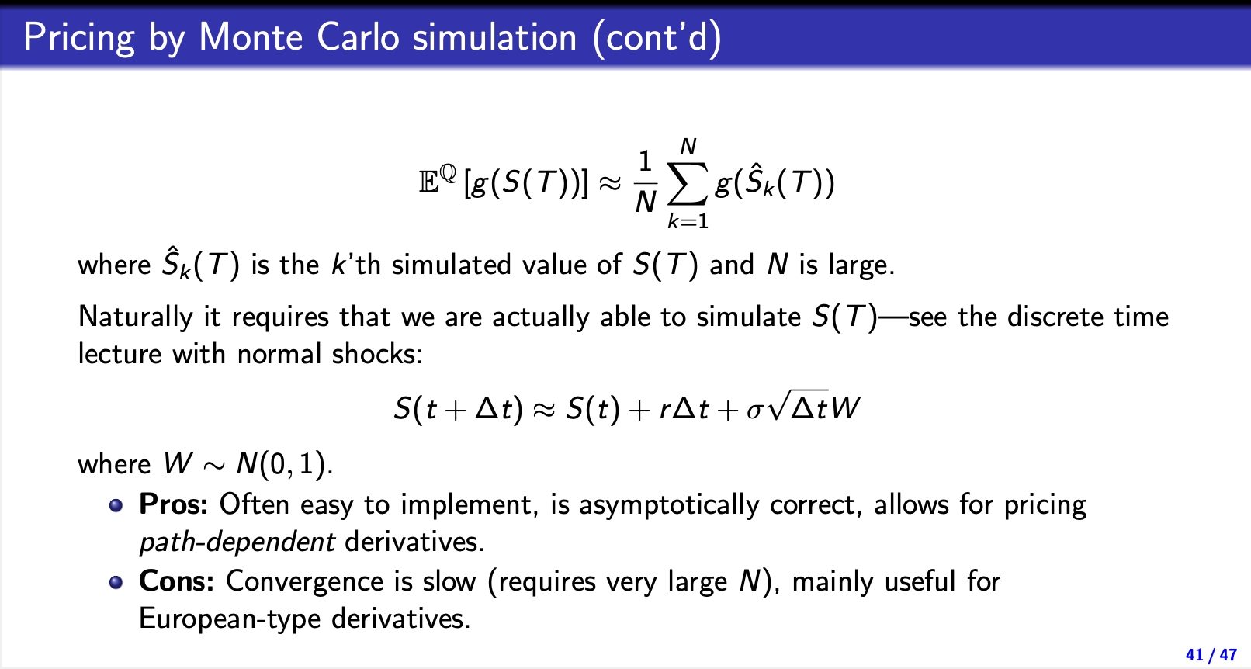

BSM with dividends:
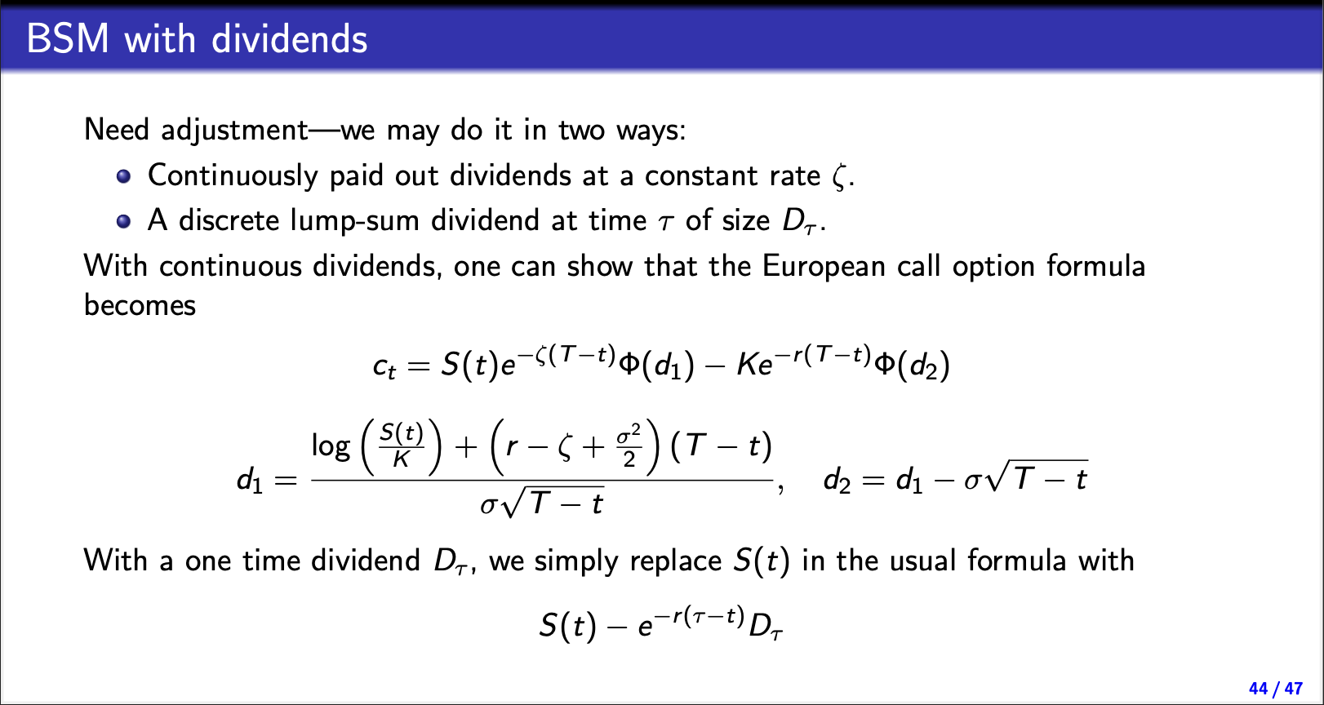

BSM pros - shortcomings:
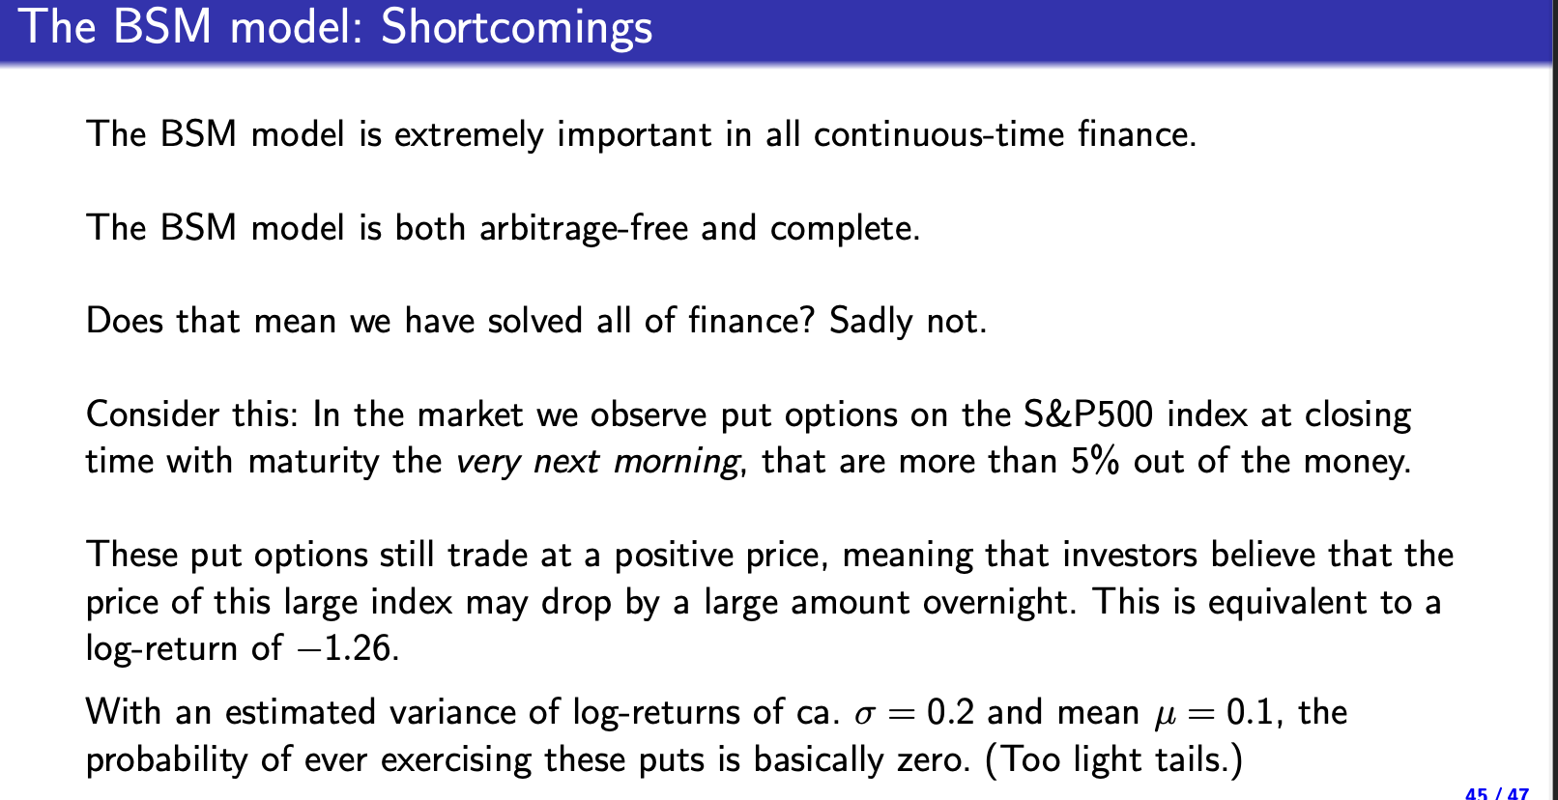
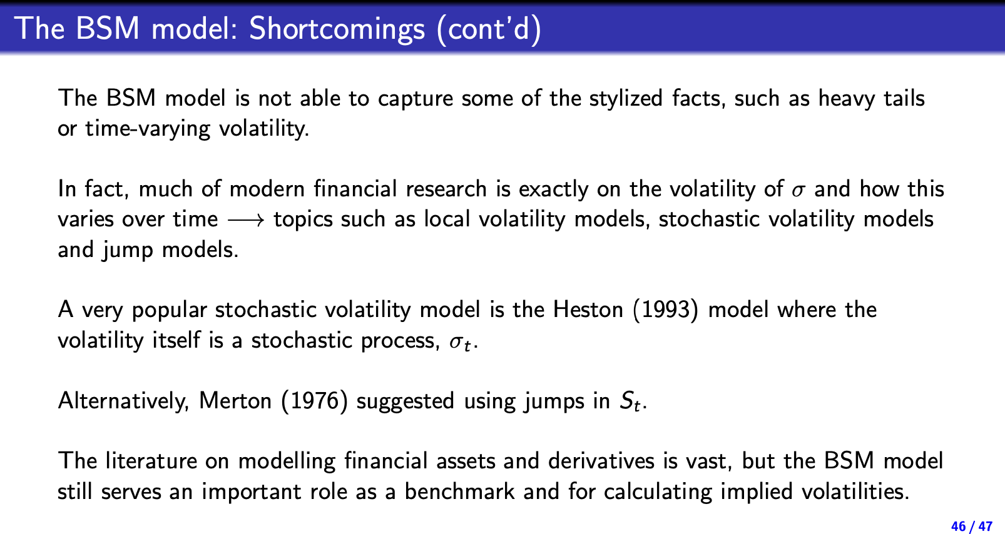

Noter fra tø

Stochastic interest rates:
In any market se must have our discount factors
$$d_{t,T}=e^{-\int_{t}^{T}{r(s)ds}}$$
Thus by risk neutral pricing the ZCB must be priced
$$B_{t,T}=E^{Q}\left[e^{-\int_{t}^{T}{r\left(s\right)ds}}\right]$$
If r is deterministic we will simply have our normal discont factors
But we still want to choose some interest rates that do not allow arbitrage

We Assume that our models are formulated directly under Q making
The underlying asset (interest rates cannot be traded so this makes it rather hard to chose Q from some P that we don’t really know
We still have that there exists one Q such that the model is free of arbitrage
We assume that the model is already formulated under this Q

We use a binomial tree
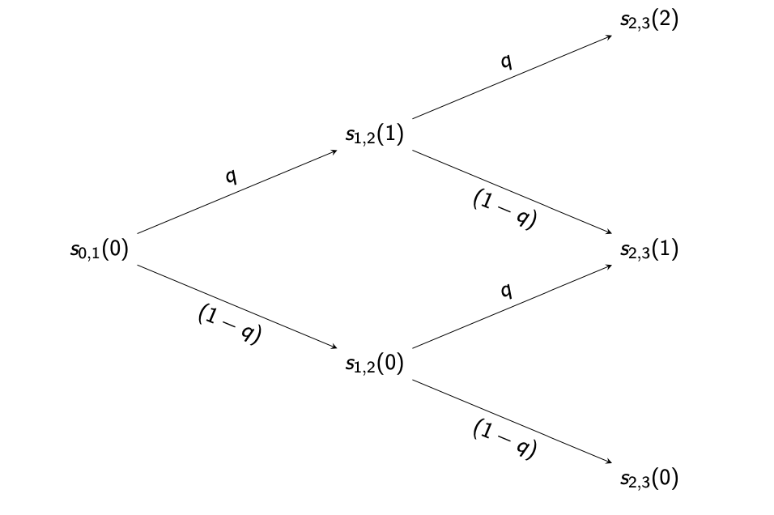

ZCB pricing on binomial tree
Then we price a zero cupon bond in this market
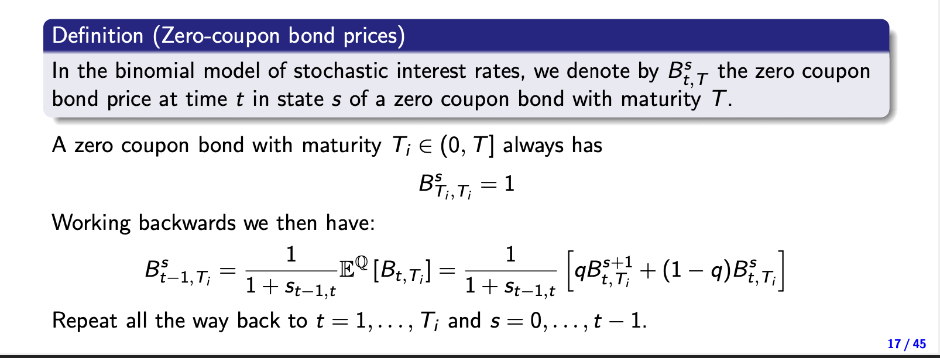
We need to be carefull, that we remember to use the right interest rates in this model

Another way is by doing it forwards by state pricing (basicly the same as from ealyer in the course just in multi periods

State prices in the bond market:
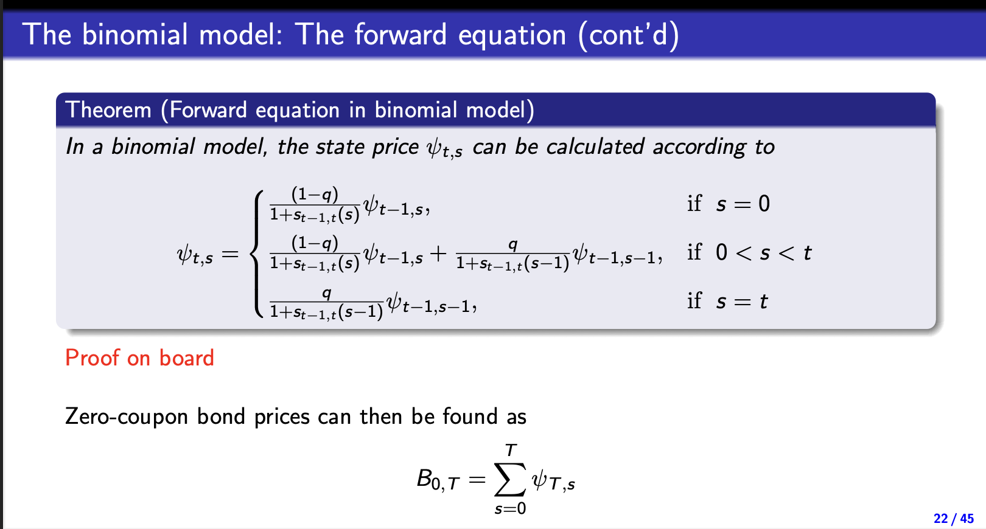

Callable bond pricing:
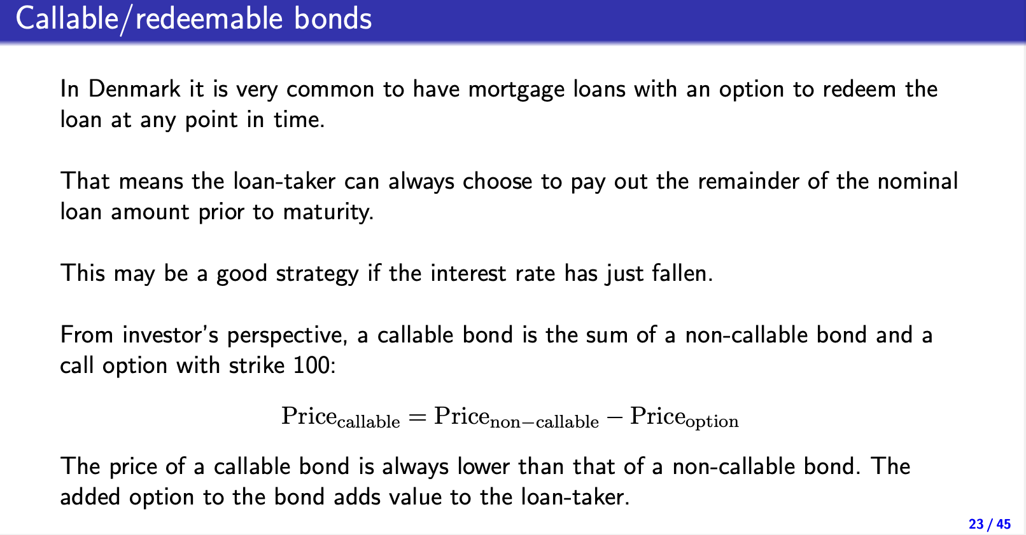
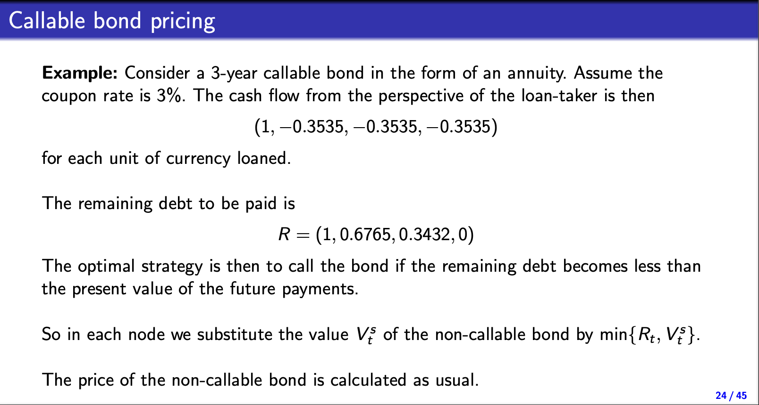

Immunisisation:

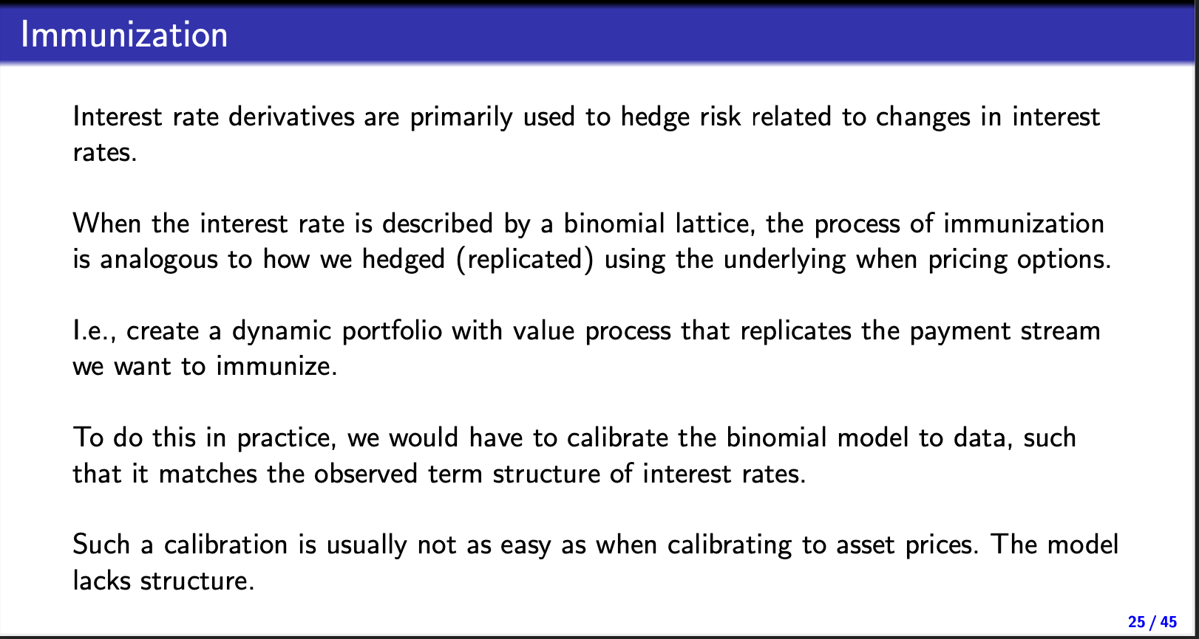

Diskrete interest rate models

Ho-Lee model:
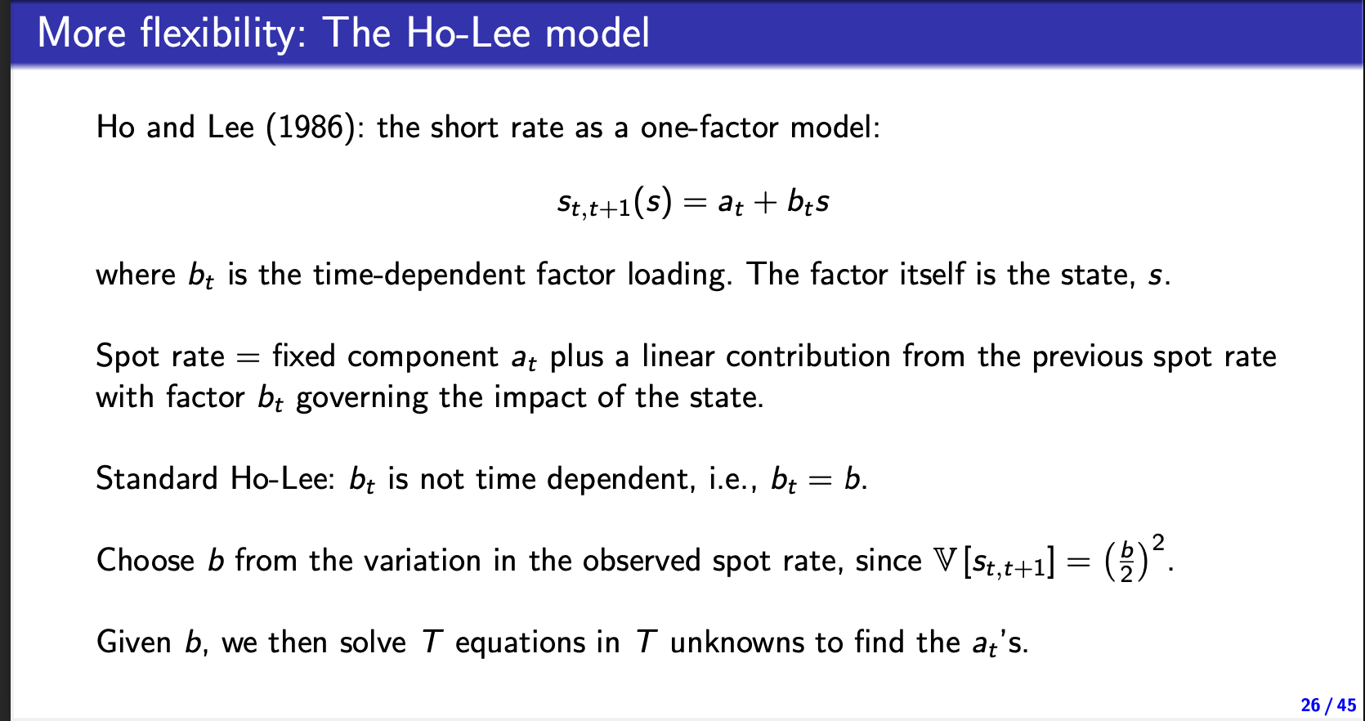

Black-derman-Toy model:
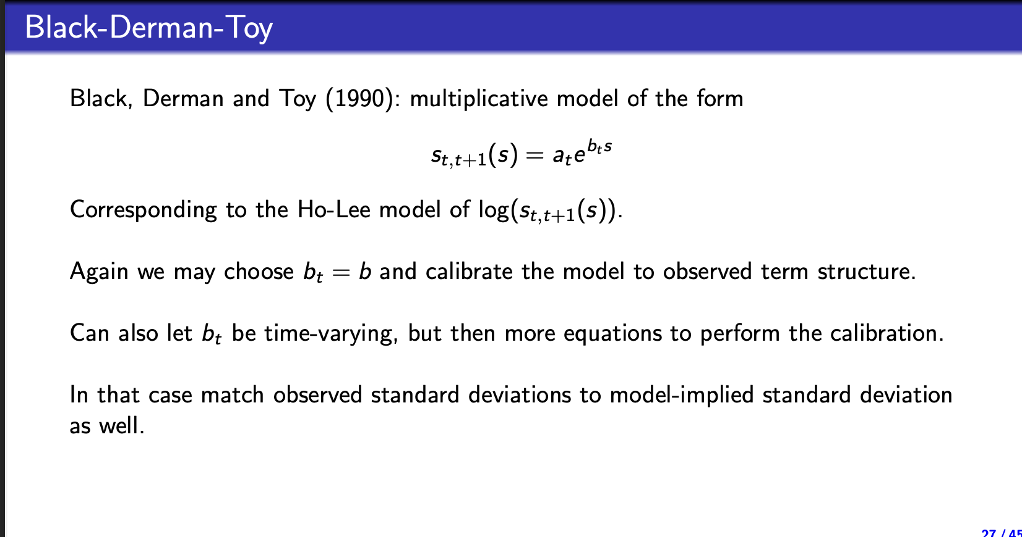

Interest rate models in continous time
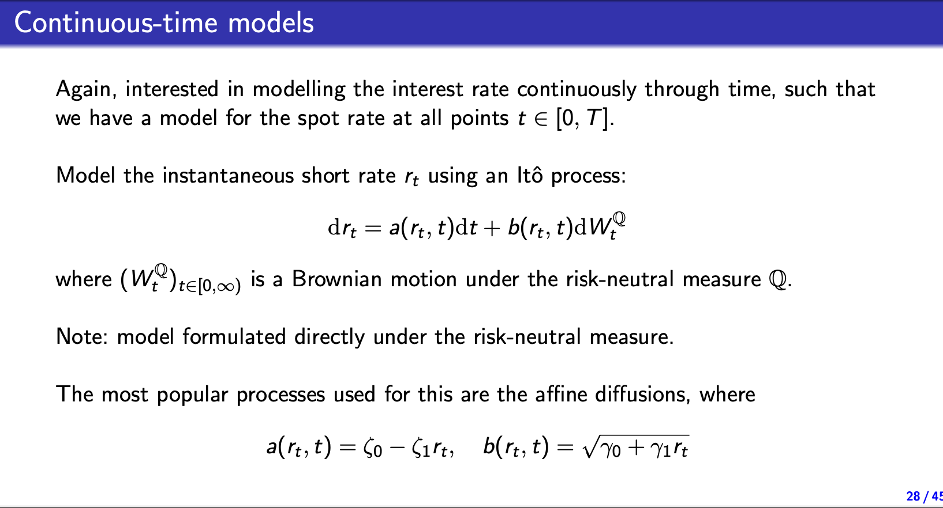

Ho-Lee model
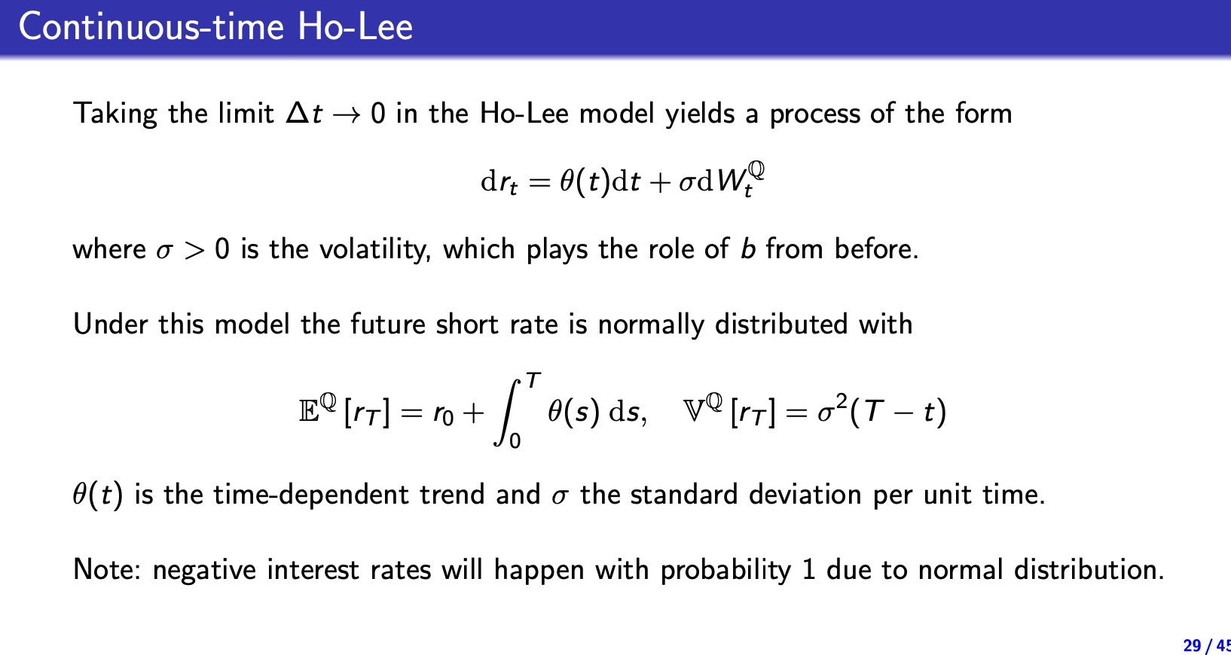

The Vasicek model
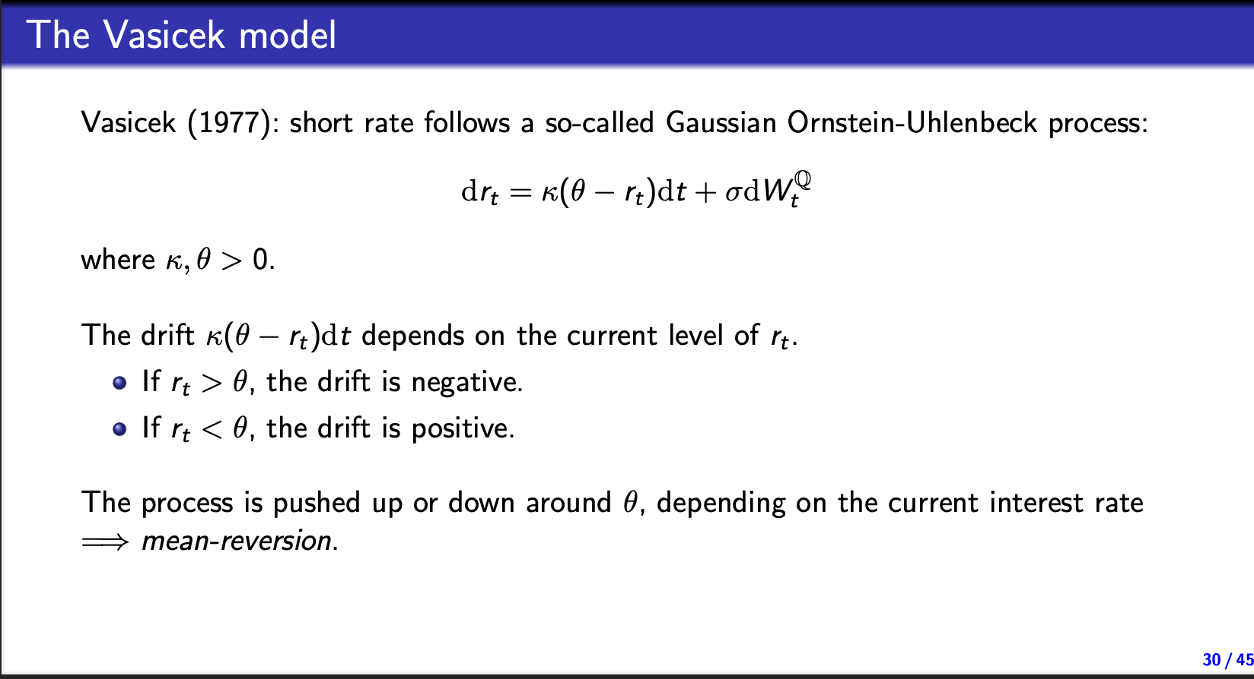
Mean reversion
Drift towards $θ$

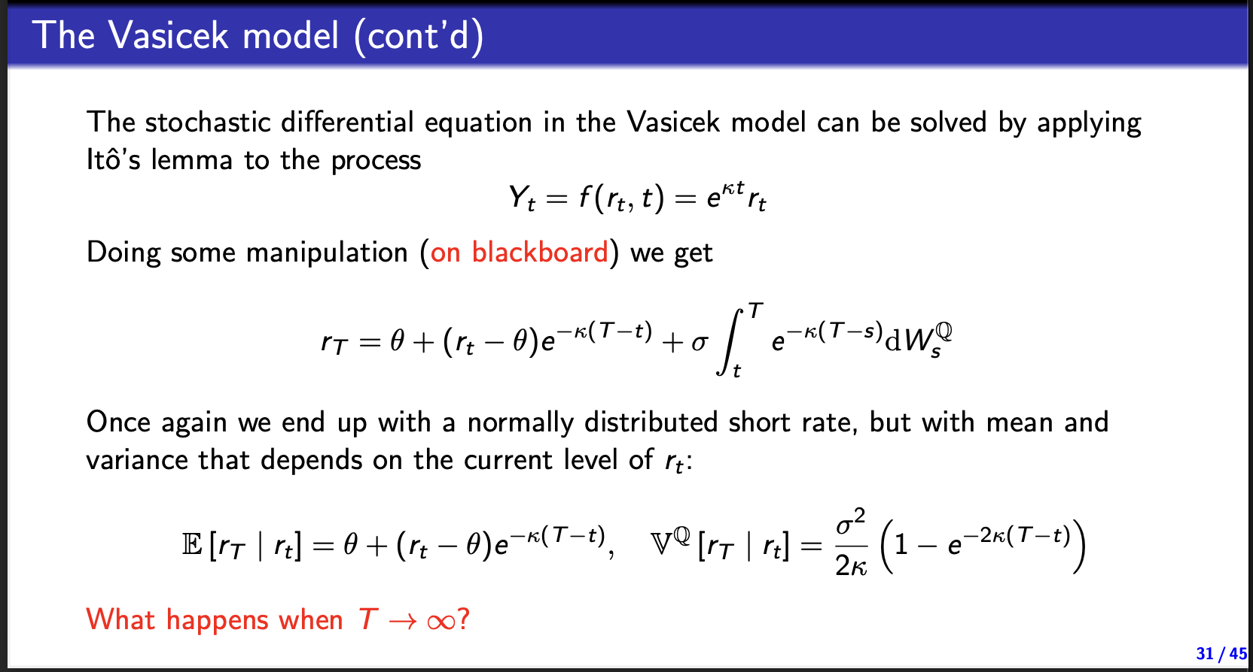
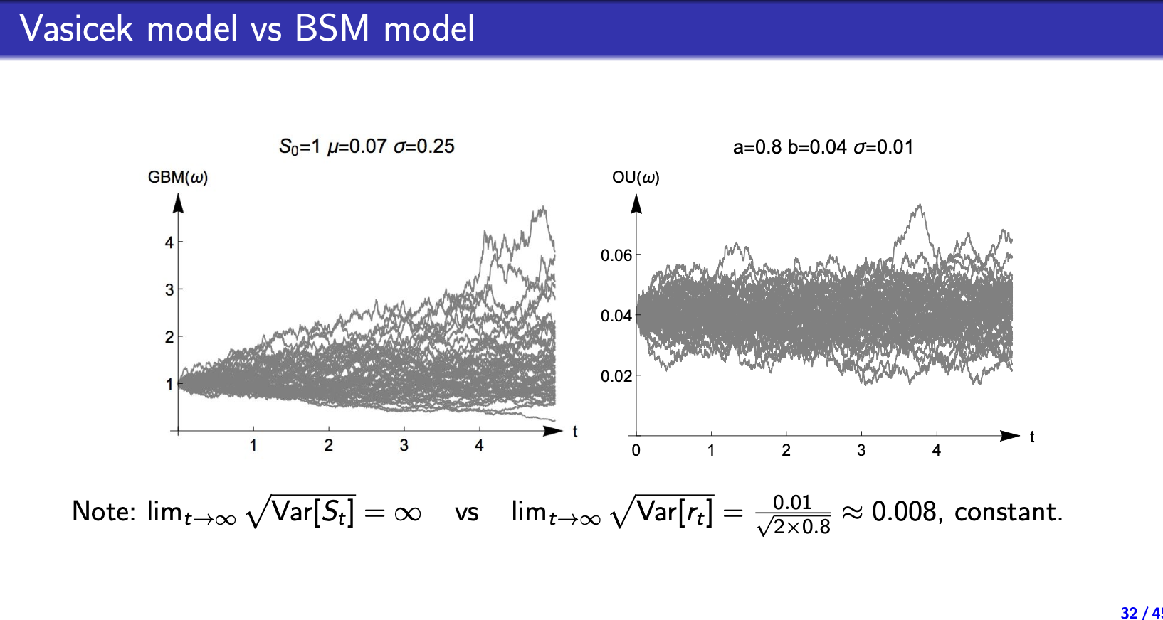

Cox-Ingersoll-Ross model (CIR)
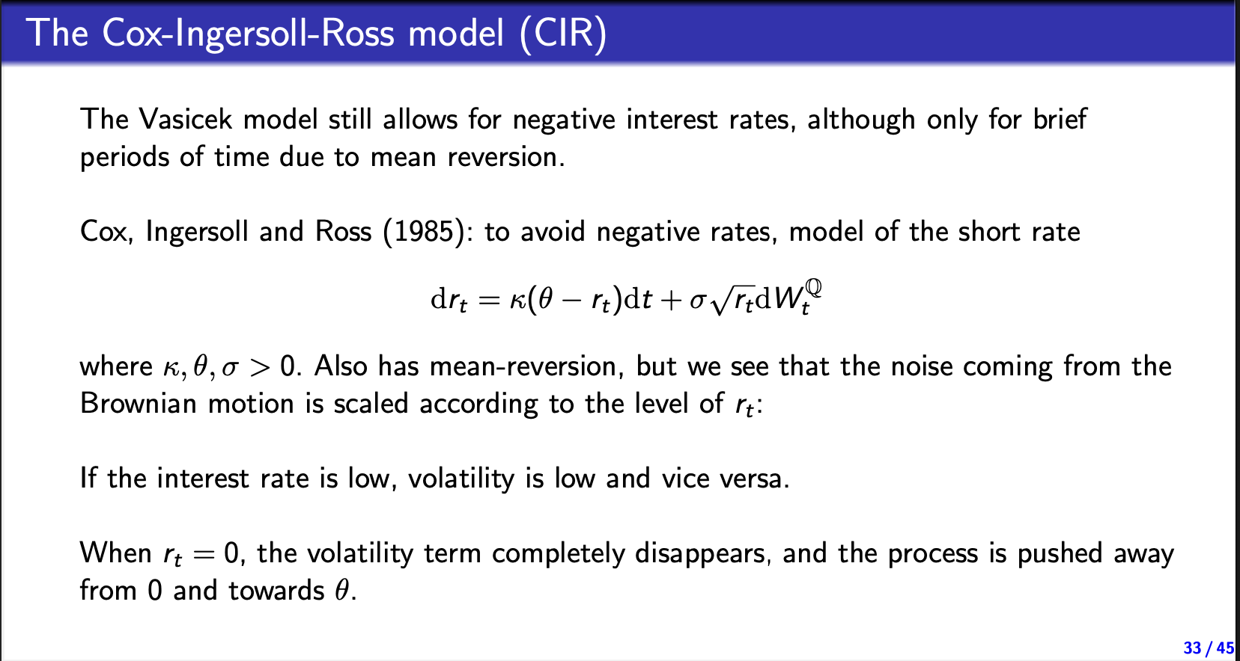
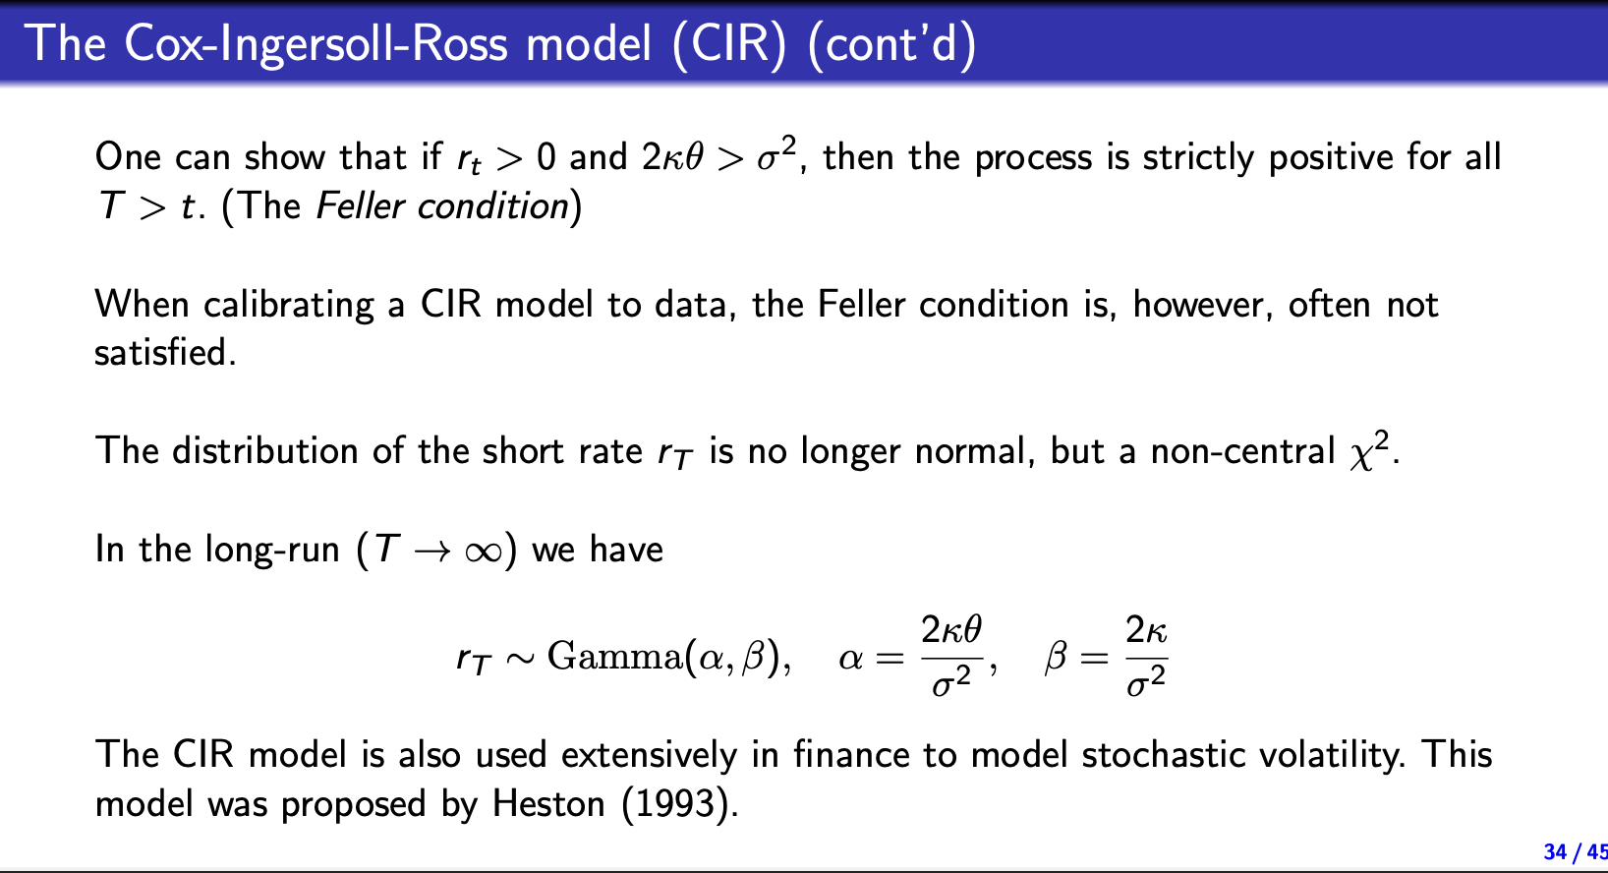
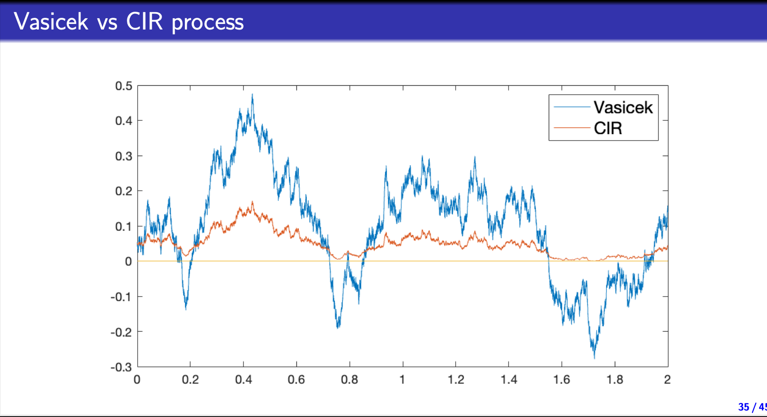

Interest rate derivatives:
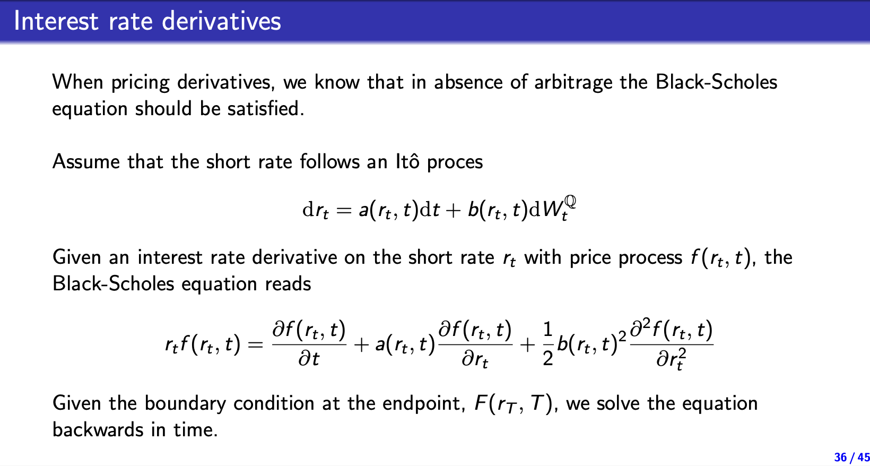

Pricing ZCB(a simple interest rate derivative)
When rates are constant
$$B_{t,T}=e^{-r\left(T-t\right)}$$

In the continous ho lee model:
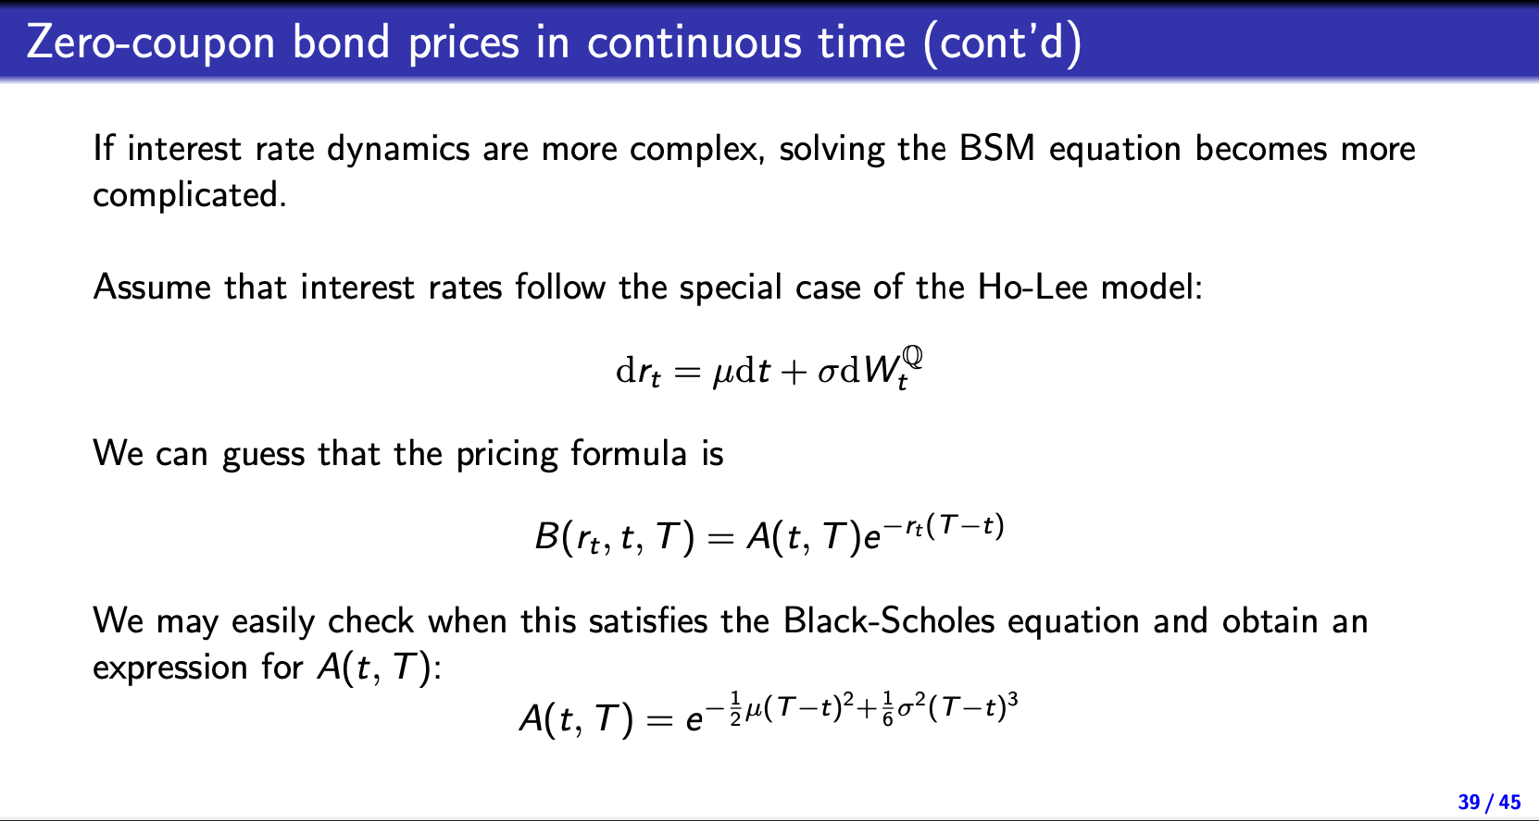

In Affine models
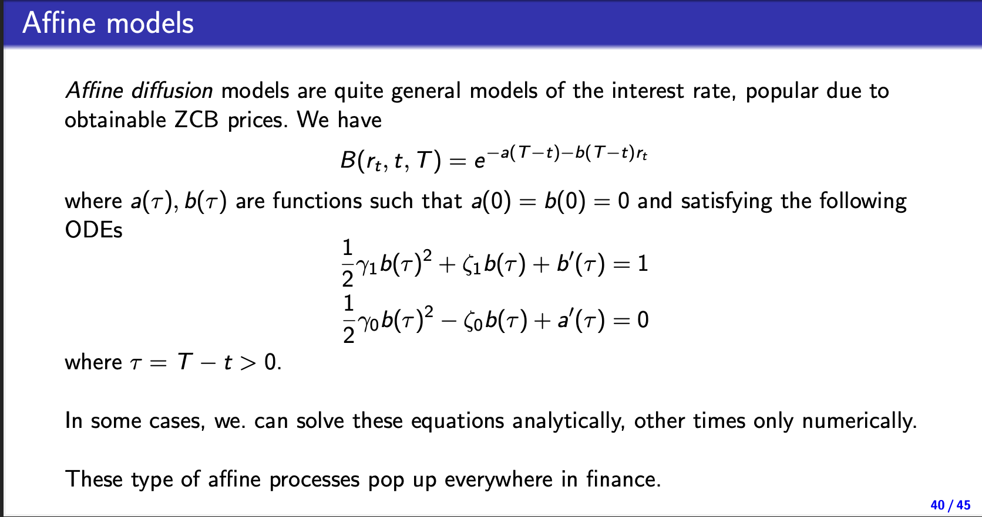

In the vasicek model
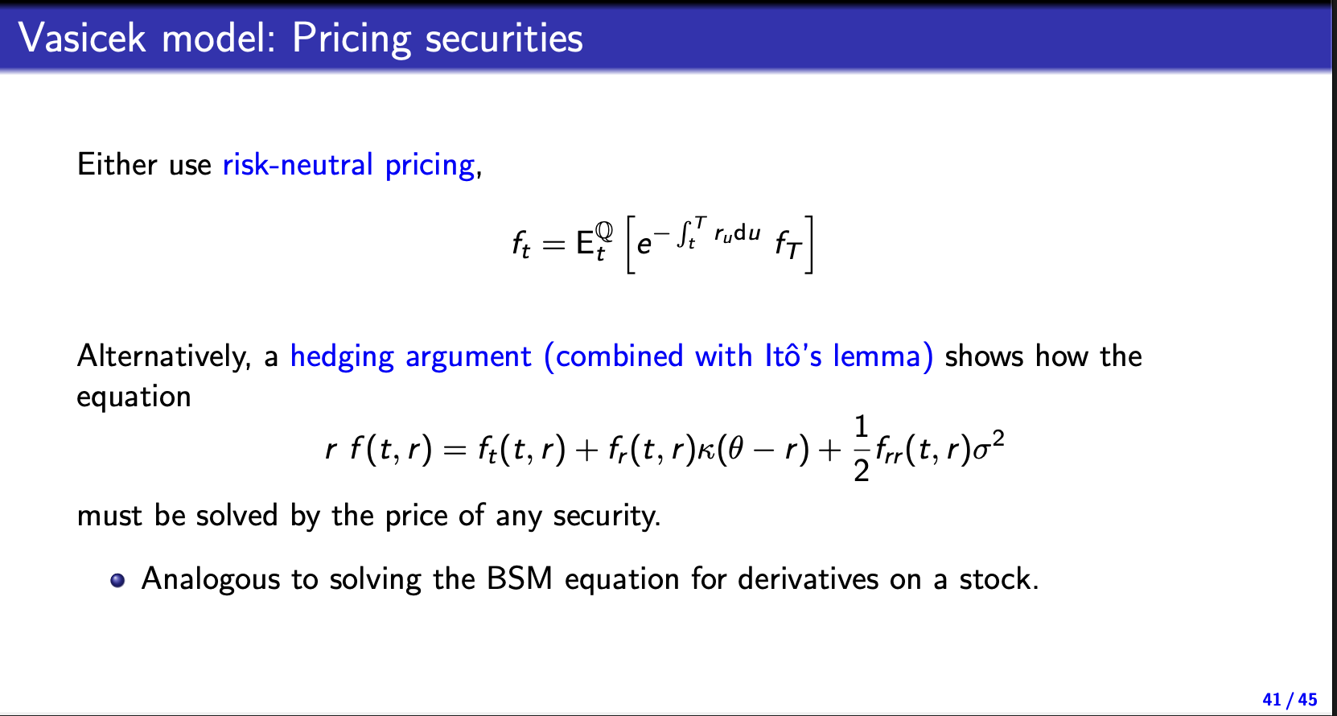
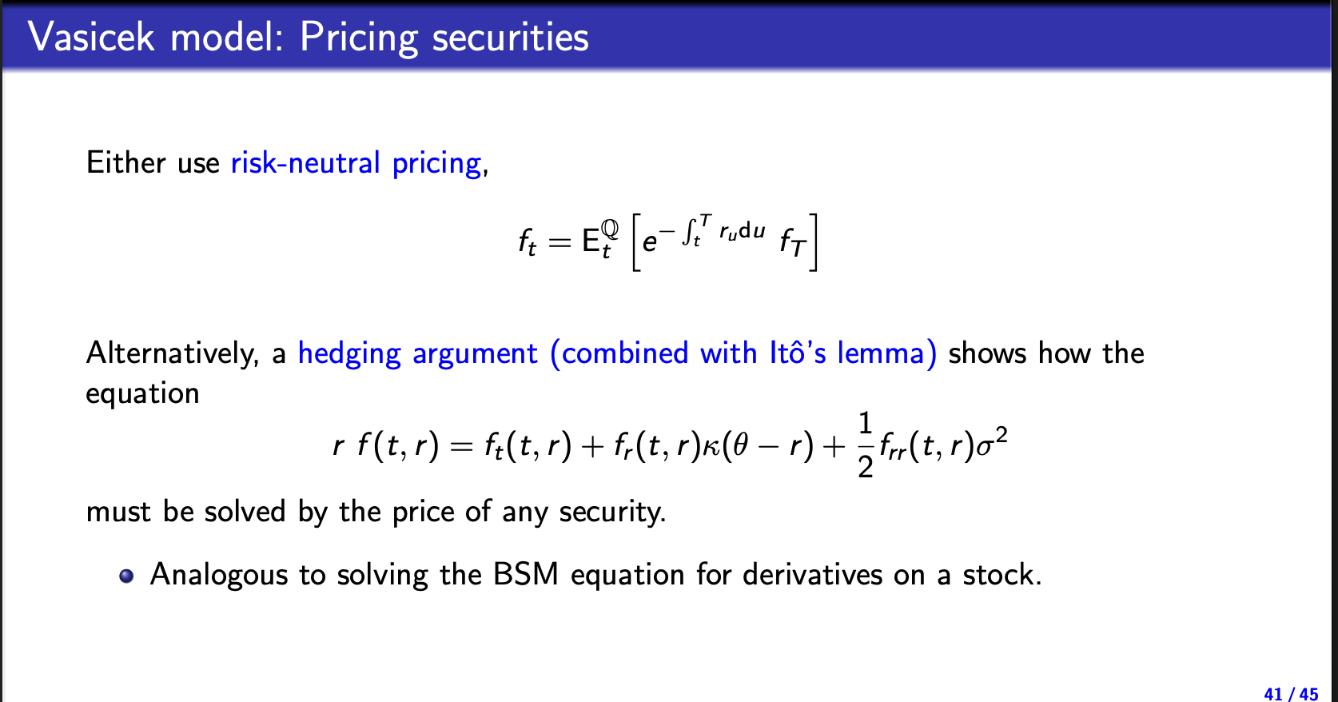
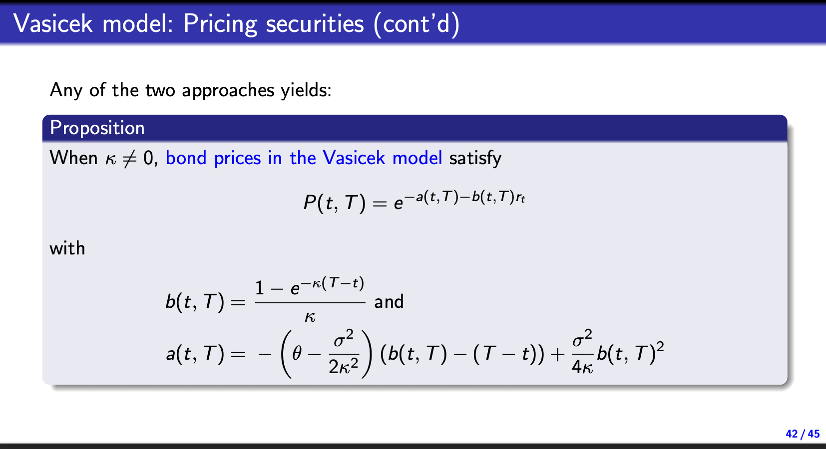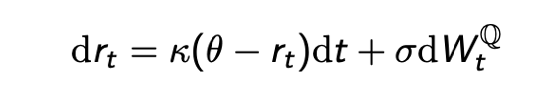
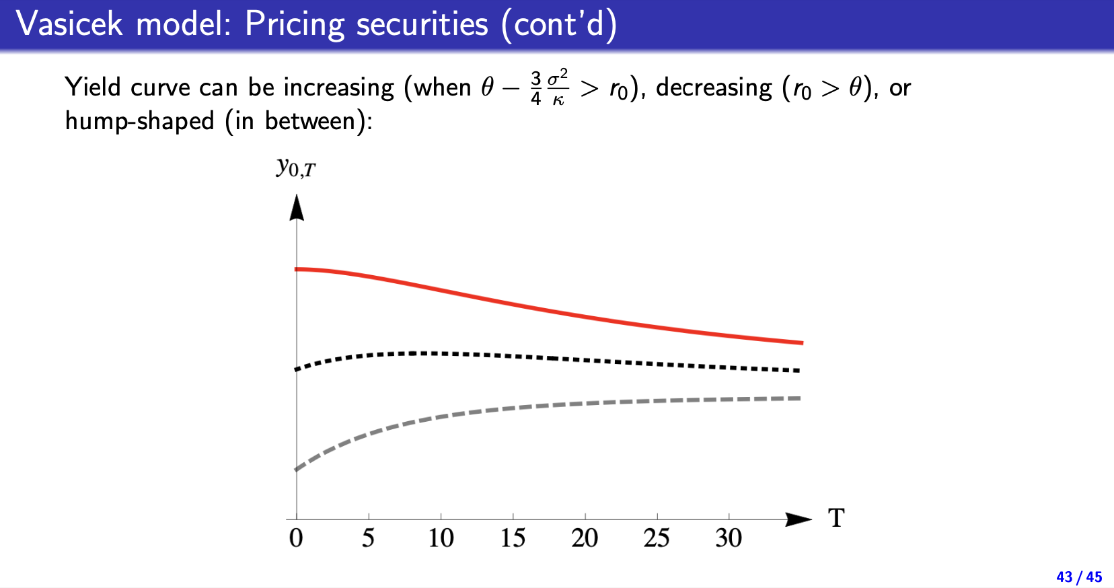

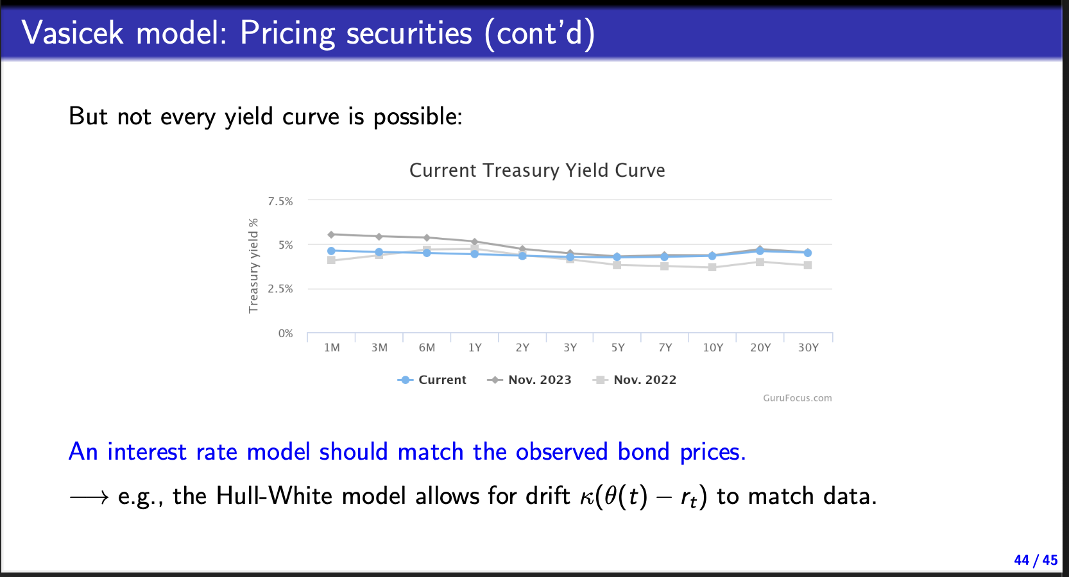
Summary:
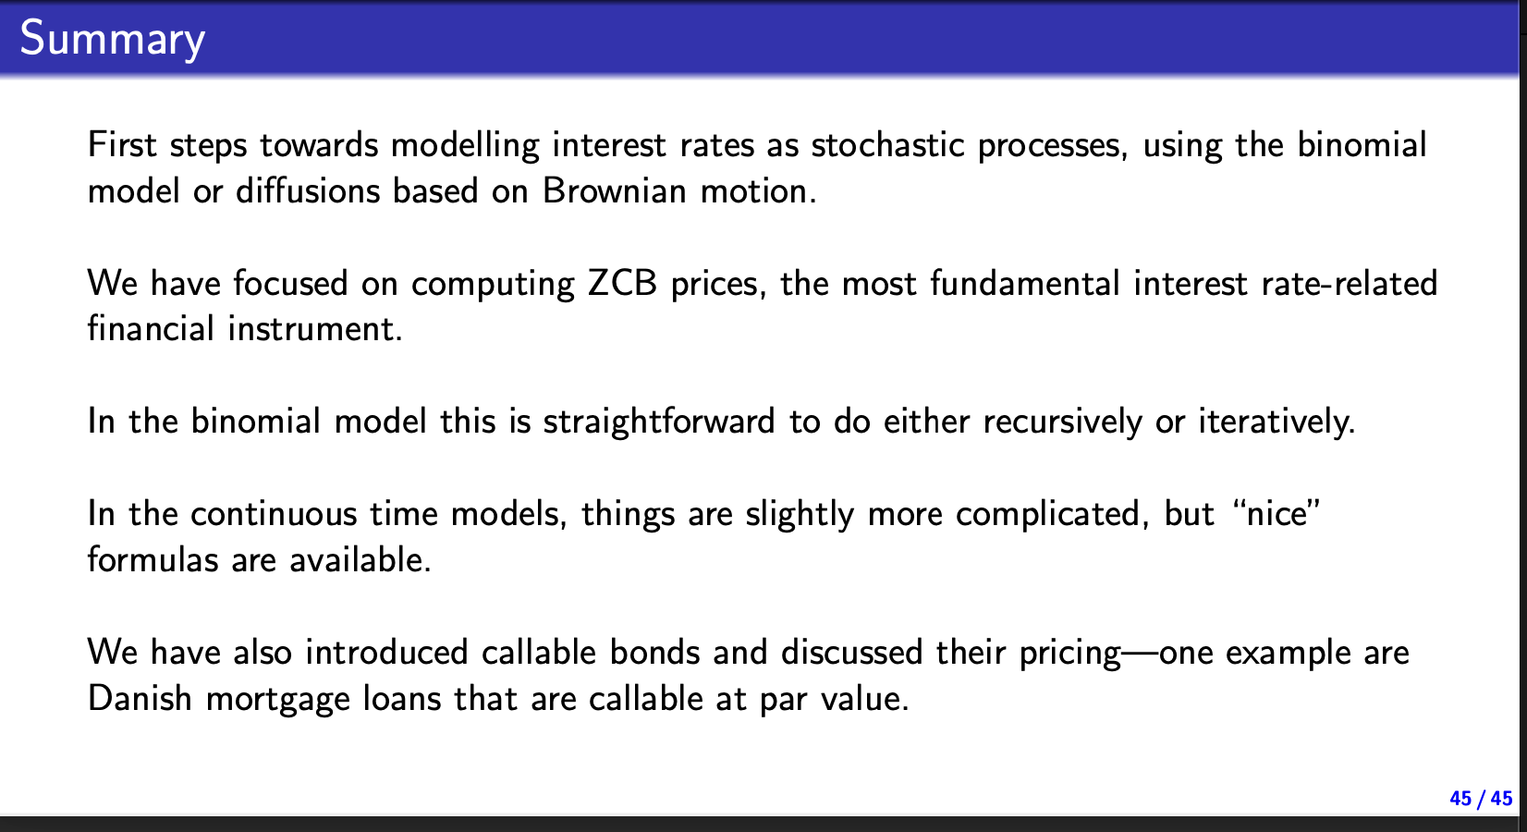

Fix sidste kapitel
Tjek tø
Tjek bog

Binomial træer:
Tjek kapitel 5 der er måske nogle godter
The risk neutral measure:
The idea of the risk neutral measure is to find a the probablities Q where the expected return on the asset is exactly the risk free rate r

Martingale pricing:
Any risk neutral measure is a martingale measure meaning at time $t_{1}$
$$E^{Q}\left[S_{t_{2}}\right]=e^{r(t_{2}-t_{1})}S_{t_{1}}$$
Forall $t_{2}>t_{1}$
Mere på side 373 I bogen

Ting jeg tænker han godt kunne finde på at give til eksamen:
Euler equation (some how)
Forward pricing med stocastisk rente
Bwvisopgaver med replication/no arbitrage
Swaptions
Risk neutral pricing(af et eller andet derivat)

Pricing opgave af interestrate derivative med vasicek modellen

